Appendix 8C-38 Critical Depth, Structural Plate

Corrugated Metal Pipe-Arch,

18” Corner Radius
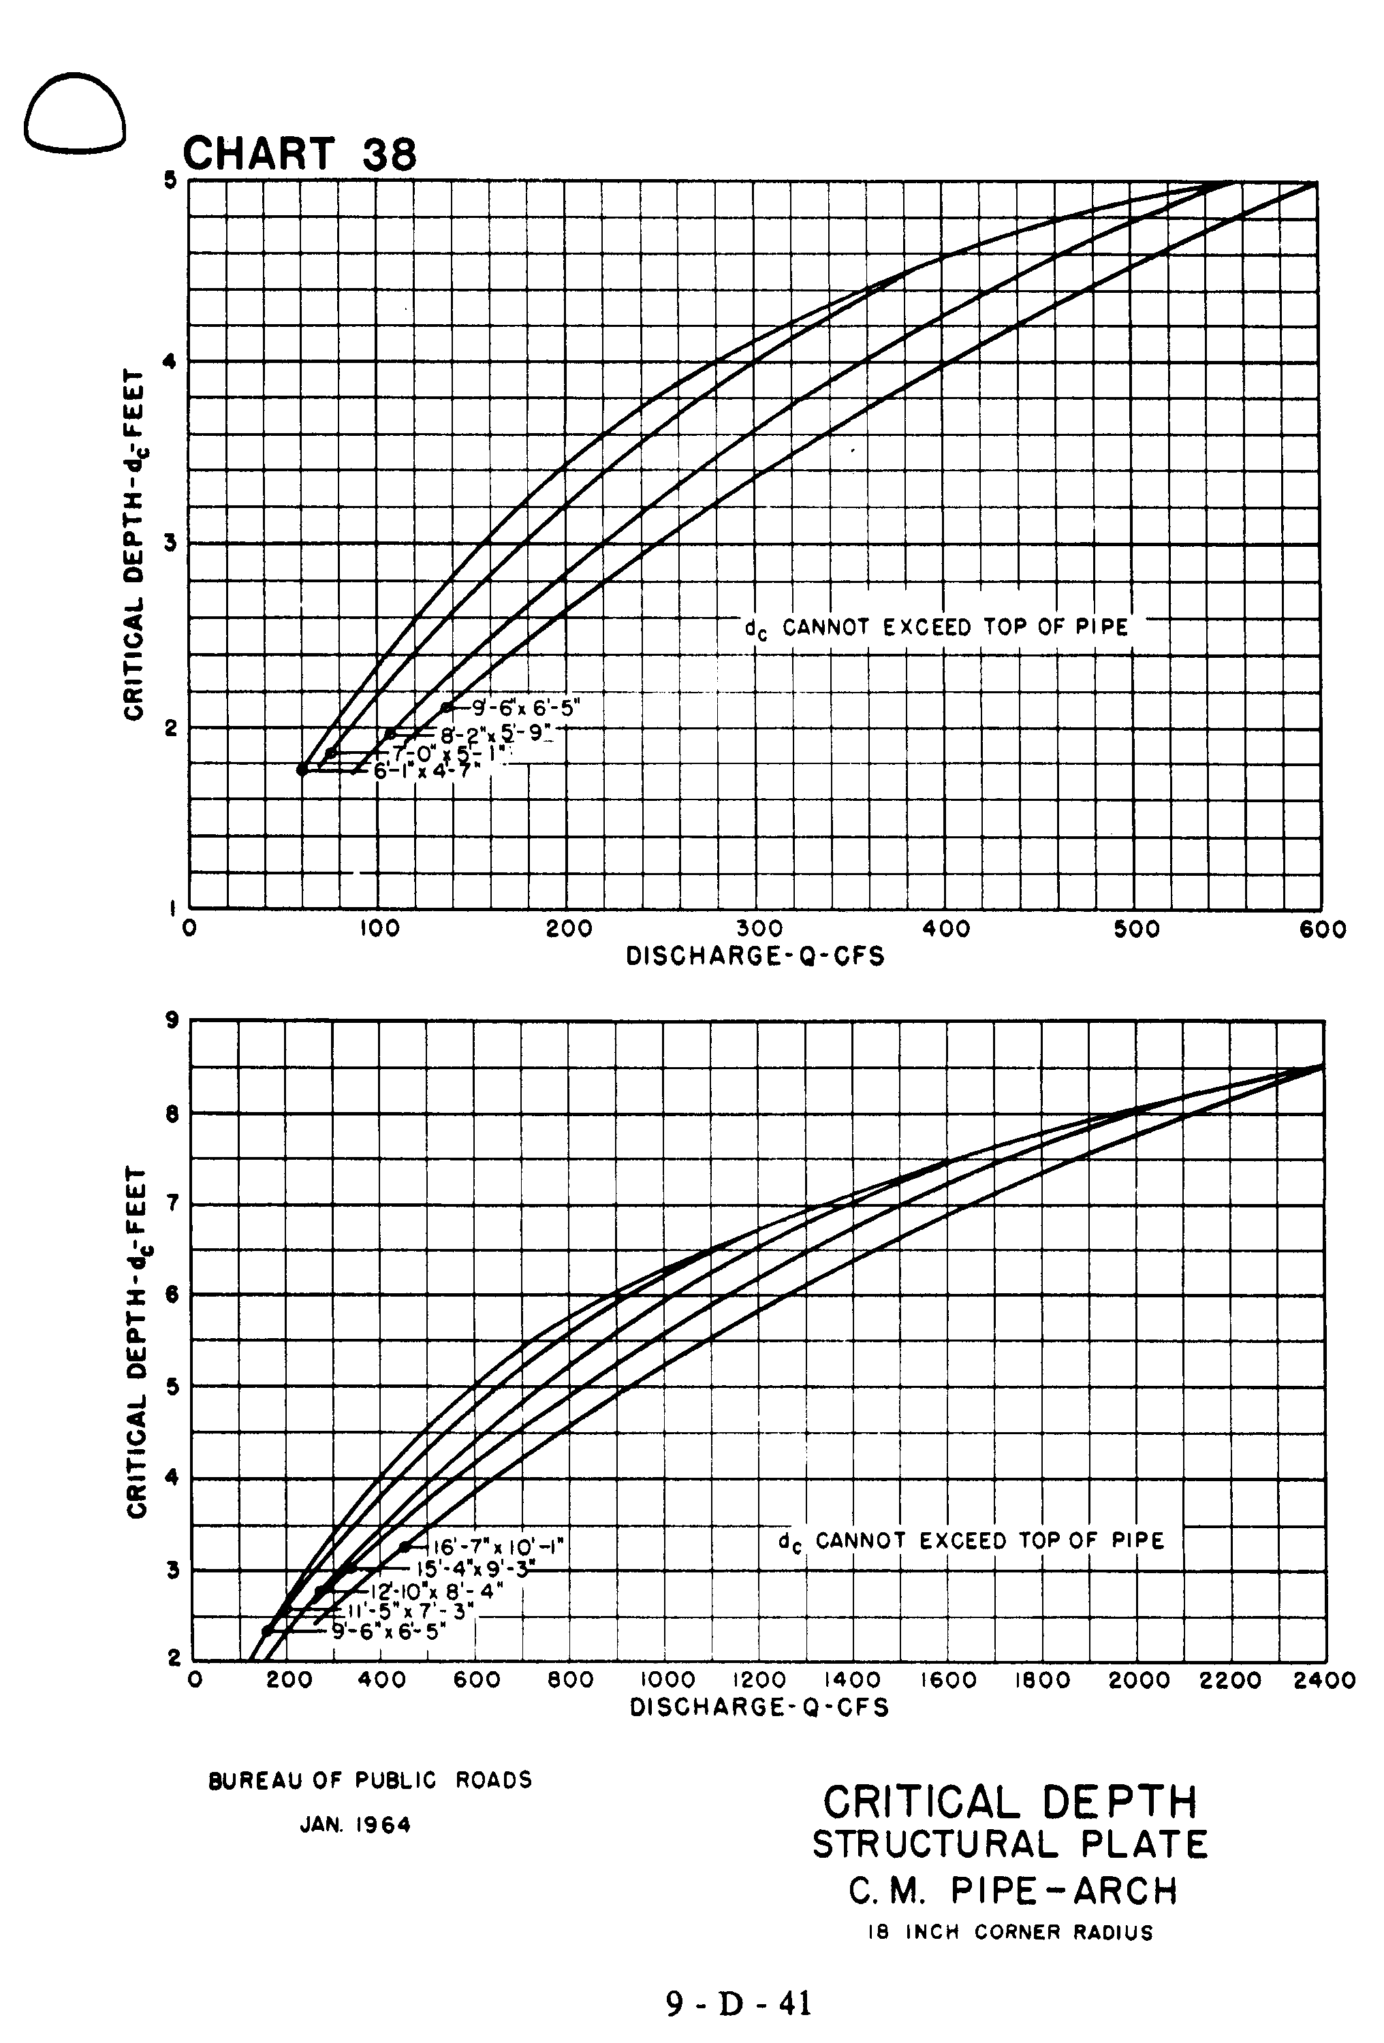
Source: HDS-5

