Appendix 8C-37 Critical Depth,

Standard Corrugated Metal Pipe-Arch
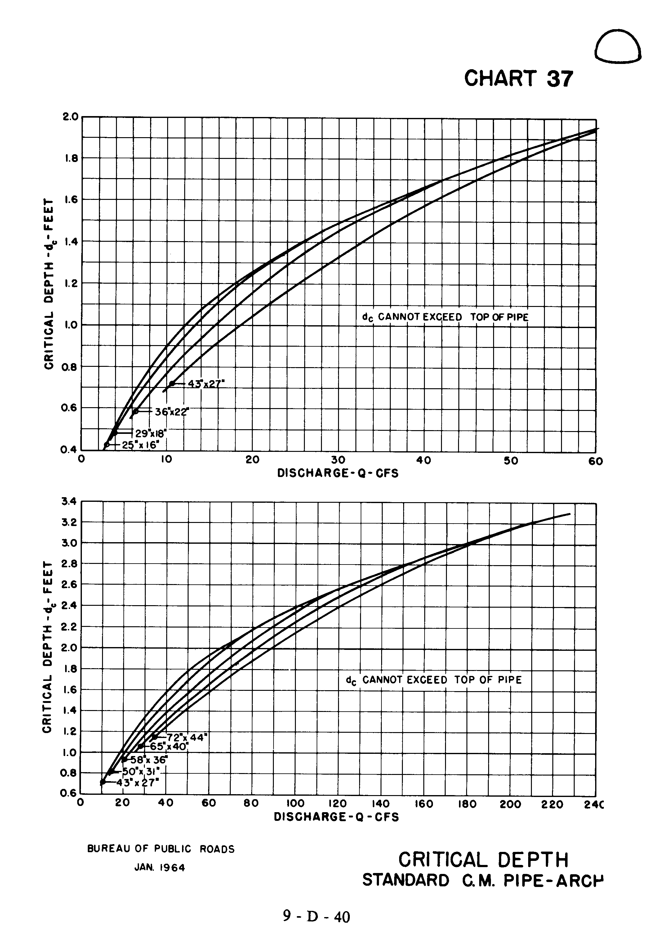

Source: HDS-5

