Appendix 8C-36 Inlet Control,

Structural Plate Pipe-Arch,

31” Corner Radius
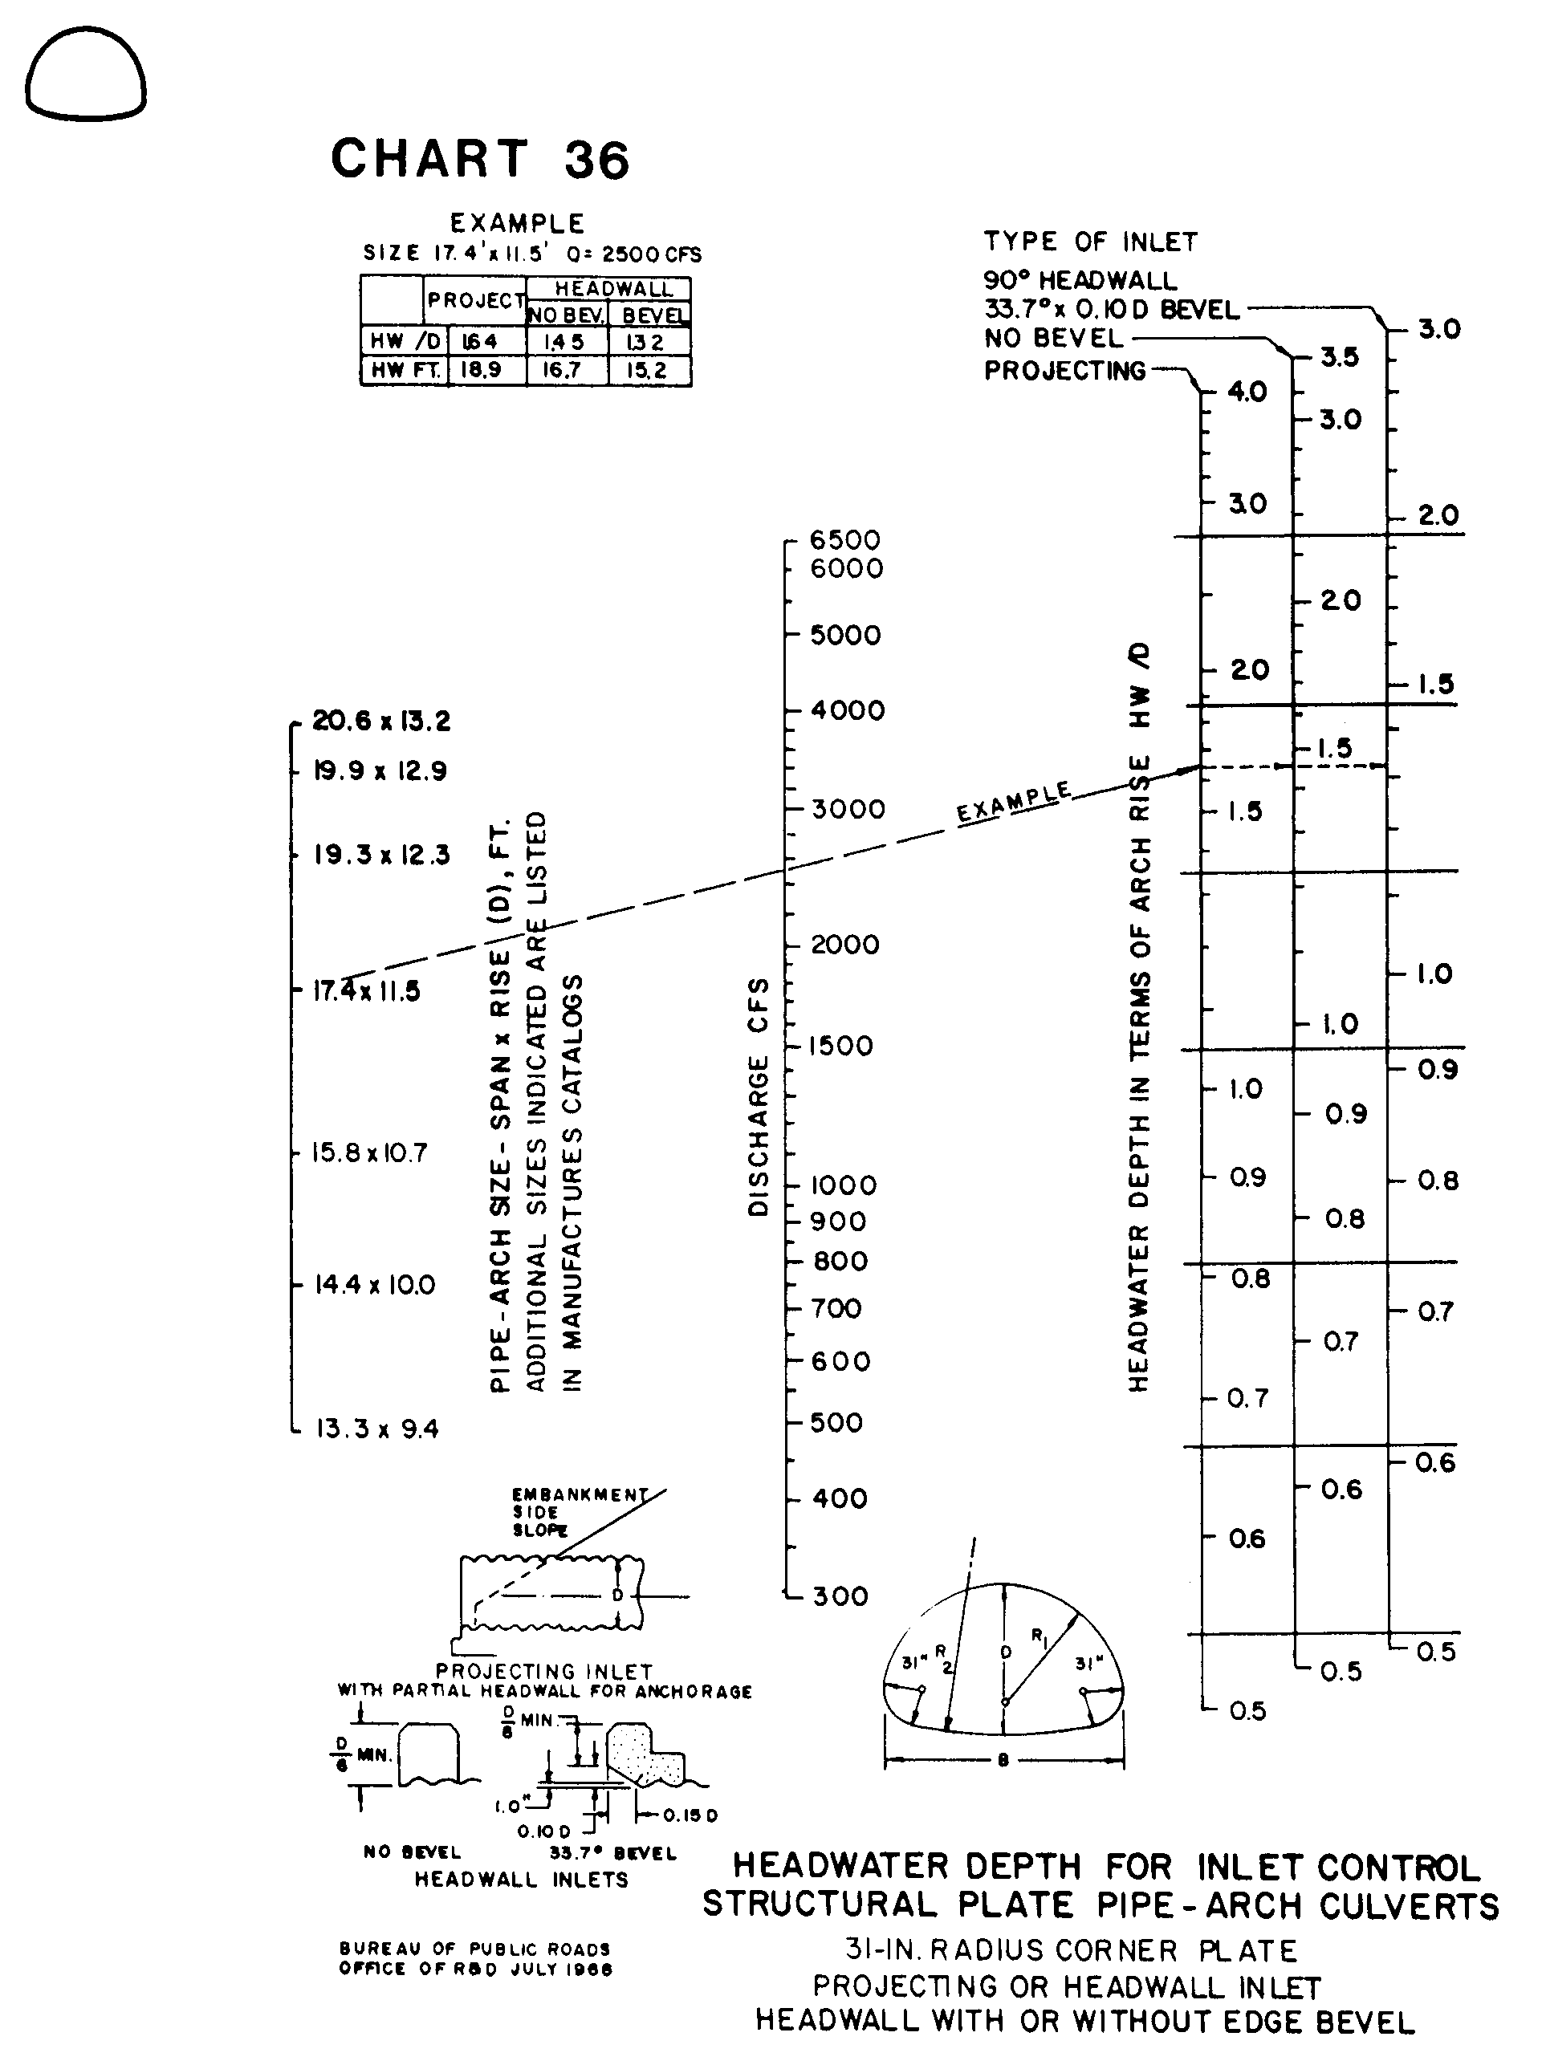

Source: HDS-5

