Appendix 8C-34 Inlet Control,

Corrugated Metal Pipe-Arch
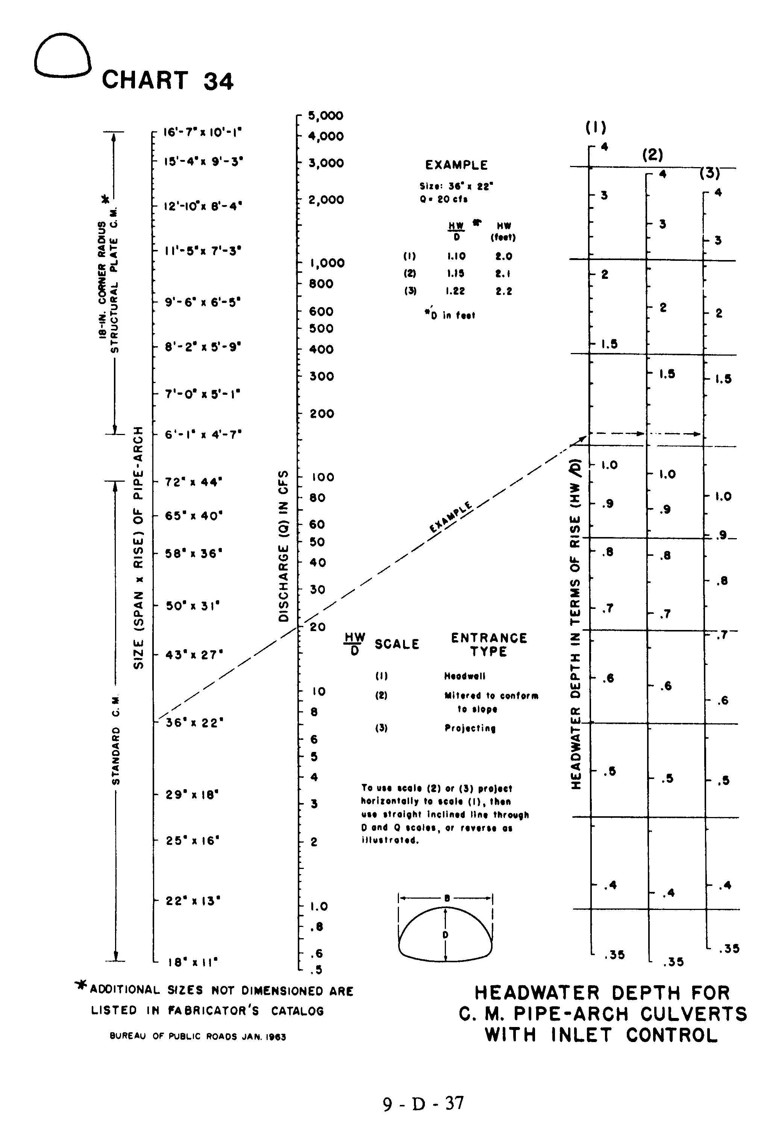
Source: HDS-5

