Appendix 8C-32 Critical Depth, Oval Concrete,

Long Axis Vertical
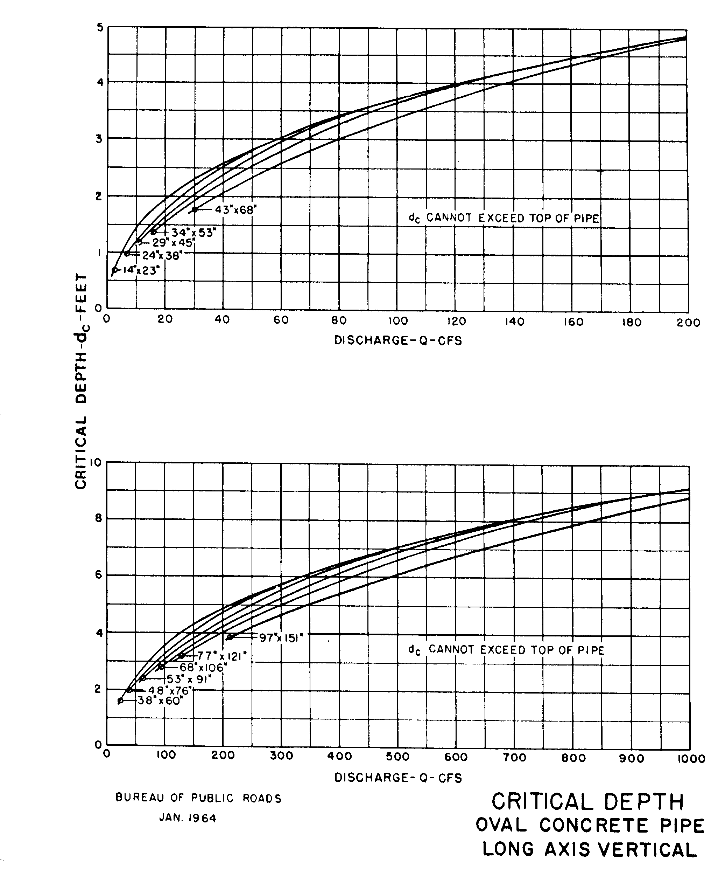

Source: HDS-5

