Appendix 8C-30 Inlet Control, Oval Concrete,

Long Axis Vertical
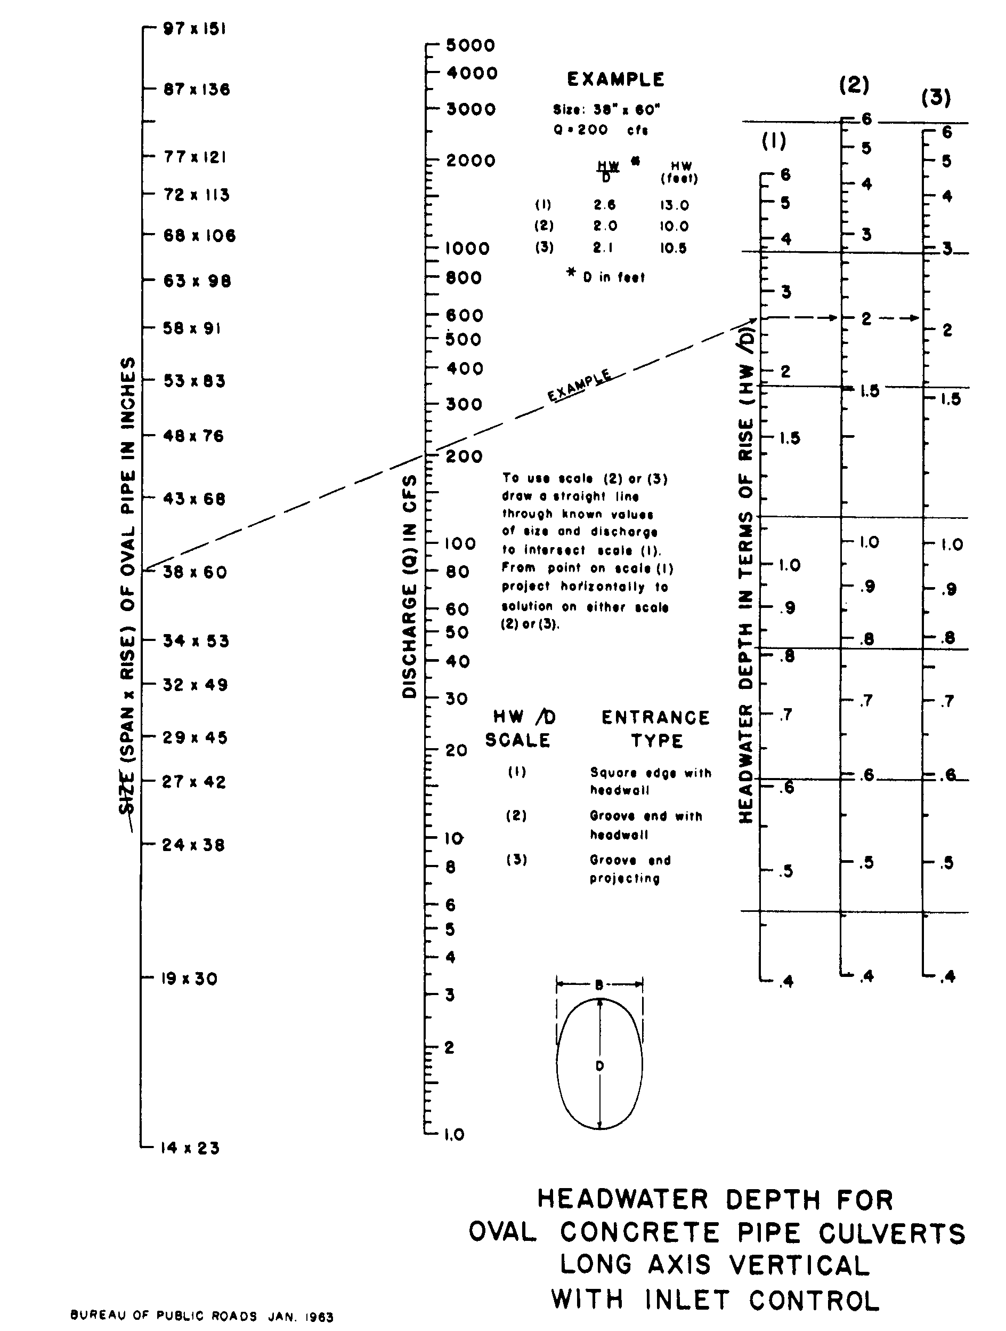

Source: HDS-5

