Appendix 8C-28 Outlet Control, Corrugated Metal Box,

Corrugated Metal Bottom,

0.5≤ Rise/Span
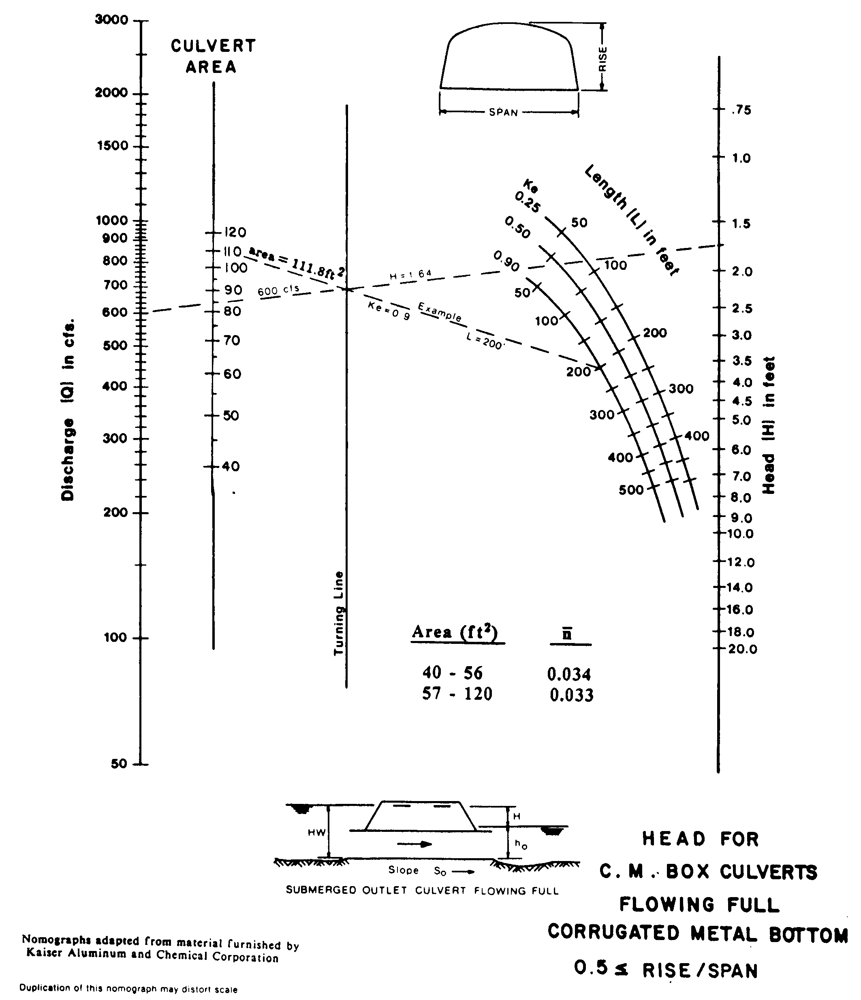

Source: HDS-5

