Appendix 8C-27 Outlet Control, Corrugated Metal Box,

Corrugated Metal Bottom,

0.4≤ Rise/Span <0.5
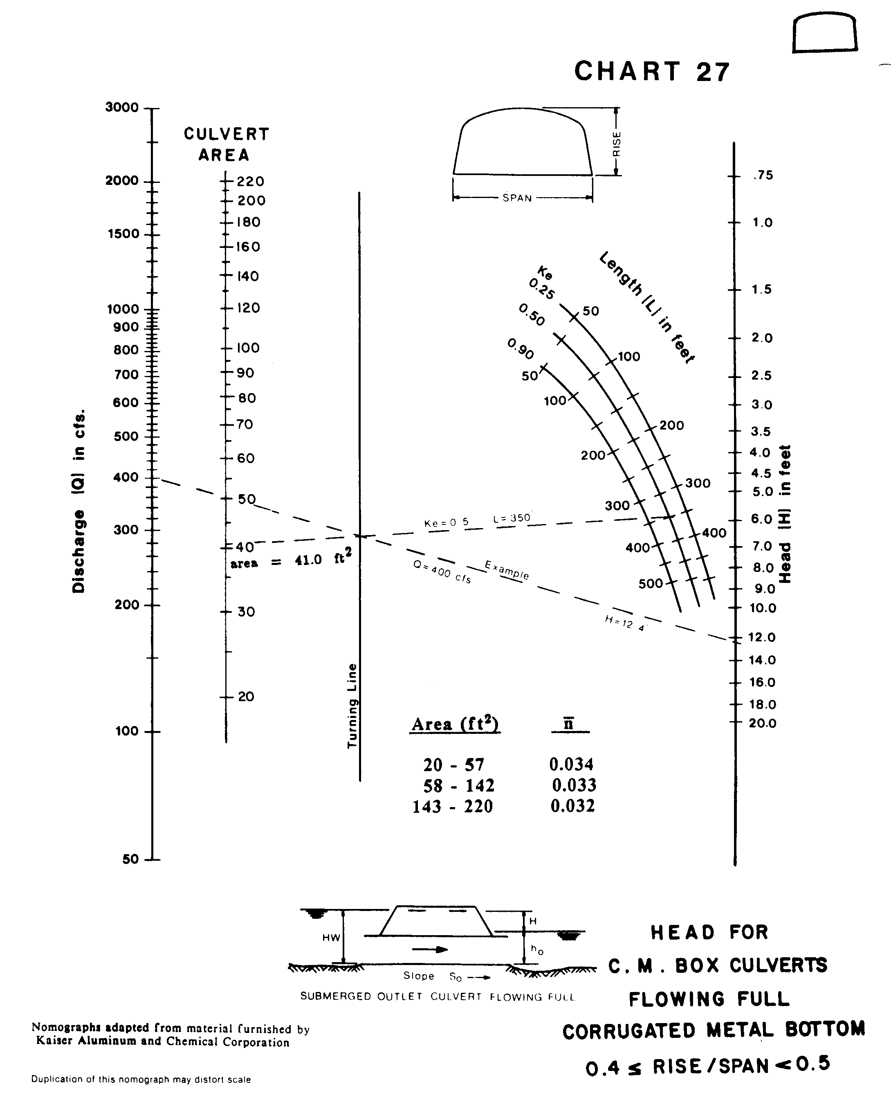

Source: HDS-5

