Appendix 8C-24 Outlet Control,

Corrugated Metal Box, Concrete Bottom

0.5≤ Rise/Span
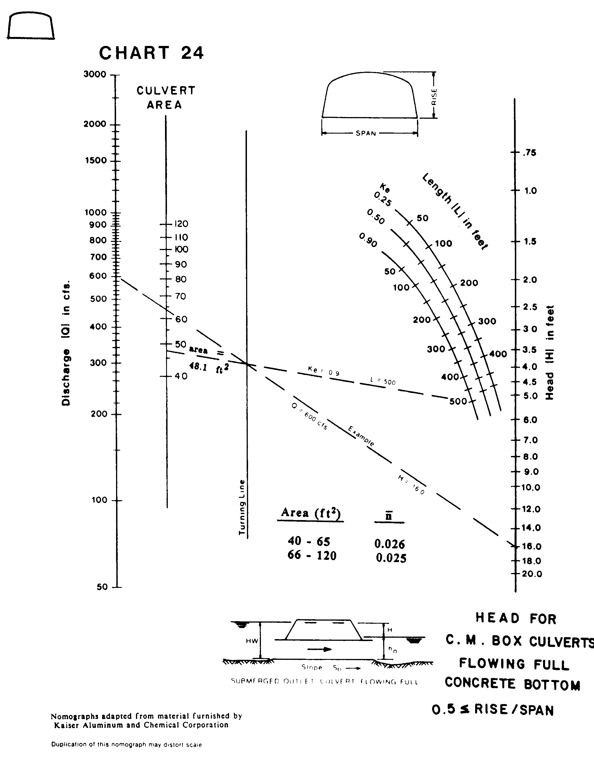

Source: HDS-5

