Appendix 8C-21 Outlet Control,

Corrugated Metal Box, Concrete Bottom

Rise/Span <0.3
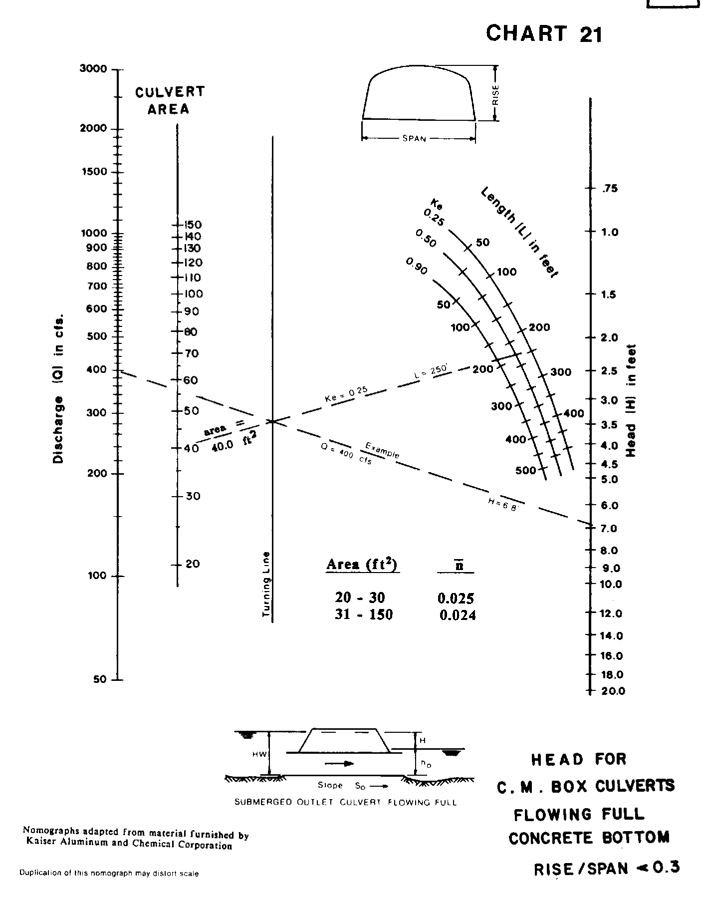

Source: HDS-3

