Appendix 8C-20 Critical Depth, Corrugated Metal Box

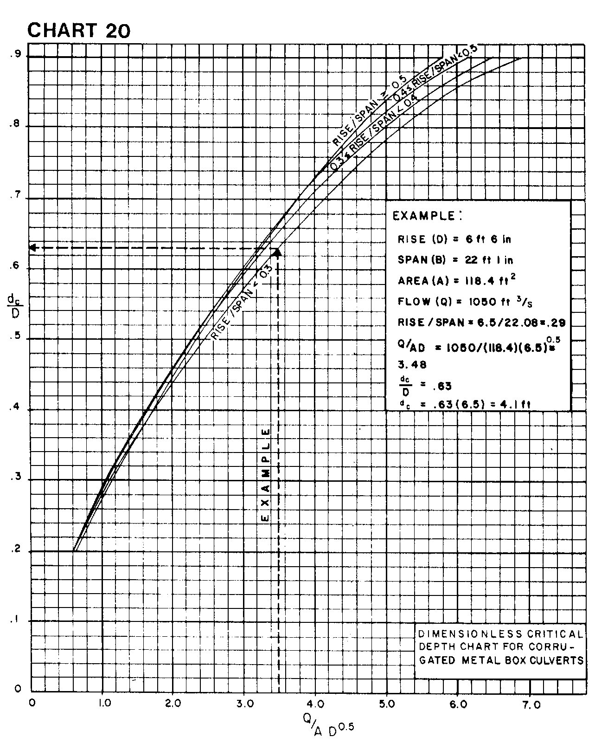

Source: HDS-5

