Appendix 8C-18 Inlet Control,

Corrugated Metal Box,

0.4<Rise/Span <0.5
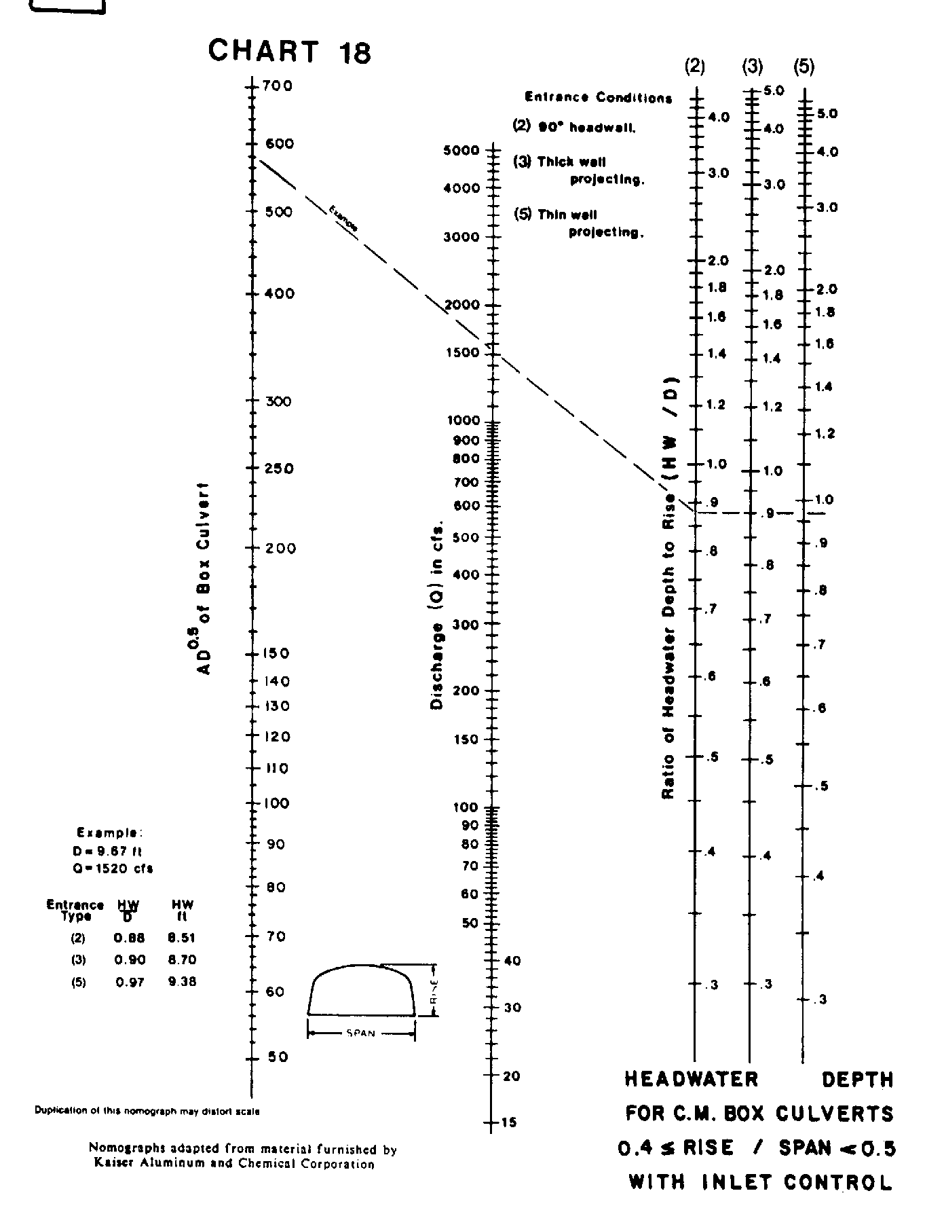

Source: HDS-5

