Appendix 8C-14 Critical Depth, Concrete Box
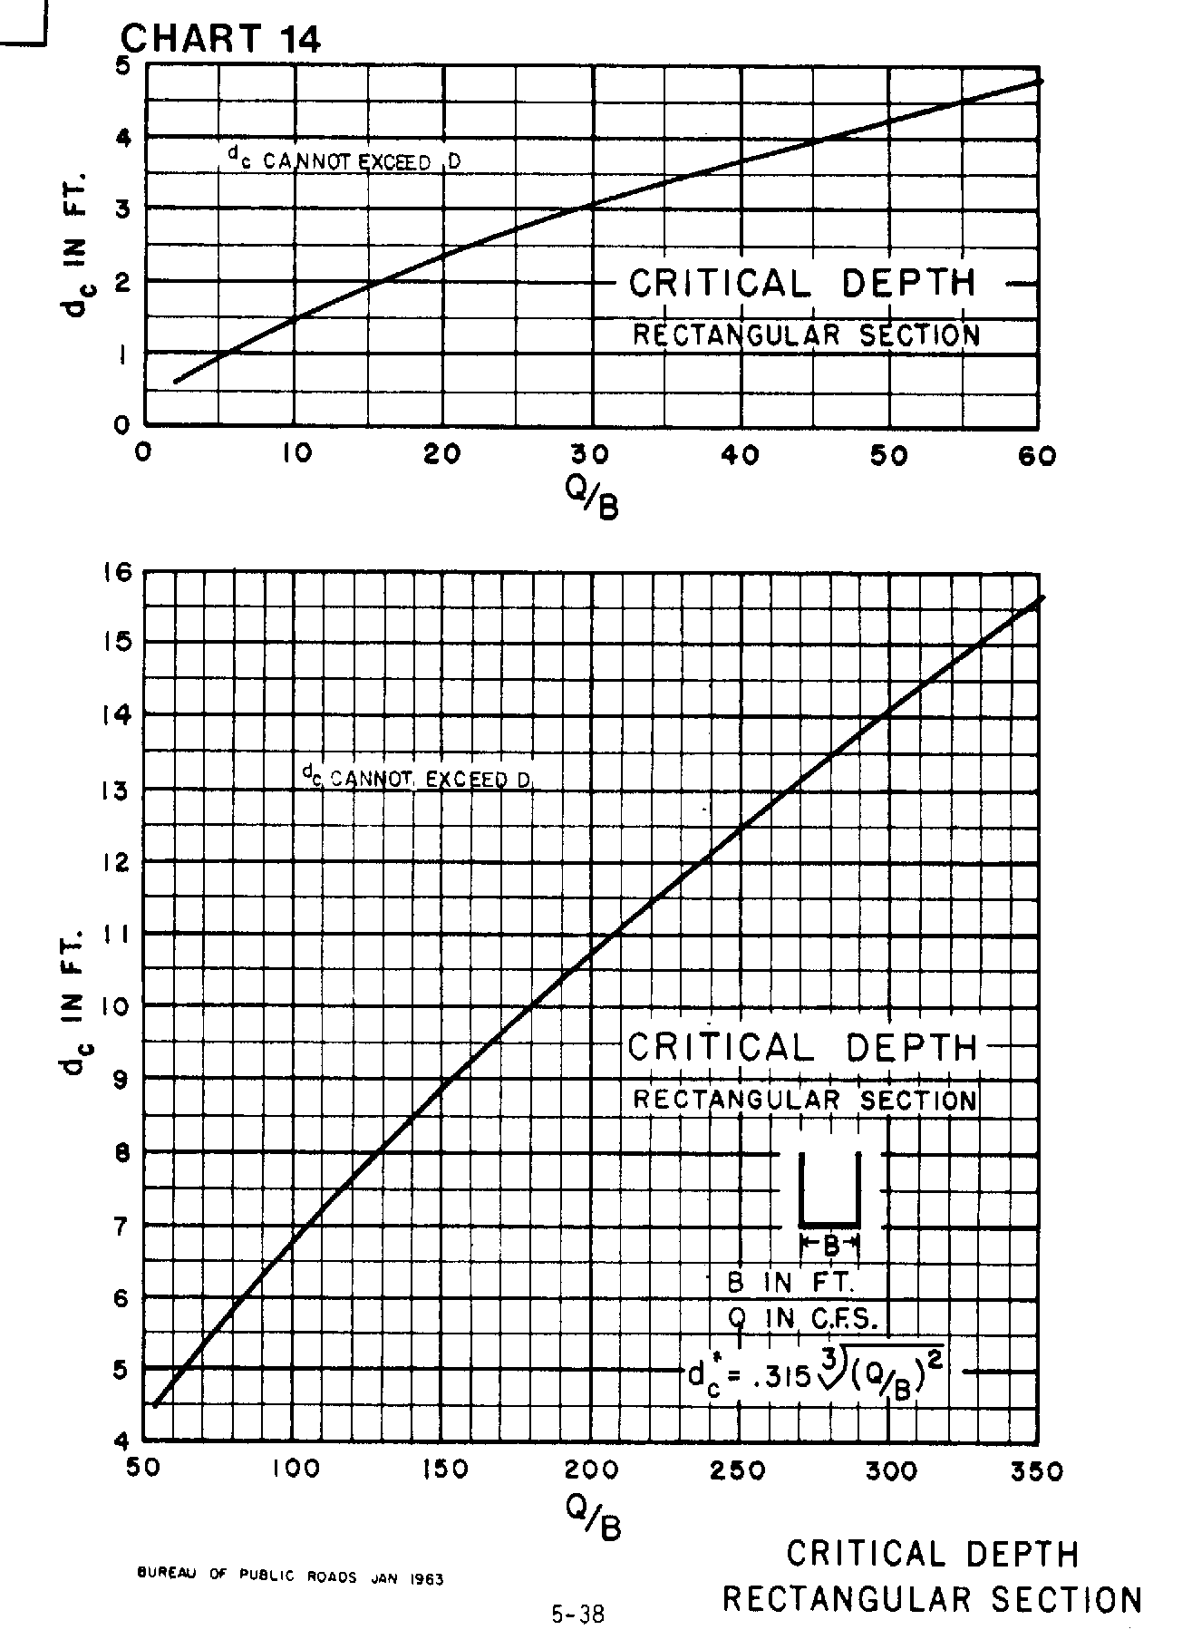

Source: HDS-5

