Appendix 8C-12 Inlet Control, Concrete Box, Flared Wingwalls,

Normal and Skewed Inlets, Chamfered Top Edge

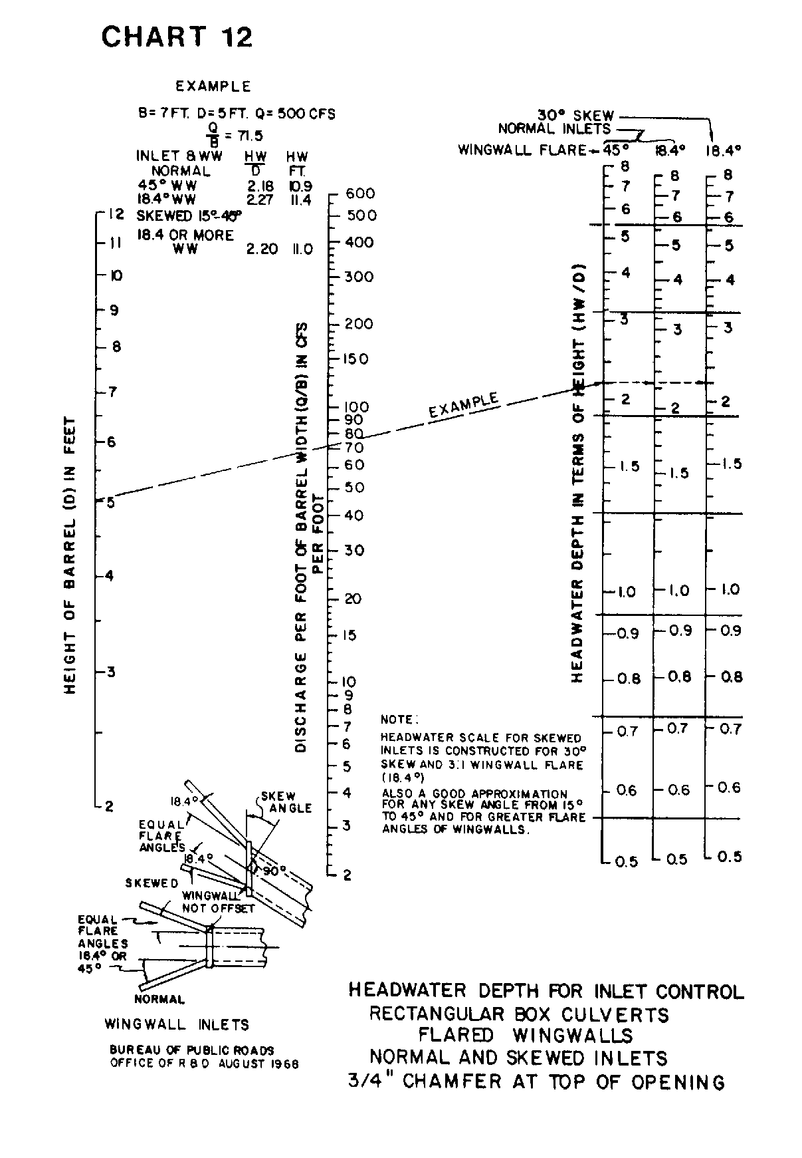

Source: HDS-5

