Appendix 8C-9 Inlet Control, Concrete Box,

Flared Wingwalls at 18° to 33.7°and 45°,

Beveled Top Edge
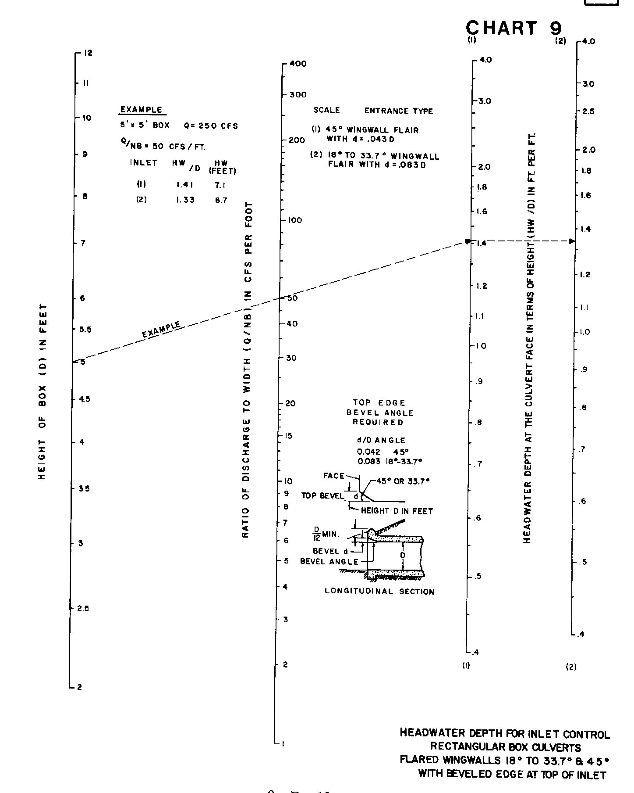

Source: HDS-5

