Appendix 8C-6 Outlet Control,
Circular Corrugated Metal

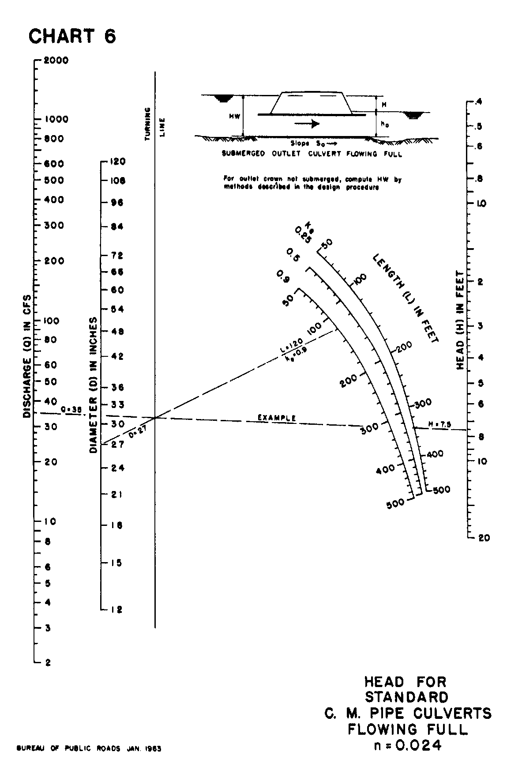

Source: HDS-5

