Appendix 8C-4 Critical Depth, Circular

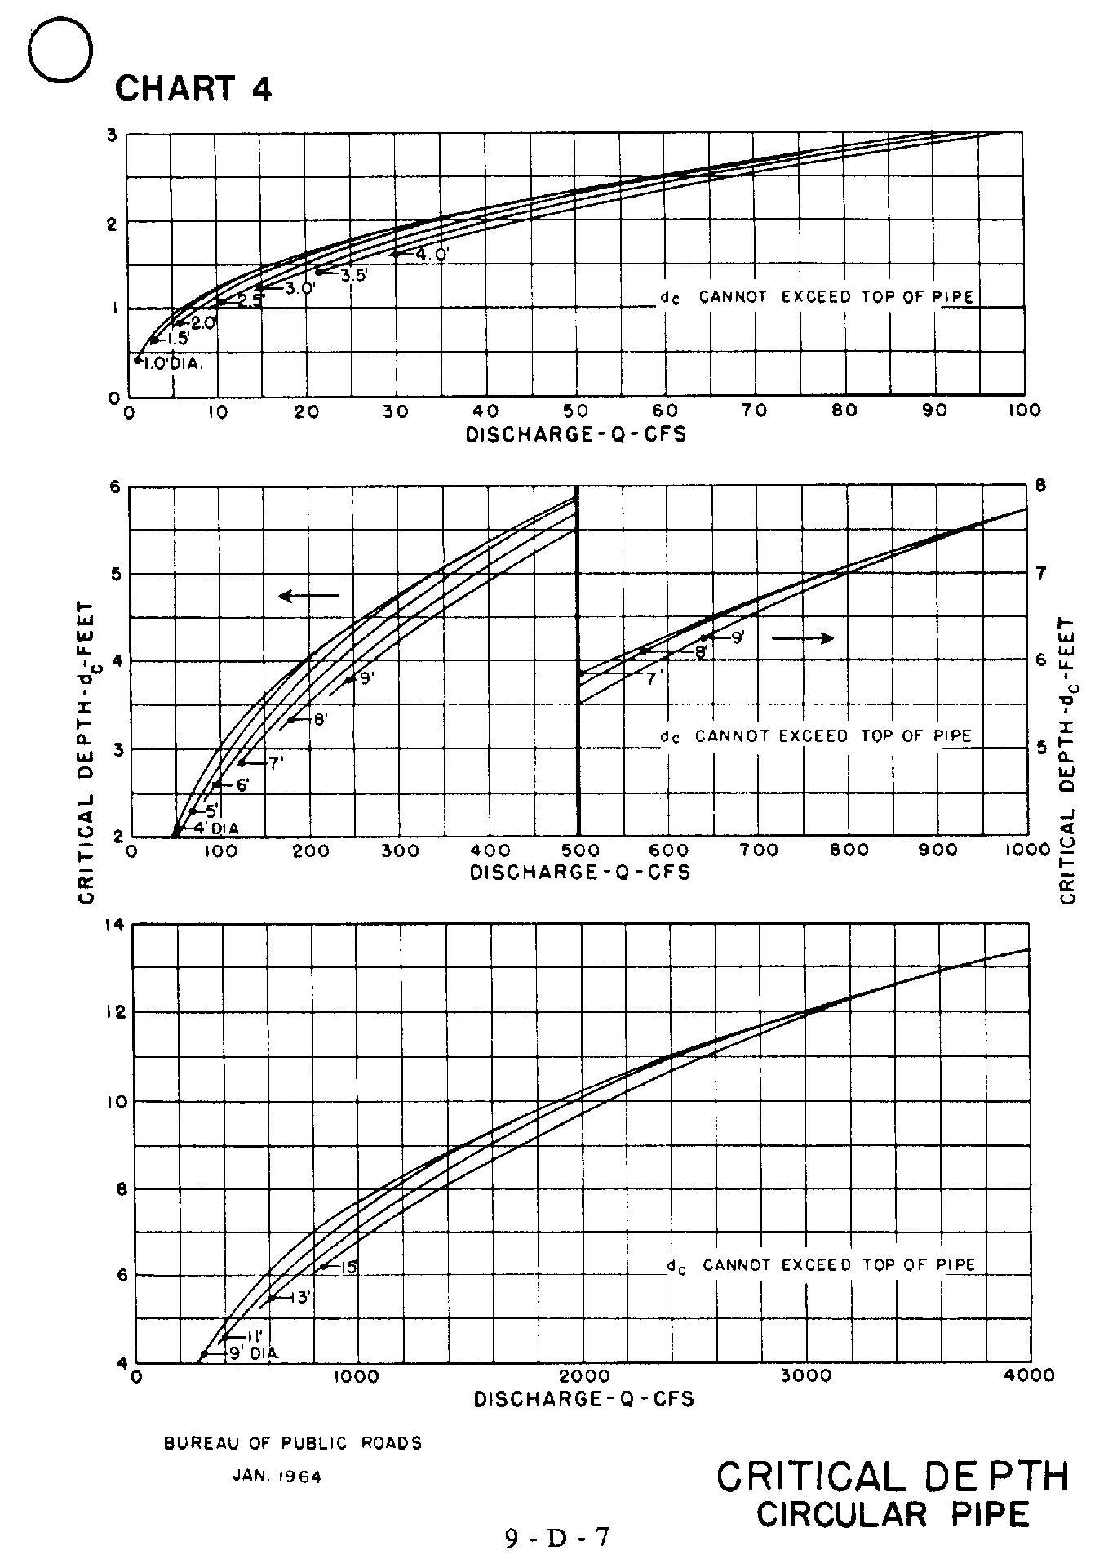

Source: HDS-5

