Appendix 8C-3 Inlet Control, Circular with Beveled Ring
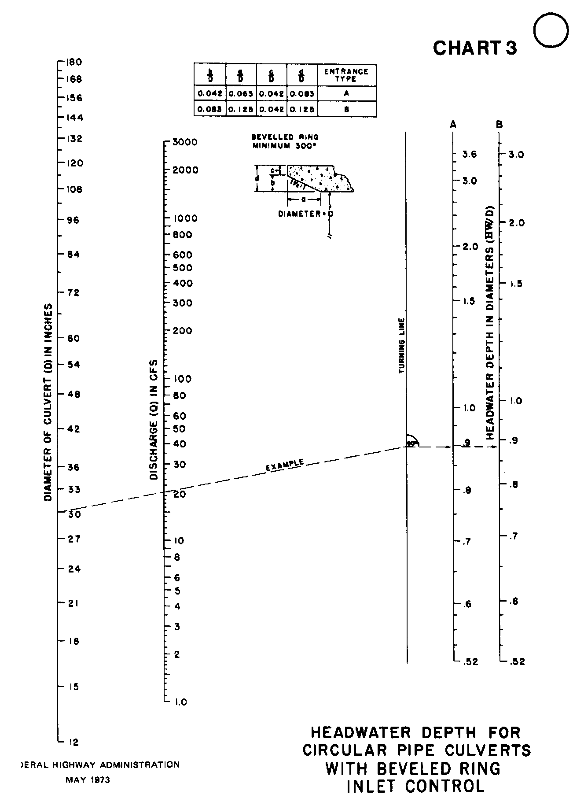

Source: HDS-5

