Appendix 8C-2 Inlet Control, Circular Corrugated Metal
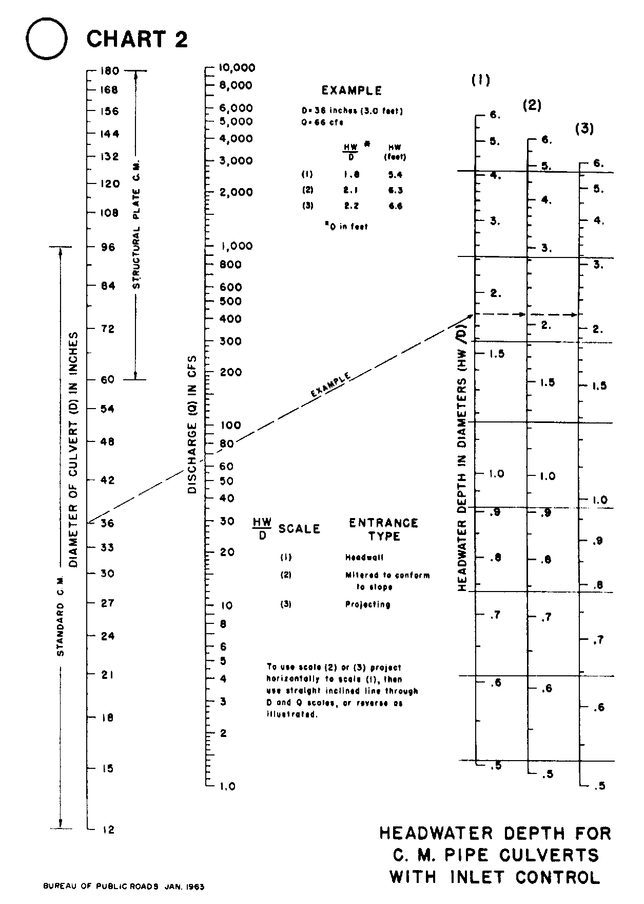

Source: HDS-5

