Appendix 8B-1 Culvert Design Form LD-269
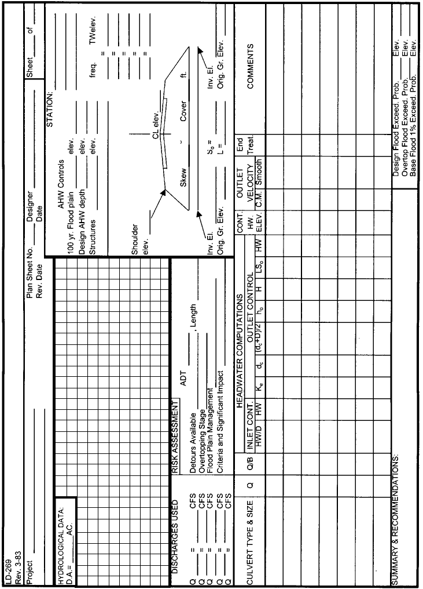
Source: VDOT

