Chapter 7 — Ditches and Channels
TABLE OF CONTENTS
Chapter 7 - Ditches and Channels 7-1
7.1 Introduction 7-1
7.2 Design Policy 7-2
7.2.1 Federal Policy 7-2
7.2.2 Commonwealth of Virginia Policy 7-2
7.2.2.1 Adequate Receiving Channels 7-2
7.2.3 VDOT Policy 7-2
7.3 Design Criteria 7-4
7.3.1 Roadside Ditches and Channel Classifications 7-4
7.3.1.1 Minor Channels (Roadside Ditches) 7-4
7.3.1.2 Major Channels (Drainage Channels) 7-4
7.3.1.3 Natural Channels 7-4
7.3.2 Adequate Receiving Channels 7-4
7.3.3 Minor Channels (Roadside Ditches) 7-5
7.3.4 Major Channels 7-6
7.3.5 Natural Channels 7-7
7.4 Design Concepts 7-8
7.4.1 Minor Channels (Roadside Ditches) 7-8
7.4.1.1 General 7-8
7.4.1.2 Design Considerations 7-8
7.4.2 Major Channels 7-8
7.4.2.1 General 7-8
7.4.2.2 Flow Classifications 7-9
7.4.3 Natural Channels 7-9
7.4.3.1 Stream Morphology 7-9
7.4.3.1.1 Introduction 7-9
7.4.4 Channel Analysis 7-10
7.4.4.1 General 7-10
7.4.4.2 Equations 7-11
7.4.4.2.1 Specific Energy 7-11
7.4.4.2.2 Velocity Distribution Coefficient 7-12
7.4.4.2.3 Total Energy Head 7-12
7.4.4.2.4 Froude Number 7-12
7.4.4.2.5 Critical Flow 7-13
7.4.4.2.6 Subcritical Flow 7-13
7.4.4.2.7 Supercritical Flow 7-14
7.4.4.2.8 Continuity Equation 7-14
7.4.4.2.9 Manning's Equation 7-14
7.4.4.2.10 Conveyance 7-15
7.4.4.2.11 Energy Equation 7-15
7.4.4.3 Hydraulic Representation of Channels 7-17
7.4.4.3.1 Cross Sections 7-17
7.4.4.3.2 Manning’s n-Value Selection 7-18
7.4.4.3.3 Calibration 7-19
7.4.4.3.4 Switchback Phenomenon 7-19
7.4.4.4 Single-Section Analysis 7-19
7.4.4.5 Water Surface Profile Analysis 7-20
7.4.4.5.1 Water Surface Profile Methodology 7-20
7.4.4.5.2 Classifications of Backwater Profiles 7-22
7.4.4.5.3 Water Surface Profile Computations 7-25
7.4.5 Water and Sediment Routing 7-25
7.4.6 Ditch and Channel Protection 7-25
7.4.6.1 Permissible Velocity 7-26
7.4.6.2 Tractive Force 7-26
7.4.6.3 Geotextile Channel Linings 7-28
7.4.6.3.1 Design Criteria, Geotextile Linings 7-28
7.4.6.4 Riprap 7-29
7.4.6.4.1 Riprap Dimensions and Weights 7-29
7.4.6.4.2 Soils Survey 7-29
7.4.6.4.3 Riprap Bedding 7-30
7.4.6.4.4 Major Channels 7-30
7.4.6.4.5 Minor Channels 7-31
7.5 Design Procedures and Sample Problems 7-32
7.5.1 Documentation Requirements 7-32
7.5.2 Roadside Ditches and Minor Channels 7-32
7.5.2.1 Roadside Ditch and Minor Channel Design Procedure 7-32
7.5.2.2 VDOT Method for Design of Roadside Ditch Linings 7-35
7.5.2.2.1 Design Procedure for Roadside Ditch Linings Using VDOT Method 7-35
7.5.2.2.2 Caveats to General Design Procedures for Roadside Ditch Linings 7-36
7.5.2.3 Roadside Ditch Lining Sample Problem 7-36
7.5.3 Major Channels 7-38
7.5.3.1 Single-Section Stage-Discharge Curve Procedure 7-38
7.5.3.2 Water Surface Profile Procedure 7-38
7.5.3.2.1 Water Surface Profile Sample Problem 7-41
7.5.4 Natural Channels 7-42
7.5.4.1 General 7-42
7.5.4.2 Natural Channels Design Procedure 7-42
7.5.5 Riprap Channel Lining Design Procedure 7-45
7.5.5.1 Riprap Lining Design Method for Major Channels (HEC-11) 7-45
7.5.5.1.1 Riprap Lining Design for Major Channels (HEC-11) Sample Problem 7-47
7.5.5.2 Riprap Lining Design Method for Minor Channels (HEC-15) 7-47
7.5.5.2.1 Channel Stability Sample Problem - Tractive Force Calculation 7-49
7.5.5.2.2 Riprap Lining Design for Minor Channels (HEC-15) Sample Problem 7-50
7.6 References 7-52

List of Figures and Tables
Figure 7-1. Sample Roadside Ditch Plan and Profile 7-6
Figure 7-2. Specific Energy Diagram for Rectangular Channels 7-12
Figure 7-3. Terms in the Energy Equation 7-17
Figure 7-4. Hypothetical Cross Section Showing Reaches, Segments, and Subsections Used in Assigning n-Values 7-18
Figure 7-5. Example of Switchback Phenomenon 7-19
Figure 7-6. Energy Slope between Two Channel Sections 7-22
Figure 7-7. Notation for Classifying Water Surface Profiles 7-23
Figure 7-8. Types of Backwater Profiles 7-24
Table 7-1. Protective Linings For Ditches And Channels 7-28
Figure 7-9. Roadside Ditch Protection Sample Problem, Plan and Section 7-37
Figure 7-10. Worksheet (LD-268) for Calculation of Roadside Ditch Protection, Sample Problem 7-38
Figure 7-11. Water Surface Profile Sample Problem 7-42
Figure 7-12. Worksheet for Calculation of Non-Uniform Flow in Open Channels, Sample Problem 7-43
Table 7-2. Manning’s n-Values for Depth Ranges 7-49
List of Appendices
Appendix 7A-1 Definitions and Abbreviations
Appendix 7A-2 Symbols
Appendix 7B-1 LD-268 Roadside and Median Ditch Design Form
Appendix 7B-2 Water Surface Profile Calculation Form
Appendix 7B-3 Channel Stability Work Sheet
Appendix 7B-4 Riprap Design Work Sheet for Standard VDOT Riprap Sizes Only
Appendix 7B-5 Riprap Design Work Sheet for Other Than VDOT Standard Riprap Sizes
Appendix 7C-1 Nomograph for Solution of Manning's Equation
Appendix 7C-2 Trapezoidal Channel Capacity Chart
Appendix 7C-3 Nomograph for Solution of Normal Depth
Appendix 7C-4 Side Ditch Flow Chart (Side Slopes = 6:1, 1.5:1)
Appendix 7C-5 Side Ditch Flow Chart (Side Slopes = 4:1, 1:1)
Appendix 7C-6 Side Ditch Flow Chart (Side Slopes = 4:1, 1.5:1)
Appendix 7C-7 Side Ditch Flow Chart (Side Slopes = 3:1. 2:1)
Appendix 7C-8 Side Ditch Flow Chart (Side Slopes = 3:1, 1.5:1)
Appendix 7C-9 Side Ditch Flow Chart (Side Slopes = 3:1, 2:1)
Appendix 7C-10 Side Ditch Flow Chart (Side Slopes = 6:1, 2:1)
Appendix 7C-11 Side Ditch Flow Chart (Side Slopes = 6:1, 4:1)
Appendix 7C-12 Triangular Median Ditch Flow Chart (Side Slopes = 6:1, 6:1)
Appendix 7C-13 Triangular Median Ditch Flow Chart (Side Slopes = 4:1, 4:1)
Appendix 7C-14 Triangular Median Ditch Flow Chart (Side Slopes = 2:1, 2:1)
Appendix 7C-15 Toe Ditch Flow Chart (Side Slopes = 1.5:1, 1.5:1)
Appendix 7C-16 Standard PG-4 Flow Chart
Appendix 7C-17 Trapezoidal Ditch Flow Chart (B=1’, Side Slopes = 1.5:1)
Appendix 7C-18 Trapezoidal Channel Flow Chart (B=2’, Side Slopes = 2:1)
Appendix 7C-19 Trapezoidal Channel Flow Chart (B=3’, Side Slopes = 2:1)
Appendix 7C-20 Trapezoidal Channel Flow Chart (B=4’, Side Slopes = 2:1)
Appendix 7C-21 Trapezoidal Channel Flow Chart (B=5’, Side Slopes = 2:1)
Appendix 7C-22 Trapezoidal Channel Flow Chart (B=6’, Side Slopes = 2:1)
Appendix 7C-23 Trapezoidal Channel Flow Chart (B=7’, Side Slopes = 2:1)
Appendix 7C-24 Trapezoidal Channel Flow Chart (B=8’, Side Slopes = 2:1)
Appendix 7C-25 Trapezoidal Channel Flow Chart (B=9’, Side Slopes = 2:1)
Appendix 7C-26 Trapezoidal Channel Flow Chart (B=10’, Side Slopes = 2:1)
Appendix 7C-27 Trapezoidal Channel Flow Chart (B=12’, Side Slopes = 2:1)
Appendix 7C-28 Trapezoidal Channel Flow Chart (B=14’, Side Slopes = 2:1)
Appendix 7C-29 Trapezoidal Channel Flow Chart (B=16’, Side Slopes = 2:1)
Appendix 7C-30 Trapezoidal Channel Flow Chart (B=18’, Side Slopes = 2:1)
Appendix 7C-31 Trapezoidal Channel Flow Chart (B=20’, Side Slopes = 2:1)
Appendix 7D-1 Values of Roughness Coefficient n (Uniform Flow)
Appendix 7D-2 Recommended Maximum Water Velocities and Manning’s n as a Function of Soil Type and Flow Depth
Appendix 7D-3 Standard VDOT Riprap Classifications, Weights, and Blanket Thickness
Appendix 7D-4 Approximate Rock Dimensions and Equivalent Weights for Riprap
Appendix 7D-5 Selection of Stability Factors
Appendix 7D-6 Permissible Velocities for Erodible Linings
Appendix 7E-1 Angle of Repose of Riprap in Terms of Mean Size and Shape of Stone
Appendix 7E-2 Permissible Shear Stress for Non-Cohesive Soils
Appendix 7E-3 Permissible Shear Stress for Cohesive Soils
Appendix 7E-4 Bank Angle Correction Factor (K₁) Nomograph
Appendix 7E-5 Correction Factor for Riprap Size
Appendix 7E-6 Riprap Size Relationship
Appendix 7E-7 Channel Side Shear Stress to Bottom Shear Stress Ratio
Appendix 7E-8 Tractive Force Ration (K₂)
Appendix 7E-9 Determination of the Mean Spherical Diameter

Ditches and Channels

Introduction
The function* of ditches and open channels is to convey stormwater runoff from, through, or around roadway rights-of-way without damage to the highway, to the open channel, to other components of the highway system, or to adjacent property. Culverts and storm drains can be used for the same purposes. Open channels may be natural or constructed. In either case, the water surface is exposed to the atmosphere, and the gravity force component in the direction of motion is the driving force. Open channels are free to overflow their banks, and cannot develop pressure flow, as can closed conduits such as circular pipes. However, closed conduits flow as open channels when the water surface is below the crown of the conduit, and the design concepts of this chapter apply to closed conduits flowing partly full.

Design Policy
Following are Federal, Commonwealth of Virginia, and Virginia Department of Transportation (VDOT) design policies related to channel design.

Federal Policy
Channel designs and/or designs of highway facilities that impact channels should satisfy the policies of the Federal Highway Administration applicable to floodplain management. Federal Emergency Management Agency (FEMA) floodway regulations and Corps of Engineers (COE) wetland restrictions for permits should also be satisfied.

Commonwealth of Virginia Policy

Adequate Receiving Channels
The Virginia Erosion and Sediment Control Regulations, Minimum Standard 19 (VESCR MS-19 <http://www.dcr.virginia.gov/>) requires that properties and waterways, downstream from new development sites, shall be protected from sediment deposition, erosion, and damage due to increases in the volume, velocity, and peak flow rate of stormwater runoff for the stated frequency storm of 24-hour duration. Design criteria for adequate channels are summarized in Section 7.3.2.

VDOT Policy
The following statements represent VDOT goals for ditch and channel design:
- Coordination with other Federal, State and local agencies concerned with water resources planning has high priority in the planning of highway facilities
- Safety of the general public is an important consideration in the selection of the cross-sectional geometries of artificial drainage channels
- The design of artificial drainage channels or other facilities should consider the frequency and type of maintenance expected and make allowance for maintenance access
- Stability is the goal for all channels that are located on highway right-of-way or that impact highway facilities
- Environmental impacts of channel modifications, including disturbance of fish habitat, wetlands and channel stability, should be assessed
- The range of design channel discharges should be selected by the designer based on class of roadway, consequences of traffic interruption, flood hazard risks, economics, and local site conditions
- Wherever possible, encroachment into streams should be avoided and encroachment onto flood plains should be minimized to the fullest extent practical
- Whenever natural channels must be relocated or otherwise modified, the extent of channel reach and degree of modification should be the minimum necessary to provide compatibility of the channel and roadway, and will incorporate any necessary natural channel design and/or stream restoration
A thorough analysis of the stream’s morphology and environment shall be conducted and documented in addition to the economic and engineering alternatives available for the particular location.

Design Criteria

Roadside Ditches and Channel Classifications
In this chapter, ditches and channels are classified as:

Minor Channels (Roadside Ditches)
Minor channels collect sheet flow from the highway pavement or right-of-way and convey that flow to collection points in larger channels or pipes. Flows are generally 50 cubic feet per second (cfs) or less in minor channels. Minor channels usually parallel the highway embankment and are within the highway right-of-way. See Section 7.3.3 for minor channel criteria.

Major Channels (Drainage Channels)
Major channels collect drainage from minor channels, pipe systems, and off-site areas, and convey that flow to an adequate discharge point on- or off-site. Flows are generally greater than 50 cfs in major channels. See Section 7.3.4 for major channel criteria.

Natural Channels
Natural channels are formed through geomorphologic activity, including erosion and sedimentation. Generally meandering and irregular in cross-section, natural channels may convey any flow rate. See Section 7.3.5 for natural channel criteria.

Adequate Receiving Channels
Minimum Standard 19 (Virginia Erosion and Sediment Control Handbook) for adequate receiving channels establishes the following design criteria for all channels.
Concentrated stormwater runoff leaving a development site must be discharged directly into an adequate* well-defined, natural or man-made off-site receiving channel, pipe, or storm sewer system. If there is no adequate off-site receiving channel or pipe, one must be constructed to convey stormwater to the nearest adequate channel. Newly constructed channels shall be designed as adequate channels.
An adequate channel is defined as follows: (1) A natural channel, which is capable of conveying the runoff from a 2-year storm without overtopping its banks or eroding after development of the site in question, (2) A previously constructed man-made channel shall be capable of conveying the runoff from a 10-year storm without overtopping its banks, and bed or bank erosion shall not occur due to a 2-year storm, (3) Pipes and storm sewer systems shall contain the 10-year storm.
A receiving channel may also be considered adequate at any point where the total contributing drainage area is at least 100 times greater than the drainage area of the development site in question; or, if it can be shown that the peak rate of runoff from the site during a 2-year storm will not be increased after development.
Runoff rate and channel adequacy must be verified with acceptable engineering calculations. Refer to Chapter 6, Hydrology, for peak discharge methods.
If an existing off-site receiving channel is not an adequate channel, the applicant must choose one of the following options:
- Obtain permission from downstream property owners to improve the receiving channel to an adequate condition. Such improvements should extend downstream until an adequate channel section is reached.
- Develop a site design that will not cause the pre-development peak runoff rate from a 2-year storm to increase when outfall is into a natural channel, or will not cause the pre-development rate from a 10-year storm to increase when outfall is to a man-made channel. Such a design may be accomplished by enhancing the infiltration capability of the site or by providing on-site stormwater detention measures. The pre-development and post-development peak runoff rates must be verified by engineering calculations.
- Provide a combination of channel improvement, stormwater detention, or other measures which are satisfactory to prevent downstream channel erosion.
All channel improvements or modifications must comply with all applicable laws and regulations.
Increased volumes of unconcentrated sheet flows which may cause erosion or sedimentation of adjacent property must be diverted to an adequate outlet or detention facility.
Outfall from a detention facility shall be discharged to an adequate channel. Outlet protection and/or energy dissipation should be placed at the discharge point as necessary.

7.3.3 Minor Channels (Roadside Ditches)
Minor channels are normally V-shaped and sometimes trapezoidal in cross section and lined with grass or a protective lining. They are usually designed to convey the 10-year discharge, and to resist erosion from the 2-year discharge. Higher design discharges may be necessary when the channel intercepts off-site drainage.
Special design ditches are designed for storm frequencies appropriate to the functional classification of the roadway and the risk involved when the design capacity is exceeded.
A secondary function of a roadside ditch is to drain subsurface water from the base of the roadway to prevent saturation and loss of support for the pavement or to provide a positive outlet for subsurface drainage systems such as pipe underdrains.
The alignment, cross-section, and grade of roadside ditches are usually constrained largely by the geometric and safety standards applicable to the project. These ditches should accommodate the design runoff in a manner that assures the safety of motorists and minimizes future maintenance, damage to adjacent properties, and adverse environmental, or aesthetic effects. A sample roadside ditch plan and profile is shown in Figure 7-1. The VDOT Method for Design of Roadside Ditch Linings (Section 7.5.2.2) is recommended for use on minor channels.
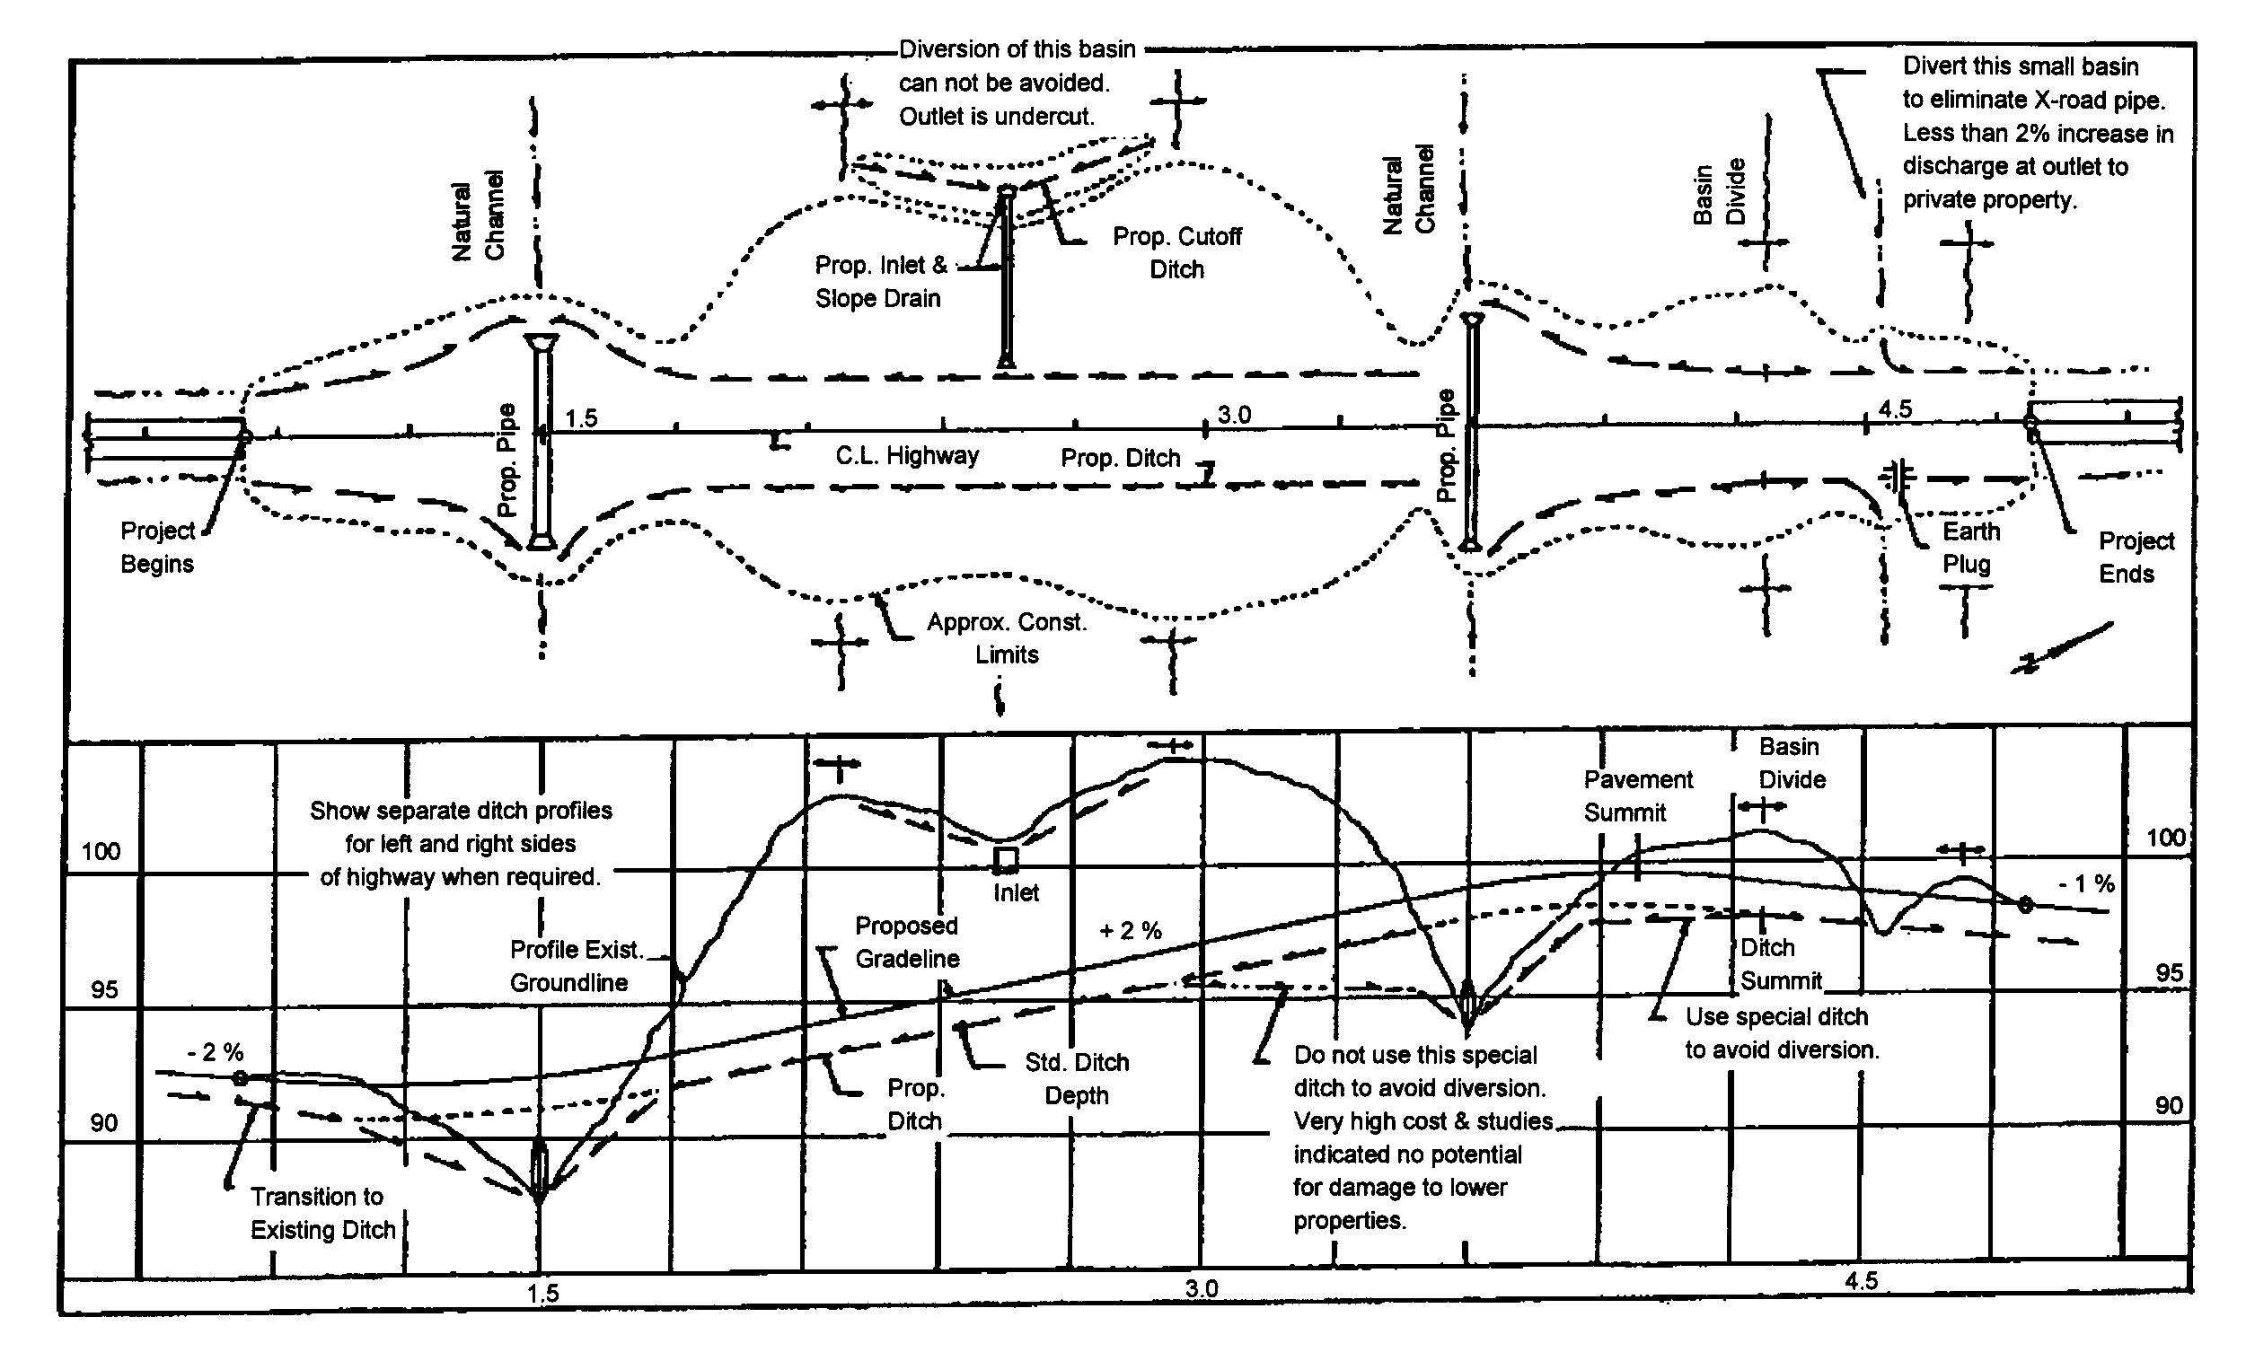
Figure 7-1. Sample Roadside Ditch Plan and Profile

7.3.4 Major Channels
Major channels may be within or outside the highway right-of-way. The same design criteria apply as for minor channels. Conveyance is usually based on the 10-year storm but may be greater based upon risk. Erosive protection is based on the 2-year storm. Major channels are usually trapezoidal in cross section. One foot or more of freeboard is recommended for larger channels where the consequences of overtopping are significant. The consequences of failure are usually more severe for major channels; therefore, a higher level of engineering analysis and design is usually justified for major channels.

7.3.5 Natural Channels
The hydraulic effects of floodplain encroachments should be evaluated over a full range of frequency-based peak discharges from the 2-year through the 500-year recurrence intervals on any major highway facility, as deemed necessary by the Department. The hydrologic and hydraulic analysis procedure and required documentation for such situations are more fully described in Chapter 12, Bridge and Structure Hydraulics. If the floodplain encroachment is located in a FEMA or other officially delineated floodplain, no increase in the established natural 100-yr. flood level will be permitted either up or downstream. It should be noted that the Department’s criteria is more stringent than FEMA’s in this instance. In situations where no FEMA or other officially delineated floodplain exists, it will be acceptable to increase the level of the 100-yr flood event not to exceed one foot up or downstream, provided such increase does not adversely impact adjacent properties, buildings, etc. If an increase in the 100-yr flood level will cause such adverse impact then no increase shall be permitted. The Department’s State Hydraulics Engineer must approve exceptions to either of the above criteria.*
If relocation of a stream channel is unavoidable, the cross-sectional shape, meander, pattern, roughness, sediment transport, and slope should conform to the existing conditions as far as practical. Some means of energy dissipation may be necessary when existing conditions cannot be duplicated.
Streambank stabilization should be provided when appropriate, because of any stream disturbance such as encroachment and should include both upstream and downstream banks as well as the local site.
Relocation of major streams is complex, and special expertise in river mechanics engineering and appropriate natural channel and/or stream restoration design may be necessary.

Design Concepts

Minor Channels (Roadside Ditches)

General
Design discharges (peak flows) should be determined by the Rational Method as defined in Chapter 6, Hydrology.
Velocity should be based on normal depth computed using Manning’s equation. Manning's equation requires information on the ditch geometry, such as side slopes, the longitudinal grade, and the appropriate Manning’s n-value.
Ditch side slopes should not exceed the angle of repose of the soil and/or lining and should usually be 2H:1V or flatter. See Section 7.4.6 for further discussion on channel linings. Figure 7-1 shows a sample plan and profile for a roadside ditch.

Design Considerations
Roadside ditch design involves both capacity and erosion resistance. A trial-and-error process may be necessary to obtain the optimum design. More information on roadside ditch design procedures is contained in Section 7.5.
The VDOT method for design of roadside ditch linings is recommended for use on minor channels. Consideration should be given to ditch bends, steep slopes, and composite linings, which are further defined in Section 7.4.6, HEC-11, and HEC-15. The riprap design procedures described in HEC-15 are for minor channels having a design discharge of 50 cfs or less. When the design discharge exceeds 50 cfs, the design procedures presented in HEC-11 should be followed for riprap-lined channels. HEC-15 may be used for design of larger channels with linings other than riprap.

Major Channels

General
Design analysis of both natural and artificial channels proceeds according to the basic principles of open channel flow (see Chow, 1959*; Henderson, 1966). The basic principles of fluid mechanics, continuity, momentum, and energy can be applied to open channel flow with the additional complication that the position of the free surface is usually one of the unknown variables. The determination of this unknown is one of the principal problems of open channel flow analysis and it depends on quantification of the flow resistance. Natural channels display a much wider range of roughness values than do artificial channels.

Flow Classifications
The classifications of open channel flow are summarized as follows:
Steady Flow (Rate of flow remains constant with time)
1. Uniform Flow (Velocity and depth of flow remain constant over length)
2. Non-uniform Flow (Velocity and depth of flow vary over length)
- Gradually Varied Flow
- Rapidly Varied Flow
Unsteady Flow (Rate of flow varies with time)
1. Unsteady Uniform Flow (rare)
2. Unsteady Non-uniform Flow
- Gradually Varied Unsteady Flow
- Rapidly Varied Unsteady Flow
The steady uniform flow class and the steady non-uniform flow class are the most common types of flow treated in highway engineering hydraulics. However, uniform flow is rare in natural channels.

Natural Channels

Stream Morphology

Introduction
The form assumed by a natural stream, which includes its cross-sectional geometry as well as its plan-form, is a function of many variables for which cause-and-effect relationships are difficult to establish. The stream may be graded or in equilibrium with respect to long time periods, which means that on the average it discharges the same amount of sediment that it receives, although there may be short-term adjustments in its bed-forms in response to flood flows. On the other hand, the stream reach of interest may be aggrading or degrading as a result of deposition or scour in the reach, respectively. The plan-form of the stream may be straight, braided, or meandering. These complexities of stream morphology can be assessed by inspecting aerial photographs and topographic maps for changes in slope, width, depth, meander form and bank erosion with time.
A qualitative assessment of the river response to proposed highway facilities is possible through a thorough knowledge of river mechanics and accumulation of engineering experience. The FHWA publications "Stream Stability at Highway Structures" (HEC-20)* and “River Engineering for Highway Encroachments” (HDS-6) provide additional and more detailed information on making such assessments . Both publications can be accessed and/or downloaded from the FHWA’s Internet web site at http://www.fhwa.dot.gov/engineering/hydraulics/library_listing.cfm .*

Channel Analysis

General
The hydraulic analysis of a channel determines the depth and velocity at which a given discharge will flow in a channel of known geometry, roughness and slope. The depth and velocity of flow are necessary for the design or analysis of channel linings and highway drainage structures.
Two methods are commonly used in hydraulic analysis of open channels. The single-section method is a simple application of Manning's equation to determine tailwater rating curves for culverts or to analyze other situations in which uniform or nearly uniform flow conditions can be assumed.
The step-backwater method is used to compute the complete water surface profile in a stream reach to evaluate the unrestricted water surface elevations for bridge hydraulic design or to analyze other gradually varied flow problems in streams.
- Where the 100-year discharge for a particular site is less than 500 cfs, the site is generally considered to be a minor drainage installation. A single cross section analysis, using nomographs and charts, usually provides an acceptable level of hydraulic analysis. Documentation requirements are satisfied by supplying all requested information on VDOT standard hydraulic computation forms.
- Where the 100-year discharge for a particular site is 500 cfs or more, the site is generally considered to be a major drainage installation. The method of hydraulic analysis and the level of documentation must conform to hydrology analysis (H&HA) outline provided in Chapter 12, Bridge and Structure Hydraulics. This type of analysis often requires water surface profile calculations such as those provided by the HEC-2, HEC-RAS, or WSPRO computer models. However, other methods of analysis, which provide the necessary data for proper documentation, may be approved for use.
The single-section method will generally yield less reliable results than the step-backwater method because it requires more judgment and assumptions. In many situations, however, the single-section method is all that is justified. In minor drainage channels such as roadside ditches, the single section method is adequate, except in the case of special design channels or critical locations.
The step-backwater method should be used for important major channels, where an accurate definition of the water surface profile is needed. The basic principles of open channel hydraulics are applicable to all drainage channels, as well as culverts and storm drains. The variable is the level of detail required in design, which depends on the risks of damage or loss of life caused by a failure of the facility.

Equations
The following equations are those most commonly used to analyze open channel flow. The detailed use of these equations in analyzing open channel hydraulics is discussed in Section 7.5.

Specific Energy
Specific energy (E) is defined as the energy head relative to the channel bottom. If the channel slope is less than 10 percent and the streamlines are nearly straight and parallel (so that the hydrostatic assumption holds), the specific energy (E) becomes the sum of the depth and velocity head:
(7.1)
Where:
d = Depth of flow, ft
α = Velocity distribution coefficient (see Equation 7.2)
v = Mean velocity, fps
g = Gravitational acceleration, 32.2 ft/s²
When specific energy is plotted against depth of flow, a curve with a minimum specific energy results, as shown in Figure 7-2. At the minimum specific energy, the depth is called critical depth. Depths above critical depth are subcritical, and below critical depth are supercritical. The velocity distribution coefficient is usually assumed to have a value of one for turbulent flow in prismatic channels but may be significantly different than one in natural channels.

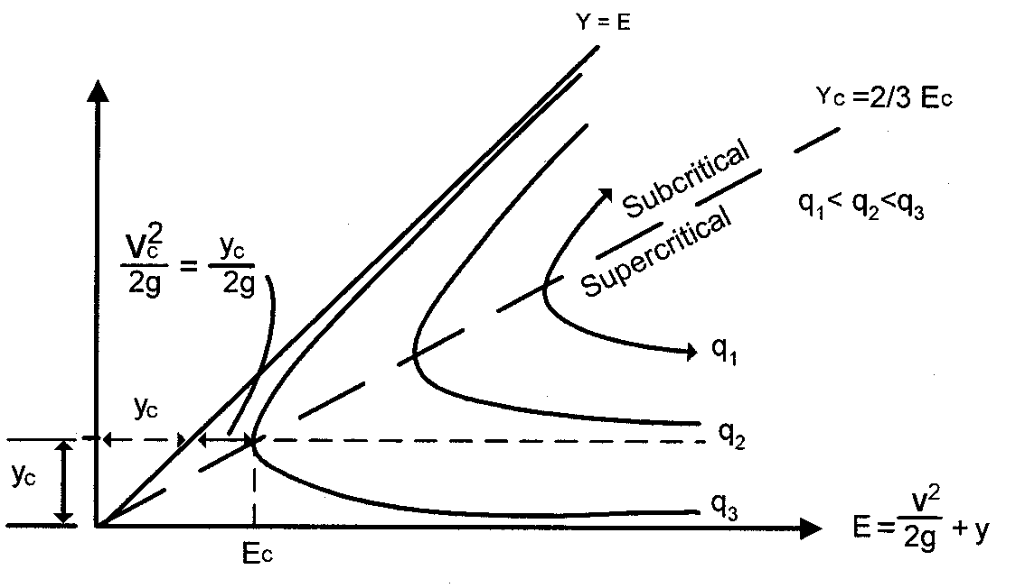
Note: y = d in Equation 7.1
Figure 7-2. Specific Energy Diagram for Rectangular Channels

Velocity Distribution Coefficient
Due to the presence of a free surface and due to friction along the channel boundary, the velocities in a channel are not uniformly distributed across the channel cross section. Because of non-uniform distribution of velocities in a channel section, the velocity head of an open channel is usually greater than the average velocity head computed as (Q/A_{t})²/2g. A weighted average value of the velocity head is obtained by multiplying the average velocity head, above, by a velocity distribution coefficient (α) defined as:
(7.2)
Where:
K_{i} = Conveyance in subsection (see Equation 7.8)
K_{t} = Total conveyance in section (see Equation 7.8)
A_{i} = Cross-sectional area of subsection, ft²
A_{t} = Total cross-sectional area of section, ft²
n* = Number of subsections

Total Energy Head
The total energy head is the specific energy head plus the elevation of the channel bottom with respect to some datum. A plot of the energy head from one cross section to the next defines the energy grade line.

Froude Number
The Froude number (F_{r}) is an important dimensionless parameter in open channel flow. It represents the ratio of inertial forces to gravitational forces and is defined as:
(7.3)
Where:
α = Velocity distribution coefficient
V = Mean velocity = Q/A, fps
g = Gravitional acceleration*, 32.2 ft/s²

H_{D} = Hydraulic depth = , ft
(For rectangular channels the hydraulic depth is equal to the flow depth.)
A = Cross-sectional area of flow, ft²
T = Channel top width at the water surface, ft
Q = Discharge, cfs
This expression for Froude number applies to channel flow at any cross section. The Froude number is useful in determining the flow regime for water surface profiles.
- F_{r} < 1, Subcritical Flow
- F_{r} = 1, Critical Flow
- F_{r} > 1, Supercritical Flow

Critical Flow
Critical flow occurs when the specific energy is a minimum for a given flow rate (see Figure 7-2). The variation of specific energy with depth at a constant discharge shows a minimum in the specific energy at a depth called critical depth at which the Froude number has a value of one. Critical depth is the depth of maximum discharge when the specific energy is held constant. During critical flow the velocity head is equal to one-half of the hydraulic depth. The general expression for flow at critical depth is:
(7.4)
Where:
α = Velocity distribution coefficient
Q = Discharge, cfs
g = Gravitational acceleration, 32.2 ft/s²
A = Cross-sectional area of flow, ft²
T = Channel top width at the water surface, ft
When flow is at critical depth, Equation 7.4 must be satisfied, regardless of the shape of the channel.

Subcritical Flow
Depths greater than critical occur in subcritical flow. The Froude number is less than one for subcritical flow. In this state of flow, small water surface disturbances can travel both upstream and downstream, and the control is always located downstream.

Supercritical Flow
Depths less than critical depth occur in supercritical flow. The Froude number is greater than one. Small water surface disturbances are always swept downstream in supercritical flow, and the location of the flow control is always upstream.

Continuity Equation
The continuity equation is the statement of conservation of mass in fluid mechanics. For the special case of one-dimensional, steady flow of an incompressible fluid, it assumes the simple form:
Q = A₁•V₁ = A₂•V₂* (7.5)
Where:
Q = Discharge, cfs
A = Cross-sectional area of flow, ft²
V = Mean cross-sectional velocity, fps (which is perpendicular to the cross section)

Subscripts 1 and 2 refer to successive cross sections along the flow path.

Manning's Equation
For a given depth of flow in an open channel with a steady, uniform flow, the mean velocity (V) can be computed using Manning's equation:
(7.6)
Where:
V = Velocity, fps
n = Manning's roughness coefficient
R = Hydraulic radius = A/P, ft
A = Flow area, ft²
P = Wetted perimeter, ft
S = Slope of the energy grade line, ft/ft
The selection of Manning's n is generally based on observation; however, considerable experience is essential in selecting appropriate n-values. The selection of Manning's n is discussed in Section 7.4.4.3.2. The range of n-values for various types of channels and floodplains is given in Appendix 7D-1 and 7D-2.
The continuity equation can be combined with Manning's equation to obtain the steady, uniform flow discharge as:
(7.7)
For a given channel geometry, slope, roughness, and a specified discharge (Q), a unique value of depth occurs in steady, uniform flow. It is called normal depth. At normal depth, the slope of the energy grade line, the hydraulic grade line, and the channel slope are the same. Normal depth is computed from Equation 7.7 by expressing the area and hydraulic radius in terms of depth. The resulting equation may require a trial-and-error solution. See Section 7.5 for a more detailed discussion of the computation of normal depth.
If normal depth is greater than critical depth, the channel slope is classified as a mild slope. On a steep slope, the normal depth is less than the critical depth. Thus, uniform flow is subcritical on a mild slope and supercritical on a steep slope.

Conveyance
In channel analysis, it is often convenient to group the channel properties in a single term called the channel conveyance (K):
(7.8)
Then Equation 7.7 can be written as:
(7.9)
The conveyance represents the carrying capacity of a stream cross-section based upon its geometry and roughness characteristics alone and is independent of the streambed slope.
The concept of channel conveyance is useful when computing the distribution of overbank flood flows in the stream cross-section and the flow distribution through the opening in a proposed stream crossing. It is also used to determine the velocity distribution coefficient (α).

Energy Equation
The energy equation (Bernoulli's Equation) expresses conservation of energy in open channel flow defined as energy per unit weight of fluid. This dimensions of length is called energy head. The energy head is composed of potential energy head (elevation head), pressure head, and kinetic energy head (velocity head). These energy heads are scalar quantities, the sum of which gives the total energy head at any cross section. Written between an upstream open channel cross section designated 1 and a downstream cross section designated 2, the energy equation is:
(7.10)
Where:
h₁ = Upstream water surface elevation, ft.
h₂ = Downstream water surface elevation, ft.
α = Velocity distribution coefficient
V = Mean velocity, fps
h_{L} = Head loss due to local cross-sectional changes (minor loss) plus friction loss, ft
The stage, h, is the sum of the elevation head (z) at the channel bed and the pressure head, or depth of flow (y); i.e., h = z+y. The terms in the energy equation are illustrated graphically in Figure 7-3. The energy equation states that the total energy head at an upstream cross section is equal to the energy head at a downstream section plus energy head losses between two consecutive sections. The energy equation can only be applied between two cross sections at which the streamlines are nearly straight and parallel so that vertical acceleration can be neglected.
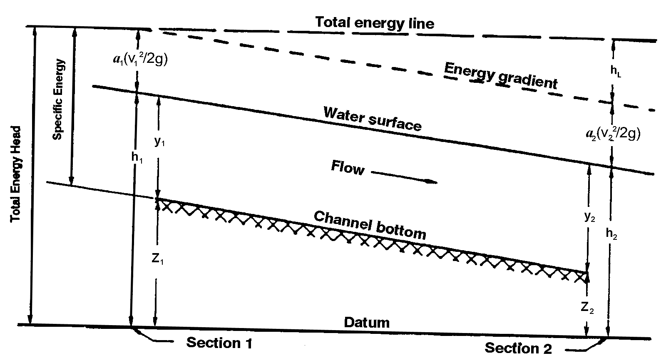
Figure 7-3. Terms in the Energy Equation

Hydraulic Representation of Channels
The following sections describe the data needed to apply Manning's equation to the analysis of open channels.

Cross Sections
The cross-sectional geometry of streams is defined by coordinates of lateral distance and ground elevation, which locate individual ground points. Individual cross sections are taken normal to the flow direction along a single straight line where possible, but in wide floodplains or bends it may be necessary to use intersecting straight lines to form a section; i.e., a "dog-leg" section. It is especially important to make a plot of the cross section to reveal any inconsistencies or errors.
Cross sections should be located to be representative of the sub-reaches between them. Stream locations with major breaks in bed profile, abrupt charges in roughness or shape, control sections such as free overfalls, bends and contractions, or other abrupt changes in channel slope or conveyance will require cross sections taken at shorter intervals in order to better model the changes in conveyance.
Cross sections should be subdivided with vertical boundaries where there are abrupt lateral changes in geometry and/or roughness as in the case of overbank flows. The conveyances of each subsection are computed separately to determine the flow distribution and α, and are then added to determine the total flow conveyance. The subsection divisions must be chosen carefully so that the distribution of flow or conveyance is nearly uniform in each subsection (Davidian, 1984). Selection of cross sections and vertical subdivision of a cross section are shown in Figure 7-4.
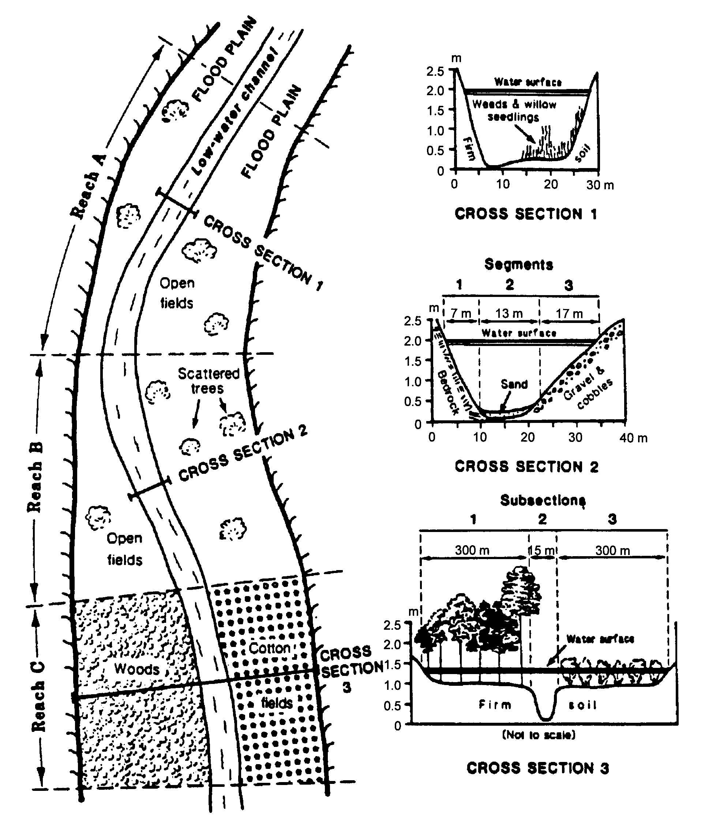
Figure 7-4. Hypothetical Cross Section Showing Reaches, Segments, and Subsections Used in Assigning n-Values

Manning’s n-Value Selection
Manning's n is affected by many factors and its selection, especially in natural channels depends heavily on engineering experience. Photographs of channels and flood plains, for which the discharge has been measured, and Manning's n has been calculated, are very useful (see Arcement and Schneider, 1984; Barnes, 1978). For situations lying outside the engineer's experience, a more regimented approach is presented (Arcement and Schneider, 1984). Once the Manning's n-values have been selected, it is highly recommended that they be verified or calibrated with historical highwater marks and/or gaged stream flow data.
Manning's n-values for artificial channels are more easily obtained than for natural stream channels. Refer to Appendix 7D-1 and 7D-2 for typical n-values for both man-made and natural stream channels.

Calibration
For major channel analyses in existing channels, the equations should be calibrated with historical highwater marks and/or gaged stream flow data to ensure that they accurately represent local channel conditions. The following parameters, in order of preference, should be used for calibration: Manning's n, slope, discharge, and cross section. Proper calibration is essential if accurate results are to be obtained.

Switchback Phenomenon
If the cross section is improperly subdivided, the mathematics of Manning's equation causes a switchback. A switchback results when the calculated discharge decreases with an associated increase in elevation. This occurs when, with a minor increase in water depth, there is a large increase of wetted perimeter. Simultaneously, there is a corresponding small increase in cross-sectional area, which causes a net decrease in the hydraulic radius from the value computed for a lesser water depth. With the combination of the lower hydraulic radius and the slightly larger cross-sectional area, a discharge is computed which is lower than the discharge based upon the lower water depth. More subdivisions within such cross sections should be used, and the divisions should be based on both vegetation and geometry, in order to avoid the switchback error. Figure 7-5 depicts an example of the switchback phenomenon.
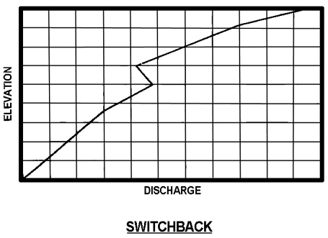
Figure 7-5. Example of Switchback Phenomenon

Single-Section Analysis
The single-section analysis method (slope-area method) is simply a solution of Manning's equation for the normal depth of flow, given the discharge and channel cross section properties including geometry, slope and roughness. It implicitly assumes the existence of steady, uniform flow; however, uniform flow rarely exists in either man-made or natural channels. Nevertheless, the single-section method is often used to design man-made channels for uniform flow as a first approximation, and to develop a stage-discharge rating curve in a natural channel for tailwater determination at a culvert or storm drain outlet. The single-section analysis method is used in the VDOT method for design of roadside ditch linings.
A stage-discharge rating curve is a graphical relationship of stream flow depth or elevation versus discharge at a specific point on a channel. This relationship should cover a range of discharges up to at least the base (100-year) flood. The stage-discharge curve procedure is discussed in Section 7.5.3.1.
Alternatively, a graphical technique such as those given in the appendices can be used for trapezoidal and prismatic channels. The best approach, especially in the case of natural channels, is to use a computer program such as FEMA's "Quick-2" software package.
In natural channels, the transverse variation of velocity in any cross section is a function of subsection geometry and roughness and may vary considerably from one stage and discharge to another. It is important to know this variation for purposes of designing erosion control measures and locating relief openings such as in highway fills. The single-section method can be used by dividing the cross section into subsections of relatively uniform roughness and geometry. It is assumed that the energy grade line slope is the same across the cross section so that the total conveyance (K_{t}) of the cross section is the sum of the subsection conveyances. The total discharge is then K_{t}S^{1/2} and the discharge in each subsection is proportional to its conveyance. The velocity in each subsection is obtained from the continuity equation, V = Q/A.

Water Surface Profile Analysis
The step-backwater analysis is useful for determining unrestricted water surface profiles where a highway crossing or encroachment is planned, and for analyzing how far upstream the water surface elevations would be affected. Because the calculations involved in this analysis are tedious and repetitive, it is recommended that a computer program such as the Corps of Engineers HEC-RAS model be used.

Water Surface Profile Methodology
When uniform flow cannot be reasonably assumed and, therefore, a single cross section cannot represent the channel segment, then an energy balance method must be used to compute the water surface profile (elevation). The energy equation is used in computing the water surface profile.
The method requires definition of the geometry and roughness of each cross section as discussed previously. Manning's n values can vary both horizontally and vertically across the section. Expansion and contraction head loss coefficients, variable main channel and overbank flow lengths and the method of averaging the slope of the energy grade line can all be specified.
The energy equation is derived from Equation 7.10 in Section 7.4.4.2.11.
(7.11)
Where:
d = Depth of flow, ft
V = Mean velocity, fps
z = Elevation of flow line, ft
h_{L} = Total head loss, ft
$α$ = Velocity distribution coefficient*
Equation 7.11 shows that the total head at Section 1 is equal to the total head at Section 2 and the energy (head) losses. Total energy losses include friction and minor losses.
(7.12)
Where:
h_{L} = Total head losses, ft.
h_{f} = Friction loss, ft.
h_{o} = Summation of minor losses, ft.
In most simple water surface profile calculations, minor losses are ignored. Therefore, h_{L} is assumed to be equal to h_{f}.
(7.13)
Where:
L = Length of channel segment, ft.
S_{A} = Average energy slope of channel segment, ft./ft.

(7.14)
Where:
S₁ = Energy slope at Section 1, ft./ft.
S₂ = Energy slope at Section 2, ft./ft.

The energy slope at a given cross section is computed using Equation 7.15 and is shown graphically in Figure 7-6.
(7.15)
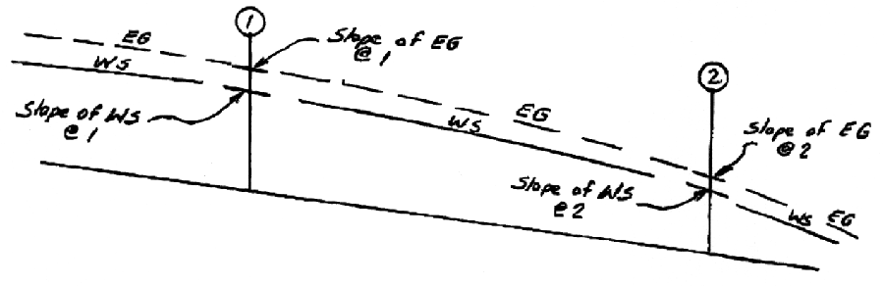
Figure 7-6. Energy Slope between Two Channel Sections

Classifications of Backwater Profiles
Figure 7-7 shows the notation for classifying water surface profiles and Figure 7-8 shows the types of possible flow profiles. Figure 7-7 and Figure 7-8 are from the USACE’s Gary Brunner.
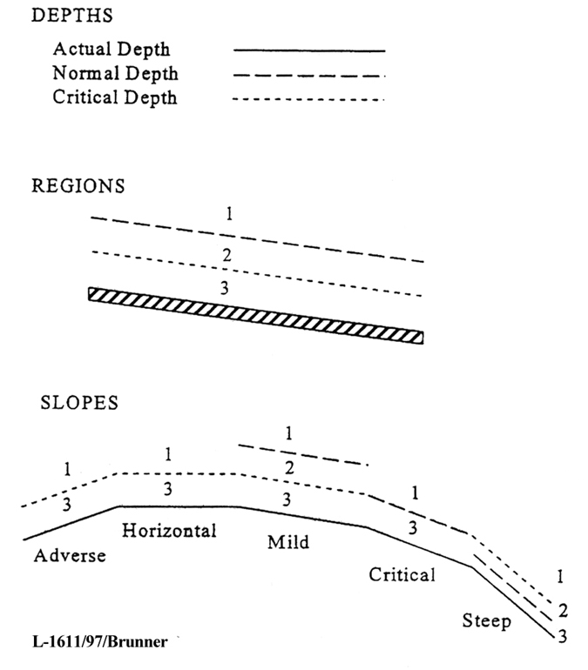

Figure 7-7. Notation for Classifying Water Surface Profiles
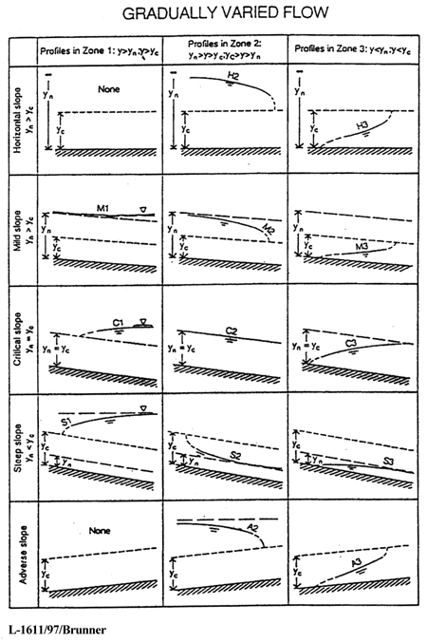
Figure 7-8. Types of Backwater Profiles

Water Surface Profile Computations
The references (Davidian, 1984 and USACE, 1986) are valuable sources of guidance on the practical application of the step-backwater method to roadway drainage problems involving open channels. These references contain guidance on cross section determination, location and spacing, and stream reach determination. The reference (USACE, 1986) investigates the accuracy and reliability of water surface profiles related to n-value determination and the survey or mapping technology used to determine the cross section coordinate geometry.

Water and Sediment Routing
Water and sediment routing is a complex phenomenon, and a detailed discussion is beyond the scope of this manual. Information may be found in documentation of the BRI-STARS (Bridge Stream Tube Model for Alluvial River Simulation) Computer Model, (Molinas, 2000*). The model is semi-two dimensional, and both energy and momentum functions are incorporated so that the water surface profile computation can be carried out through combinations of subcritical and supercritical flows without interruption. Another computer model for sediment routing is the Corps of Engineers HEC-6, "Scour and Deposition in Rivers and Reservoirs." (legacy software)

Ditch and Channel Protection
A significant means of reducing erosion associated with roadways is through the use of properly designed ditches and ditch lining. Linings may be flexible such as vegetation, synthetic material; or riprap or linings may be rigid such as concrete. Erosion resistant vegetation should be used whenever possible and may in some locations require the use of either a temporary protective covering (VDOT Standard EC-2) or a permanent soil stabilization mat (VDOT Standard EC-3, Type A, or Type B). Flexible linings are generally less expensive than rigid linings and permit infiltration and filtering of pollutants. Flexible linings provide a lower flow capacity for a given cross-sectional area when compared to rigid linings. They also have correspondingly lower velocities than rigid linings.
Rigid linings are used on steep grades due to high velocities and may be used for areas where channel width is restricted and the higher flow capacity is needed. Rigid channels require channel protection or energy dissipation at the termination point to prevent scour due to the high outlet velocities. Rigid linings can be damaged or destroyed due to flow undercutting the lining at bends, joints or intersecting ditches where the flow is not contained within the lining. The design of channels with rigid lining should provide any design details that are needed to protect the undercutting of the lining and preserve the integrity of the ditch.
Two methods are commonly applied to determine whether a channel is stable from an erosion standpoint: Permissible Velocity and Tractive Force. These methods are described in the following sections.

Permissible Velocity
Using the permissible velocity approach, the channel is assumed to be stable if the mean velocity is lower than the maximum permissible velocity. The application of the permissible velocity method is quite simple. The Manning equation is used to compute the flow velocity in the channel for the design storm. The flow velocity is then compared with the maximum permissible velocity for the channel bed and bank soils and the lining material.
If the computed velocity is less than the maximum permissible velocity, the channel should be stable. Corrections to the maximum permissible velocity may be applied based on flow depth and channel sinuosity.
The maximum permissible velocity (MPV) in a channel varies with the channel bed material and with the material being transported by the water. Clear water is the most erosive, and therefore its MPVs are the lowest for a given bed material (see Appendix 7D-6). When the water is transporting fine silts, the MPV is up to 100 percent higher than for clear water. For this reason, clear water being released from a settling facility such as a detention pond is often called “hungry water.”
For water carrying a courser material such as sand and gravel, the MPV may be higher or lower than for clear water. For this situation, refer to Appendix 7D-6 to obtain the MPV for the given channel bed material.
While the permissible velocity method is widely used, the tractive force (permissible shear) method provides a more physically based and realistic model for particle detachment and erosion processes (FHWA's HEC-15 , “Design of Roadside Channels with Flexible Linings”). It is recommended that the permissible velocity method be used for roadside ditches and that the tractive force method be used for major channel analyses.

Tractive Force
The Tractive Force Method takes into account the physical factors of bed material, channel geometry, depth, and velocity of flow. The method is confined to non-cohesive materials for which the permissible tractive force is related to particle size and shape and the sediment load in the water. Particle diameters are based on the equivalent spherical volume and assume 75 percent of the mass is smaller by weight (D₇₅). In the absence of a gradation curve, it may be assumed that the D₇₅ stone size is equal to 1.96 times the D₅₀ stone size.
The material on the side slope may establish the limiting condition for permissible tractive force, rather than the material on the bed. The resistance to movement of the material on the side slope is reduced by the downward sliding force due to gravity. The ratio of critical shear on the side slope to critical shear on the bottom is expressed as factor K₁.
Note: K₁ in HEC-11 is the same variable as K₂ in HEC-15.
(7.16)
Where:
θ = Side slope angle (measured from the horizontal), degrees
φ = Natural angle of repose of material under consideration (measured from the horizontal), deg.

Note: The descriptions for θ and φ (above) are reversed in Appendix 7E-8.
(shown one way in HEC-11 and the other way in HEC-15)*
The angles of repose for various sizes of non-cohesive materials can be determined from Appendix 7E-1.
The permissible tractive force for various non-cohesive soils is obtained from Appendix 7E-2. Appendix 7E-3 can be used to estimate the permissible tractive force for cohesive soils.
The average tractive force formula is:
(7.17)
Where:
τ_{o} = Average tractive force, lbs/ft²
R = Hydraulic radius, ft.
S_{o} = Channel slope, ft/ft.

In channels whose width (B) to depth (d) ratio is 10 or more, the depth of flow (d) may be substituted for R, thus obtaining the maximum tractive force on the channel bed.
(7.18)
Where:
d = Depth of flow, ft
A convenient form that can be used for manually performing this computation is found in Appendix 7B-3.

Geotextile Channel Linings
Geotextile materials designated as Standard EC-3 (Type A and B) Soil Stabilization Mat are used for protective linings in ditches. Standard EC-3 Soil Stabilization Mat is intended to be used as a protective ditch lining material to be applied when the design velocity exceeds the allowable velocity for Standard EC-2, Jute Mesh.
When the design velocity exceeds the allowable velocity for Standard EC-3, a paved (or riprap) lining is required.
The Standard EC-3 (Type C) Soil Stabilization Mat may be used as a protective slope lining for dry cut or fill slopes and wet cut slopes to stabilize the slope on which vegetation is being established. (See VDOT Road and Bridge Standards)

Design Criteria, Geotextile Linings
Standard EC-3 Type A is to be employed where the 2-year design velocity in the ditch does not exceed 7* feet per second (fps).
Standard EC-3 Type B is to be employed where the 2-year design velocity does not exceed 10 fps.
A Manning’s n-value of 0.05 should be used with Standard EC-3.
Typically, the use of Standard EC-3 Type A should begin at the point where the flow velocity exceeds 4 fps (velocity is assumed to be for flow in an EC-2 lined channel) and change to EC-3, Type B at the appropriate point, until the design velocity exceeds 10 fps or until the velocity decreases so that the use of a ditch lining can be discontinued.
Table 7-1. PROTECTIVE LININGS FOR DITCHES AND CHANNELS
Type of Lining | Mannings “n” Value (Default) | Maximum Allowable Velocity (fps)
Bare Earth | 0.03 | Varies
VDOT EC-2 | 0.05 | 4.0
VDOT EC-3 Type A | 0.05 | 7.0
VDOT EC-3 Type B | 0.05 | 10.0
Concrete | 0.015 | NA
VDOT Riprap | 0.04-0.045 | Based on Sheer Stress

Riprap
Riprap is defined as a blanket of well-graded stone used to counteract the effects of erosion or scouring on channels, ditches, embankments, jetties, shorelines, and bridge substructure members such as abutments and piers. Riprap is usually described in terms of the size and/or weight of the stone whose volume makes up approximately 50 percent of the total mass. The size of the 50 percent stone is measured in terms of its equivalent mean spherical diameter (MSD) and is referred to as the stone’s D₅₀. The weight of the 50 percent stone is referred to by its W₅₀. The Department has six standard riprap classifications whose 50 percent stone size and weights and recommended blanket thickness (T) are tabulated in Appendix 7D-3.
Additional information on VDOT standard riprap may be found in the Department's Road and Bridge Specifications.

The designer shall specify on the plans the type of Riprap and the dimensions (length, width and depth) for placement. The quantity shall be computed using two (2) tons per cubic yard (148 lbs. per cu. ft.) for plan estimating purposes, unless otherwise specified by the District Administrator.
The following general note is to be copied on the plans when riprap is specified.

“The proposed riprap may be omitted by the Engineer if the slope upon which the plans designate riprap to be placed is found to meet the following criteria: The slope designated for placement of riprap is comprised of solid rock or closely consolidated boulders with soundness, size and weight equal to or exceed the specifications for the proposed riprap. If the slope is found to be comprised of material, which is coarser than the bedding aggregate filter blanket specified on the plans, the aggregate filter blanket may be deleted by the Engineer.”

Riprap Dimensions and Weights
Appendix 7D-4 may be used as a guide to match certain rock dimensions to equivalent weights. This table is not to be used for acceptance or rejection of riprap material.
The approximate percentages of voids for all VDOT standard riprap classes is 25 percent for the estimation of quantities.

Soils Survey
A soil survey is to be conducted through areas where a channel change is proposed and through embankment areas where riprap may be required. The plans or profile rolls for the regular soil survey will show the location of channel changes and the location where riprap will be required on the fill section.
Borings along the proposed channel change are to be taken at sufficient intervals to determine the type of material encountered along the slopes and in the bottom of the channel.
The borings made in the cut sections or in the borrow pits for construction of the fills are adequate to determine the type of material used in the fills. The test results on the material used in embankments or along channel changes where riprap is required should include the plastic and liquid limits of the minus No. 40 sieve and the grading or particle size of the total sample. This information should be submitted in the regular soil survey report.
The Project Inspector will visually examine the slope upon which the plans designate riprap to be placed. If the slope material appears coarser than the bedding aggregate specified the Project Inspector is to notify the District Material Engineer, through normal channels, for a more detailed investigation to determine the actual need for the bedding. If the slope is comprised of solid rock or closely consolidated boulders with soundness, size and weight equal to or exceeding the specifications for the proposed riprap, then the riprap may be deleted by the District Construction Engineer.
The quantities will be field adjusted, using the supplier’s stone weight and the applicable percent of voids for the type or class of material used, to obtain the actual quantity.

Riprap Bedding
Riprap shall be placed over an appropriate bedding material consisting of a geotextile and aggregate cushion layer in accordance with the following guidelines*
- In the case of Class AI, I, and II riprap, the aggregate cushion is not required.
- In the case of Class III, Type I, and Type II riprap, the an intermediate aggregate cushion layer will be required which consists of a material of a size, gradation, and thickness as recommended by the Materials Division

The geotextile may only be omitted under the conditions discussed above or with the approval of the District Materials Engineer or District Drainage Engineer.

Major Channels
Riprap is often used as slope protection for natural or man-made stream channels. The need for such slope protection is predicated on the fact that the native soil material or fill material may be displaced by design flows in the channel. The first step in the design process is to determine whether or not the fill or native material will be displaced. The tractive force method is usually employed to make this determination.

Minor Channels
VDOT normally does not permit the use of standard riprap for linings in standard roadside or median ditches due to its size and normal blanket thickness reducing the ditch cross section. In addition, hand placement, as opposed to end dumping, would probably be necessary in small channels. There are, however, situations in which the smaller riprap sizes such as Class AI and I may be used to good advantage where special design small trapezoidal ditches such as those connecting culvert cross drains, outfalls, or the discharge point of standard design ditches, are required. In such situations, the Department requires that the riprap be sized in accordance with procedures presented in HEC-15. When riprap is used to line minor channels, the design for the channel cross section should allow for the thickness of the riprap and bedding layers without reducing the available flow section.

Design Procedures and Sample Problems
The following design procedures and examples pertain to minor channels, major channels, and natural channels. The procedures are similar, but become more detailed for the larger channel projects.

Documentation Requirements
These items establish a minimum requirement for all channels except roadside ditches. Also, see Chapter 3, Documentation.* The following items used in the design or analysis should be included in the documentation file:
- Hydrology and stage discharge curves for the design, check floods and any historical water surface elevation(s)
- Cross section(s) used in the design water surface determinations and their locations
- Roughness coefficient assignments (n-values)
- Information on the method used for design water surface determinations
- Observed highwater, dates and discharges
- Channel velocity measurements or estimates and locations
- Water surface profiles through the reach for the design, check floods and any historical floods
- Design or analysis of materials proposed for the channel bed and banks;
- Energy dissipation calculations and designs
- Copies of all computer analyses.

Roadside Ditches and Minor Channels

Roadside Ditch and Minor Channel Design Procedure
The following six basic design steps are normally applicable to minor channel design projects:
Step 1: Establish a roadside plan
- Collect available site data
- Obtain or prepare existing and proposed plan-profile layout including highway, culverts, bridges, etc.
- Determine and plot on the plan the locations of natural basin divides and roadside ditch outlets and perform the layout of the proposed roadside ditches to minimize diversion flow lengths
An example of a roadside ditch plan/profile is shown in Figure 7-1.
Step 2: Obtain or establish cross section and data
- Provide ditch depth adequate to drain the subbase and minimize freeze-thaw effects using the standard underdrain outfall requirements that are appropriate for the project
- Choose ditch side slopes based on geometric design criteria including safety, economics, soil, aesthetics and access
- Establish bottom width of trapezoidal ditch
- Identify features which may restrict cross section design:
- Right-of-way limits
- Trees or other environmentally-sensitive areas
- Utilities
- Existing drainage facilities
Step 3: Determine initial ditch grades
  - Plot initial grades on plan-profile layout. (The roadside ditch grade in cut is usually controlled by the grade of the highway.)
  - Provide desirable minimum grade of 0.5* percent
  - Consider influence of type of lining on grade
  - Where possible, avoid features which may influence or restrict grade, such as utility locations
Step 4: Check flow capacities and adjust as necessary
- Compute the design discharge at the downstream end of a ditch segment (See Chapter 6, Hydrology)
- Set preliminary values of ditch size, roughness coefficient, and slope
- Determine maximum allowable depth of ditch, including freeboard
- Check flow capacity using Manning’s equation and the single-section analysis
- If ditch capacity is inadequate, possible adjustments are as follow:
- Increase bottom width
- Make channel side slopes flatter
- Make channel slope steeper
- Provide smoother channel lining
- Install drop inlets and a parallel storm drain pipe beneath the channel to supplement channel capacity
- Provide smooth transitions at changes in channel cross sections
- Provide extra channel storage where needed to replace floodplain storage and/or to reduce peak discharge
Step 5: Determine ditch lining/protection needed
- Use the VDOT Method – Roadside Ditch Linings (Preferred Method - Section 7.5.2.2), or
- Use the method of allowable tractive force (HEC-15)
Step 6: Analyze outlet points and downstream effects
- Identify any adverse impacts such as increased flooding or erosion to downstream properties which may result from one of the following at the channel outlet:
- Increase or decrease in discharge
- Increase in velocity of flow
- Concentration of sheet flow
- Change in outlet water quality
- Diversion of flow from another watershed
- Mitigate any adverse impacts identified in Step 6A. Possibilities include:
- Enlarge outlet channel and/or install control structures to provide detention of increased runoff in channel
- Install velocity control structures (energy dissipaters)
- Increase capacity and/or improve lining of downstream channel
- Install sedimentation/infiltration basins
- Install sophisticated weirs or other outlet devices to redistribute concentrated ditch flow
- Eliminate diversions which result in downstream damage and which cannot be mitigated in a less expensive fashion

VDOT Method for Design of Roadside Ditch Linings
The following computational procedure to determine the need for roadside ditch linings is recommended for use on roadside ditches and minor channels. It was developed by VDOT and has been used for many years.
Before the computational analysis can be performed, a soils report from the Materials Division is needed which specifies the type of soil that is found in the area of the ditch. The soil classification is then used with Appendix 7D-2 to determine the maximum allowable velocity for the native soil. Native soil is assumed for new ditches and for ditches with vegetation established for less than two years. When the maximum allowable velocity is exceeded, some type of ditch lining is needed.
Step 1: Determine the section of each ditch where the following exist:
- Steepest grade
- Highest flow or drainage area
Step 2: Determine the longitudinal grade, discharge, and velocity for these sections, assuming no lining
If the velocity is greater than the allowable velocity for the appropriate soil type, a ditch lining is needed and the following “General Design Procedure for Roadside Ditch Linings” should be used. If the velocity is less than the allowable velocity, no ditch lining is needed for this section of ditch. The same type of analysis should be used for the remainder of the ditches on the project.

Design Procedure for Roadside Ditch Linings Using VDOT Method
Roadside ditch* computations may be done using the format presented as Appendix 7B-1.
Step 1: The ditch under investigation is divided into convenient segments of length. Usually 100-foot stations are used. The drainage area and runoff coefficient(s) for use in the Rational Method are determined for the first or most upstream segment of the ditch to be analyzed.
Step 2: Determine the time of concentration to the downstream end of the first segment of ditch. Using 2-year frequency rainfall intensity, determine the 2-year discharge by the Rational Method.
Step 3: Determine the average longitudinal grade for the ditch segment under consideration.
Step 4: Find the velocity for the 2-year frequency design discharge.
Step 5: If the velocity is less than the maximum allowable velocity, no ditch lining is needed. If the velocity is more than the allowable velocity, ditch lining should be required. The usual progression of types of ditch lining used as velocities increase would begin with VDOT Standard EC-2, then EC-3 Type A, EC-3 Type B and lastly concrete lining (Standard PG-2A).
Step 6: Determine the depth of flow for the 10-year frequency discharge to insure that the hydraulic capacity has not been exceeded.
Step 7: Repeat the above steps for the next downstream segment of ditch. To calculate the discharge, add or accumulate the Rational Method CA values for each segment of the ditch contributing to the point of study. For rainfall intensity, use the rainfall intensity value from the previous segment minus 0.1 inch. This is a simplifying assumption or approximation of the actual time of concentration that is used for computational efficiency. If the computed Q value for any segment of ditch is found to be less than the preceding upstream segment, the Q should be held at the higher value of Q until a higher Q is calculated for a downstream segment.

Caveats to General Design Procedures for Roadside Ditch Linings
The designer should be cautious in using this computational procedure to ensure that the factors for runoff coefficients, times of concentration, and drainage areas properly reflect the actual conditions.
The velocity and depth of flow calculated by this method is based upon uniform flow conditions. Abrupt changes in alignment or grade may cause significant deviations from uniform flow conditions and should be carefully evaluated. Design details must be provided that provide for erosion protection of the ditch in critical areas.

Roadside Ditch Lining Sample Problem
Given:
LOCATION: Lynchburg Area
ALLOWABLE VELOCITY: 2.0 fps (Bare Earth)
DITCH SLOPE:
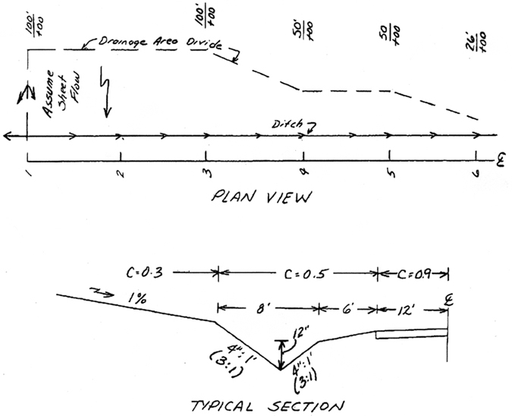
STATION | SLOPE
1-2 | 0.5%
2-3 | 2.0%
3-4 | 3.0%
4-5 | 4.0%
5-6 | 4.0%
Figure 7-9. Roadside Ditch Protection Sample Problem, Plan and Section

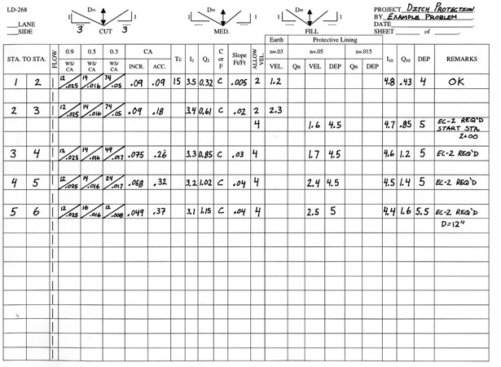
Figure 7-10. Worksheet (LD-268) for Calculation of Roadside Ditch Protection , Sample Problem

Major Channels
The following procedures are used to analyze flow in major channels.

Single-Section Stage-Discharge Curve Procedure
The stage-discharge curve procedure is basically a single section analyses. The following steps outline the development of a stage-discharge curve:
Step 1: Select the typical cross section at or near the location where the stage-discharge curve is needed
Step 2: Subdivide cross section and assign n-values to subsections as described in Section 7.4.4.3.
Step 3: Estimate water-surface slope. Since uniform flow is assumed, the average slope of the streambed is normally used.
Step 4: Apply a range of incremental water surface elevations to the cross section.
Step 5: Calculate each incremental elevation. Total discharge at each elevation is the sum of the discharges from each subsection at that elevation. In determining hydraulic radius, the wetted perimeter should be measured only along the solid boundary of the cross section and not along the vertical water interface between subsections.
Step 6: After the discharge has been calculated at several incremental elevations, a plot of stage versus discharge should be made. This plot is the stage-discharge curve and it can be used to determine the water-surface elevations corresponding to the design discharge or other discharges of interest.

Water Surface Profile Procedure
The water surface profile computations must be started at a point of a known or an assumed water surface elevation. This starting water surface elevation can be derived in one of three ways.
- Critical Depth (d_{c}) - When changes in flow conditions or channel characteristics cause a transition from subcritical to supercritical flow, or supercritical to subcritical flow, the flow must, at some point, pass through critical depth. When the transition in flow is caused by a change in the slope of the channel bed, then critical depth can be assumed to occur at the change of grade point. Critical depth d_{c} can then be used to generate a starting elevation.

- Known Water Surface Elevation - When controls within the channel section dictate a certain stage (elevation)-discharge relationship, then the elevation generated by that control for the targeted discharge can be used as a starting elevation. Examples of controls within the channel section are a culvert under an embankment across the channel, a dam across the channel section, etc.

- Slope/Area (Normal Depth - d_{n}) - Water Surface Profile computations can be started at a point in the channel where uniform flow can be assumed and, therefore, normal depth (d_{n}) can be used in order to generate a starting elevation.
The following VDOT procedure for developing water surface profiles is recommended. A convenient design form can be found in Appendix 7B-2.
Step 1: Determine flow type - subcritical or supercritical
A. If flow is supercritical, computations will proceed in a downstream direction from some known starting point.
B. If flow is subcritical, computations will proceed in an upstream direction.

Step 2: Starting point based on:
A. Critical depth (d_{c})
B. Known water surface elevation
C. Slope/Area method (d_{n})
Step 3: On computation sheet, let subscript 1 reflect the values at the known cross section and subscript 2 reflect the values at the unknown cross section
Step 4: After determining the starting point and its water surface elevation, compute the Total Head for the starting cross section
Step 5: For the channel segment between the starting point and the next cross section
A. Determine the Target Head, which is equal to the Total Head of the known cross section (starting point) (from step 4).
B. Assume a depth (d₂) at the unknown cross section.
C. Compute area (A₂), wetted perimeter (P₂), hydraulic radius (R₂) and velocity (V₂) for the unknown cross section based on the assumed depth (d₂).
D. Compute velocity head for unknown cross section (V₂²/2g). Determine z₂ (elevation) at unknown cross section and length (L) between known and unknown cross section.
E. Compute energy slope (S₁) at the known cross section
F. Compute energy slope (S₂) at the unknown cross section
G. Compute average energy slope (S_{A}) between cross section
H. Compute total head loss (h_{L}) between cross sections
I. Compute total head (h₂) at the unknown cross section
J. Solve equation:
Total Head at the upstream cross section = Total Head at the downstream cross section + head loss (h_{f} or h_{L}).
Use trial and error method until the two sides of the equation balance within the permissible tolerance.
K. Once the equation has been satisfied and the depth (d₂) established (Step 5j), then the previous unknown cross section becomes the known cross section for the next segment. Assume a depth (d₂) for the new unknown cross section, compute properties (A₂, P₂, R₂, V₂) and repeat the procedure.

Water Surface Profile Sample Problem
GIVEN: Q = 100 cfs
n = 0.15
Cross section shown in Figure 7-11

REQUIRED: Compute Water Surface Profile (WSP) between sections 1 and 3 with a tolerance of 0.2 feet.
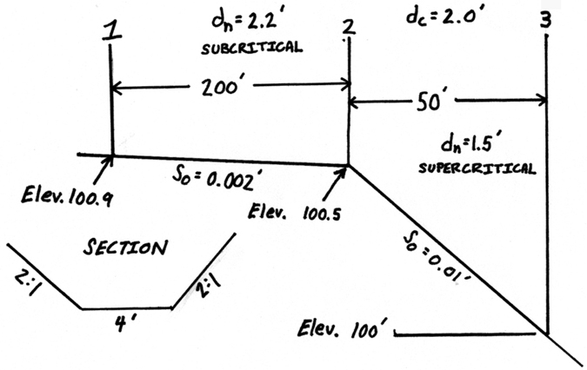
Figure 7-11. Water Surface Profile Sample Problem
(1) Compute values for d_{n} and d_{c} at each section (use the nomographs in Appendix 7C). Determine elevation at each section. Determine subcritical or supercritical flow at each section.
(2) Determine starting point and direction of computations.
Starting point = # 2 (d_{c})
Compute from # 2 to # 3 (supercritical flow)
Compute from # 2 to # 1 (subcritical flow)
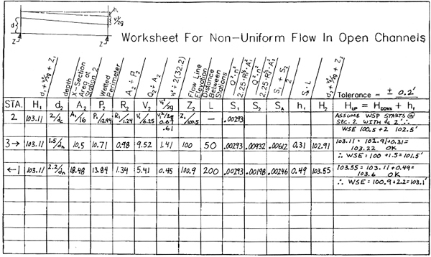
Figure 7-12. Worksheet for Calculation of Non-Uniform Flow in Open Channels, Sample Problem

Natural Channels

General
The analysis procedure for all types of channels has some common elements as well as some substantial differences. This section will outline a process for assessing a natural stream channel.

Natural Channels Design Procedure
Usually the analysis of a natural channel is in conjunction with the design of a highway hydraulic structure such as a culvert or bridge or a longitudinal encroachment such as a highway embankment. In general, the objective is to convey the water along or under the highway in such a manner that does not cause damage to the highway, stream, or adjacent property. An assessment of the existing channel is usually necessary to determine the potential for problems that might result from a proposed action. The level of detail of the studies necessary should be commensurate with the risk associated with the action, and with the environmental sensitivity of the stream and adjoining floodplain.
Although the following step-by-step procedure may not be appropriate for all possible applications, it does outline a process that will usually apply to natural channel design.
Step 1: Assemble site data and project file
A. Data Collection
- Topographic, site and location maps
- Roadway profile
- Photographs
- Field reviews
- Design data at nearby structures
- Gaging records
- Historic flood data and local knowledge
- Utilities, including existing drainage
B. Studies by other agencies
- Flood insurance studies
- Floodplain studies
- Watershed studies
C. Environmental constraints
- Floodplain encroachment
- Floodway designation
- Fish and wildlife habitat
- Commitments in review documents
D. Design criteria
Step 2: Determine the project scope
A. Determine level of assessment
- Stability of existing channel
- Potential for damage
- Sensitivity of the stream
B. Determine type of hydraulic analysis
- Single-section analysis
- Step-backwater analysis
C. Determine survey information needed
- Extent of streambed profiles
- Locations of cross-sections
- Elevations of flood-prone property
- Details of existing structures
- Properties of bed and bank materials
Step 3: Evaluate hydrologic variables
- Compute discharges for selected frequencies.
- Consult Chapter 6, Hydrology
Step 4: Perform hydraulic analysis
- Single-section analysis (7.4.4.4, 7.5.3.1)
- Select representative cross section
- Select appropriate n-values (Appendix 7D-1 and 7D-2)
- Compute stage-discharge relationship
- Step-backwater analysis (7.5.3.2)
- Calibrate with known high water
Step 5: Perform stability analysis
- Geomorphic factors
- Hydraulic factors.
- Stream response to change
Step 6: Design countermeasures
- Criteria for selection
- Erosion mechanism
- Stream characteristics
- Construction and maintenance requirements
- Cost
- Types of countermeasures
- Meander migration countermeasures
- Bank stabilization
- Bend control countermeasures
- Channel braiding countermeasures
- Degradation countermeasures
- Aggradation countermeasures
- For additional information
- HEC-20 Stream Stability
- Highways in the River Environment
- References
Step 7: Documentation (Section 7.5.1)
- Prepare report and file with background information

Riprap Channel Lining Design Procedure
In riprap lining design, it is first necessary to determine whether a lining is needed based upon the most appropriate method.

Riprap Lining Design Method for Major Channels (HEC-11)
If it is determined that riprap lining protection is required for a major stream channel, the design procedures employed by the department are predicated directly on the FHWA publication, "Design of Riprap Revetment" (HEC-11). This publication can be accessed and/or downloaded from the FHWA’s Internet web site at http://isddc.dot.gov/OLPFiles/FHWA/009881.pdf .
The riprap design procedure presented in HEC-11 is based on the equation:
(7.19)
Where:
D₅₀ = Median riprap particle size, ft
C = Stone size correction factor
V_{a} = Average velocity in the main channel, fps
d_{avg}= Average flow depth in the main flow channel, ft

The equation for $K_{1}$ is from HEC-11:*
(7.20)
Where:
θ = Side slope angle (measured from the horizontal), deg.
φ = Natural angle of repose of material under consideration (measured from the horizontal), deg.

C = C_{sg} C_{SF} (7.21)
Where:
C_{sg} = Adjustment factor for specific gravity of stone
C_{SF} = Adjustment factor for stability

Where:
S_{g} = Specific gravity of the rock riprap (Assume 2.65 for all VDOT standard riprap sizes.)
(7.22)
Where:
SF = Stability Factor, See Appendix 7D-5, (Usually 1.2)

Notes:
1. Nomographs for the solutions of φ, K₁, C, and D₅₀ are found in Appendix 7E.
2. K₁ in HEC-11 is the same variable as K₂ in HEC-15.
Convenient forms that can be used for manually performing these computations are Appendices 7B-4 for standard VDOT riprap sizes and 7B-5 for non-standard VDOT riprap sizes.

Riprap Lining Design for Major Channels (HEC-11) Sample Problem
Given: Channel is in a relatively straight section of stream. Curve radius/channel width (RW) > 30 with uniform flow. Wave action and floating debris are not a consideration. The average velocity is 5.4 fps. The average depth is 2 ft. The side slope ratios are 2:1 (26.57º). The angle of repose for the riprap is 42º. The specific gravity of the riprap is 2.65.
Determine:
Size of required riprap slope protection and appropriate VDOT standard riprap.
Solution:
Step 1: Determine the stability factor (SF)
From Appendix 7D-5, select a stability factor (SF) of 1.2.
Step 2:
Step 3:
Step 4:
Step 5:
Step 6:
Step 7: Closest standard VDOT riprap size = Class AI (D₅₀ = 0.8 ft).

Riprap Lining Design Method for Minor Channels (HEC-15)
The following design procedures employed by the department are predicated directly on* the FHWA publication, “Design of Roadside Channels With Flexible Linings” (HEC-15). This publication can be accessed and/or downloaded from the FHWA’s Internet web site at http://www.fhwa.dot.gov/engineering/hydraulics/pubs/05114/05114.pdf.* Once it has been determined that the natural or backfill material is unstable, using either (1) the Tractive Force procedure, (2) a table of allowable velocities for specific soil types such as Appendix 7D-2 and 7D-6, or (3) engineering judgment, select a trial riprap size and proceed as follows:
Step 1: Determine the permissible shear stress (τ_{p}) for the riprap size selected
Use 3.2 lbs/ft² for Class AI Riprap and 4.4 lbs/ft² for Class I Riprap.
Step 2: Select a trial flow depth range for the ditch configuration using the following table from HEC-15:
Table 7-2. Manning’s n-Values for Depth Ranges
Riprap Size | 0-0.5 ft | 0.5-2.0 ft | >2.0 ft
Class AI | 0.104 | 0.069 | 0.035
Class I | -- | 0.078 | 0.040
Step 3: Using the n-value for the selected trial flow depth range, calculate the actual depth of flow for the ditch configuration using the actual design discharge and ditch slope using an appropriate method such as Appendix 7C-3. If the calculated depth is within the trial depth range selected, proceed to the next step. If it is not, select another trial depth range and try again.
Step 4: Calculate the actual shear stress (τ_{ο}):
(7.23)
Where:
γ = Unit weight of water (62.4 lbs/ft³)
d = Depth of flow, ft.
S = Average ditch flowline slope, ft./ft.
If τ_{o} > τ_{p}, the selected riprap size is too small. Choose the next larger size and try again.
If the ditch side slopes are steeper than 3:1, it is necessary to perform the additional calculations shown below:
Step 5: Determine the angle of repose for the riprap size determined above.
It should be noted that all VDOT standard riprap sizes are assumed to have angles of repose of 42º.
Step 6: Determine the ratio of maximum side shear to maximum bottom shear (K₁) using Appendix 7E-7.
Step 7: Determine tractive force ratio (K₂) from Appendix 7E-8.
Step 8: Calculate required D₅₀ for side slopes (D_{50 side})
From a practical standpoint, whatever riprap size is indicated for the ditch side slope should be used on the bottom as well.

Channel Stability Sample Problem - Tractive Force Calculation
Check the stability of channel's native material using tractive force calculation. Note that the “RIPRAP” computer program referenced in section 7.4.6.4.4 could be employed to perform this computation.*
Given: A natural channel with a bed and banks of native materials composed of cobbles and pebbles. Mean diameter is 1.25 inches for the D₇₅ size stone. The channel bottom width (B) is 10 ft. The longitudinal slope is 0.008 ft./ft. Its side slope is 2(h):1(v). The flow (Q) is 150 cfs at a depth (d) of 2 ft.
Determine whether the channel is stable for the indicated condition.
Solution:
Step 1: Determine the permissible shear stress (τ_{p})
From Appendix 7E-2, for a D₇₅ particle diameter of 1.25 inches, read a permissible tractive force (τ_{p}) on the channel bottom of 0.5 lbs/ft².
Step 2: For a side slope ratio of 2:1, the sine of the slope angle (θ = 26.6º) is 0.5
Step 3: From Appendix 7E-1, for a particle diameter of 1.25 inches, read an angle of repose (φ) of 40º
The sine of 40º = 0.643
Step 4:
Step 5: Permissible tractive force on the side slopes (τ_{s})
Step 6: Compute the width to depth ratio
, which is less than 10, therefore use
Step 7: Flow cross-sectional area
Step 8: Wetted perimeter
Step 9: Hydraulic radius
Step 10: Compute the average tractive force
Step 11: Compare the average tractive force of the channel to the allowable tractive force of the channel sides and bottom
τ_{o} of 0.74 > τ _{p (bottom)} of 0.5 lbs/ft² or τ _{s (side slope)} of 0.36 lbs/ft²
Native material is unstable. Channel protection is required.

Riprap Lining Design for Minor Channels (HEC-15) Sample Problem
Given: It has been determined that a special design ditch connected to culvert cross drain pipes will need a riprap lining. The ditch has a bottom width (B) of 2 ft, 2:1 side slopes (z = 2), and a slope along the ditch line (S) of 0.005 ft/ft. The design discharge is 20 cfs.
Determine what size VDOT standard riprap will be required?
Step 1: Try Class AI standard riprap, D₅₀ = 0.8 ft
τ_{p} = 3.2 lb/ft²
Step 2: Assume a depth range of from 0.5-2.0 ft. with an n-value of 0.069
Step 3: Using Appendix 7E-3 for S = 0.005 ft/ft, B = 2 ft, z = 2, Qn = 20 (0.069) = 1.38,
Read d/B = 0.78. d = 0.78 (2) = 1.56 ft. 0.5 < 1.56 <2.0,
Therefore, the assumed n-value of 0.069 is acceptable.
Step 4: Determine the maximum shear stress
Step 5: Evaluate the maximum shear stress with the permissible shear stress
τ_{max}<τ_{p},
0.49 < 3.2
Therefore, Class AI riprap is acceptable for the ditch bottom and side slopes of 3:1 or flatter. However, since the side slopes are 2:1, proceed with checking the side slope stability
Step 6: Determine the angle of repose for Class AI riprap
φ = 42º
Step 7: Determine K₁
From Appendix 7E-7, for B/d = 2 / 1.56 = 1.28 and z = 2, read K₁ = 0.9
Step 8: Determine K₂
From Appendix 7E-8 for z = 2 and angle of repose = 42º, read K₂ = 0.73.
Step 9: Determine the D₅₀ for the side slopes
Therefore, it would probably be best to use Standard Class I riprap (D₅₀ = 1.1 ft) for both the channel bottom and side slopes in lieu of the originally proposed Class AI (D₅₀ = 0.8 ft).

References
American Association of State Highway and Transportation Officials. 2005 Model Drainage Manual, ISBN I-56051-298-9, AASHTO, Washington, D.C. 2005*
American Society of Civil Engineers, High Velocity Flow in Open Channels: A Symposium: Design of Channel Curves for Supercritical Flow. Transactions, Vol. 116. 1951.
American Society of Civil Engineers, Special Committee on Irrigation Research, 1926.
Arcement, G.J., Jr., and V.R. Schneider, Guide for Selecting Manning's Roughness Coefficients for Natural Channels and Flood Plains, Report No. FHWA-TS-84-204, Federal Highway Administration. 1984. (archived)
Barnes, Harry H., Jr. Roughness Characteristics of Natural Channels, U.S. Geological Survey Water Supply Paper 1849, U.S. Government Printing Office, Washington, D.C. 1978.
Behlke, C.E. The Design of Supercritical Flow Channel Junctions, Highway Research Record No. 123, Transportation Research Board. 1966.
Blodgett, J.C. Rock Riprap Design for Protection of Stream Channels Near Highway Structures, Vol. 1, Water Resources Investigations Report 86-4127, U.S. Geological Survey, prepared in Cooperation with Federal Highway Administration. 1986.
Blalock, M.E., and T.W.Sturm. Minimum Specific Energy in Compound Open Channel, Journal of Hydraulics Division, ASCE, Vol. 107, No. HY6, pp. 699-717. June 1981.
Blodgett, J.C., and C.E. McConaughy. Rock Riprap Design for Protection of Stream Channels Near Highway Structures," Vol. 2, Water Resources Investigations Report 864127, U.S. Geological Survey, prepared in Cooperation with Federal Highway Administration. 1986.
Brown, S.A. Streambank Stabilization Measures for Stream Crossings--Executive Summary, FHWAIRD-84/099, FHWA, Washington, D.C. 1985.
Brown, SA. Design of Spur-Type Streambank Stabilization Structures, FHWA/RD-84/101,FHWA, Washington, D.C. 1985.
Brown, SA. Streambank Stabilization Measures for Highway Engineers, FHWA/RD-84/100, FHWA, Washington, D.C. 1985.
Chow, V.T. Open Channel Hydraulics, McGraw-Hill. 1959.
Clopper, Paul E. Hydraulic Stability of Articulated Concrete Block Revetment Systems During Overtopping Flow, FHWA-RD-89-199, FHWA, Washington, D.C. November 1989.
Davidian, Jacob. Computation of Water Surface Profiles in Open Channels, Techniques of Water Resources Investigation, Book 3, Chapter Al5, U.S. Geological Survey. 1984.
Federal Emergency Management Agency. HEC-RAS Procedures for HEC-2 Modelers.* April 2002
Federal Highway Administration. River Engineering for Highway Encroachments, Hydraulic Design Series No. 6, FHWA-NHI-01-004, FHWA, Washington, D.C. 2001.
Federal Highway Administration. Hydraulic Design of Energy Dissipaters for Culverts and Channels, Hydraulic Engineering Circular No. 14, FHWA-NHI-06-086, FHWA, Washington, D.C. 2006.
Federal Highway Administration. Design of Roadside Channels with Flexible Linings, Hydraulic Engineering Circular No. 15, FHWA-NHI-05-114, FHWA, Washington, D.C. 2005.
Federal Highway Administration. Design Of Riprap Revetments, Hydraulic Engineering Circular No. 11, FHWA-IP-89-016, FHWA, Washington, D.C. 1989.
Federal Highway Administration. Stream Stability at Highway Structures, Hydraulic Engineering Circular No. 20, FHWA-NHI-01-002, FHWA, Washington, D.C. 2001.
French, Richard H., Open-Channel Hydraulics. McGraw-Hill, Inc. 1985
Henderson, F.M. Open Channel Flow, Macmillan. 1966.
Lane, E.W. A Study of the Shape of Channels Formed by Natural Stream Flowing in Erodible Material, M.R.D. Sediment Series No. 9, U.S. Army Engineers Division, Missouri River, Corps of Engineers, Omaha, Nebraska. 1957.
Molinas, Albert. Users Manual For BRI-STARS, Report No. FHWA-RD-99-190, 2000.
Odgaard, A. Jacob, and Anita Spoljaric. Sediment Control by Submerged Vanes, Journal of Hydraulic Engineering, ASCE, Vol. 112, No. 12. December 1986.
Odgaard, A. Jacob, and Carlos E. Mosconi. Streambank Protection by Submerged Vanes, Journal of Hydraulic Engineering, ASCE, Vol. 113, No. 4. April 1987.
Richardson, E.V., D.B. Simons, and P.Y. Julien. Highways in the River Environment, prepared for the Federal Highway Administration, Washington, D.C. June 1990. By the Department of Civil Engineering, Colorado State University, Fort Collins, Colorado, June 1990.
Rouse, Hunter, ed. Engineering Hydraulics, John Wiley & Sons, Inc. 1950.
Shen, H.W., S.A. Schumm, J.D. Nelson, D.O. Doehring, and M.M. Skinner. Methods for Assessment of Stream-Related Hazards to Highways and Bridges, FHWA/RD-80/160, Federal Highway Administration, Washington, D.C. 1981.
Sturm, T.W. Simplified Design of Contractions in Supercritical Flow, Journal of Hydraulic Engineering, ASCE, Vol. 11, No. 5. May 1985.
U.S. Army Corps of Engineers. Accuracy' of Computed Water Surface Profiles, The Hydrologic Engineering Center, Davis, California December 1986.
U.S. Army Corps of Engineers. HEC-2 Water Surface Profiles, User's Manual, The Hydrologic Engineering Center, Davis, CA, CPD-2A. 1990 (Revised 1991). (legacy* software)
U.S. Army Corps of Engineers. HEC-RAS, River Analysis System, Hydraulic Reference Manual, The Hydrologic Engineering Center, Davis, CA.
U.S. Army Corps of Engineers. HEC-RAS, River Analysis System, User's Manual, The Hydrologic Engineering Center, Davis, CA.
U.S. Army Corps of Engineers. HEC-RAS, River Analysis System, Applications Guide, The Hydrologic Engineering Center, Davis, CA.
Vanoni, Vito A., Sedimentation Engineering, ASCE Manual No. 54, ASCE, 345 East 47th St., New York, NY.
U.S. Army Corps of Engineers. HEC-6, Scour and Deposition in Rivers and Reservoirs, The Hydrologic Engineering Center, Davis, CA. (legacy software)

* Rev 9/09
* Rev 9/09
* Rev 9/09
* Rev 9/09
* Rev 9/09
* Rev 9/09
* Rev 9/09
* Rev 9/09
* Rev 9/09
* Rev 9/09
* Rev 9/09
* Rev 9/09
* Rev 9/09
* Rev 9/09
* Rev 9/09
* Rev 9/09
* Rev 9/09
* Rev 9/09
* Rev 9/09
* Rev 9/09
* Rev 9/09
* Rev 9/09
* Rev 9/09
* Rev 9/09

