Appendix 7E-8 Tractive Force Ratio (K₂)

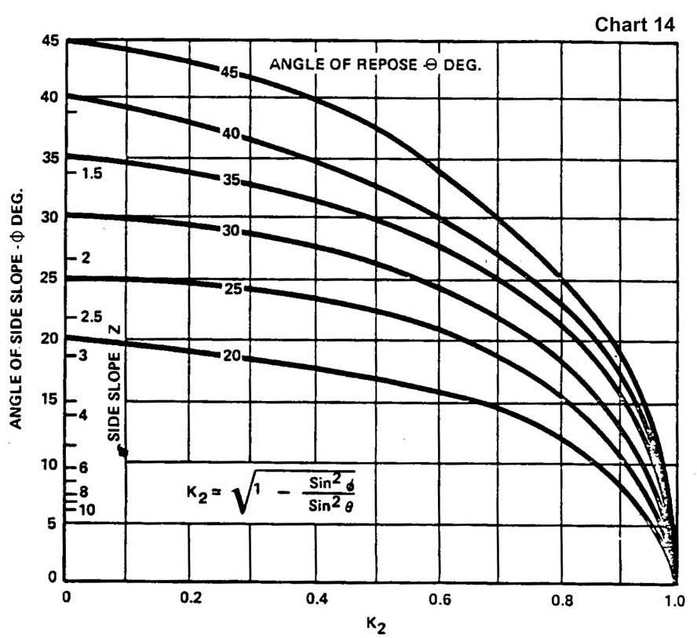

Source: HEC-15 (Archived 1988)
Comment: The symbols of Φ and θ are reversed from Appendix 7E-4.

