Appendix 7E-6 Riprap Size Relationship

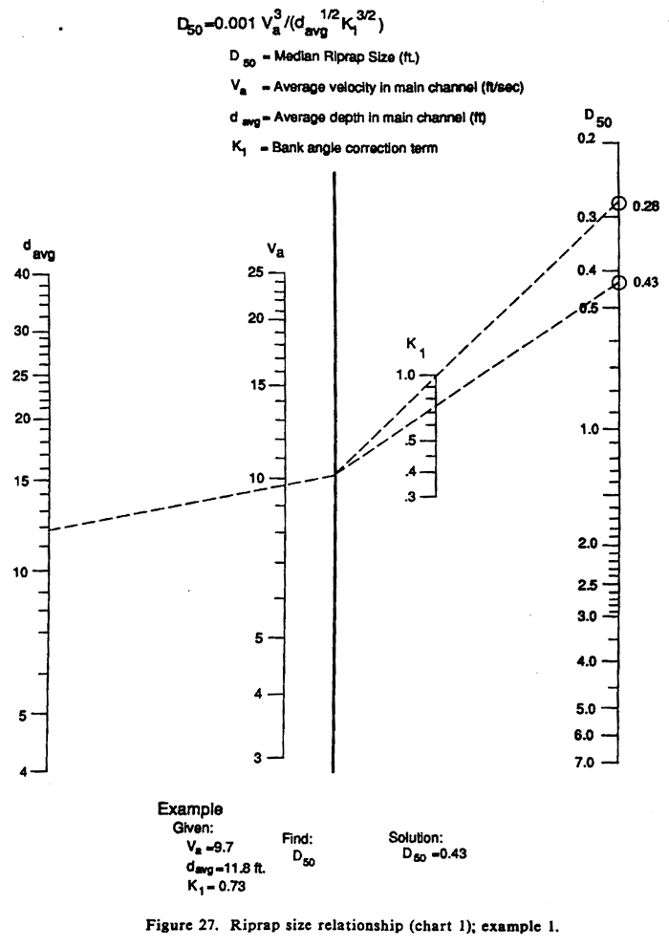

Source: HEC-11

