Appendix 7E-4 Bank Angle Correction Factor

(K₁) Nomograph
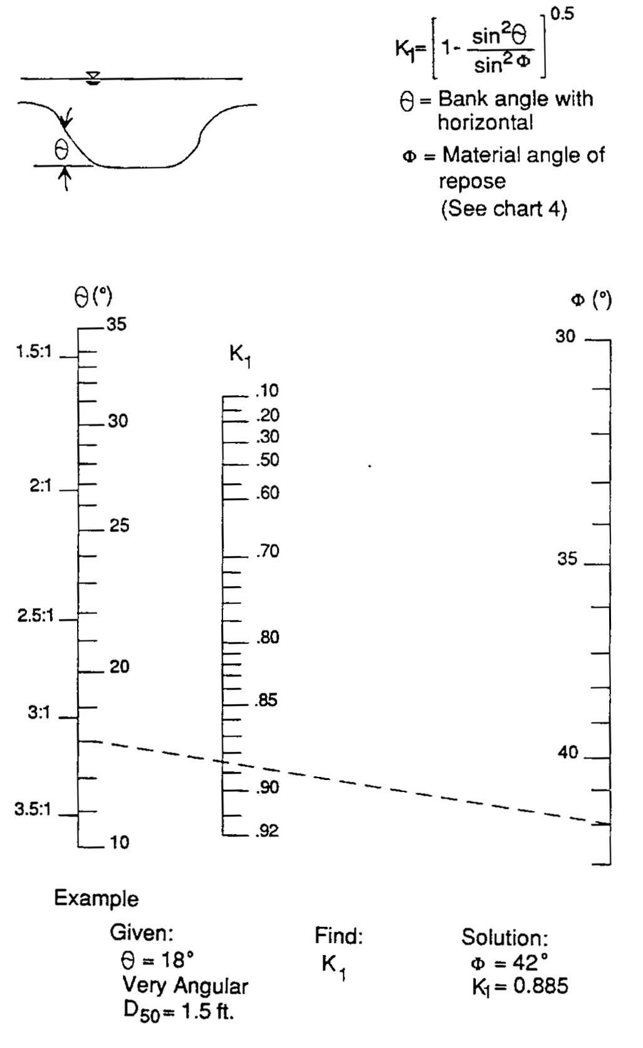

Source: HEC-11

