Appendix 7E-2 Permissible Shear Stress for Non-Cohesive Soils

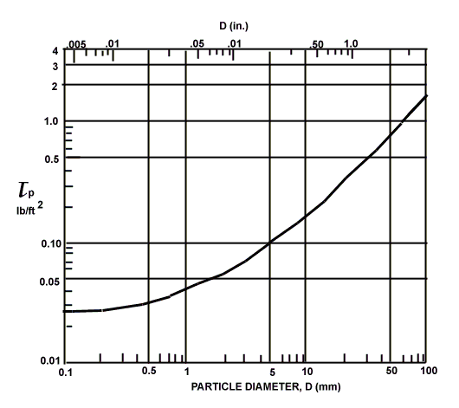

Source: HEC-15 (Archived) 1988

