Appendix 7C- 31 Trapezoidal Channel Flow Chart

(B = 20’, Side Slopes = 2:1)
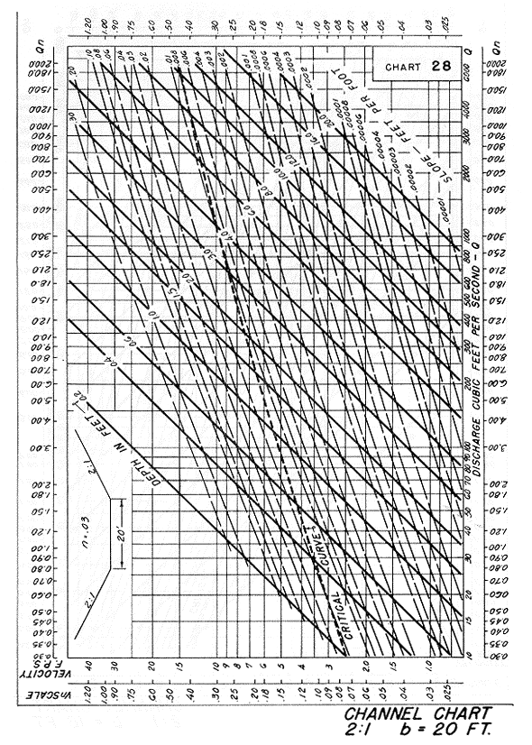

Source: HDS-3

