Appendix 7C-30 Trapezoidal Channel Flow Chart

(B = 18’, Side Slopes = 2:1)

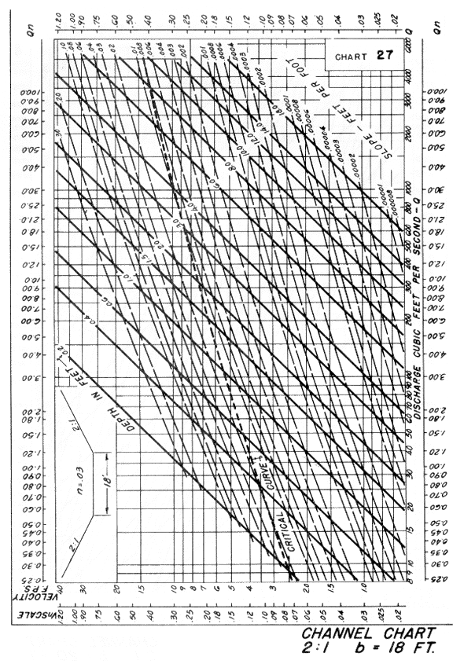

Source: HDS-3

