Appendix 7C-27 Trapezoidal Channel Flow Chart

(B = 12’, Side Slopes = 2:1)

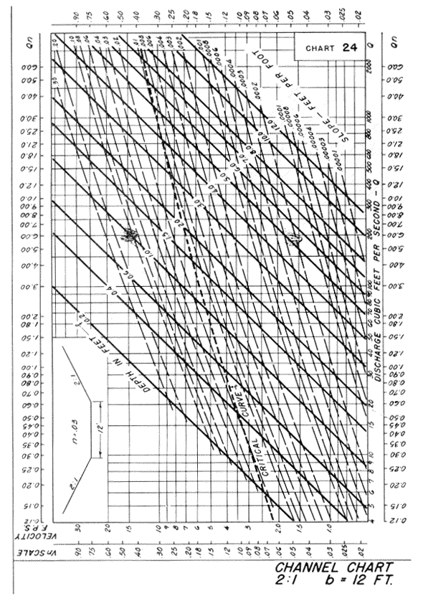

Source: HDS-3

