Appendix 7C-26 Trapezoidal Channel Flow Chart

(B = 10’, Side Slopes = 2:1)

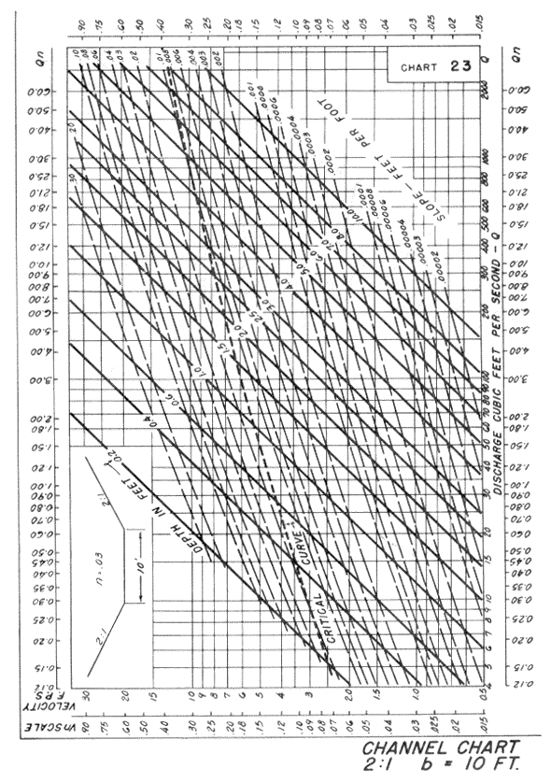

Source: HDS-3

