Appendix 7C-21 Trapezoidal Channel Flow Chart

(B = 5’, Side Slopes = 2:1)

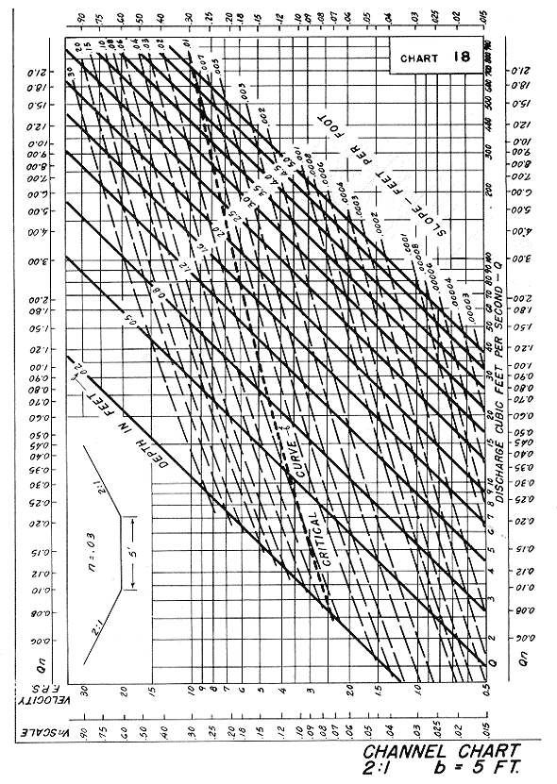

Source: HDS-3

