Appendix 7C-17 Trapezoidal Ditch Flow Chart

(B=1’, Side Slopes = 1.5:1)
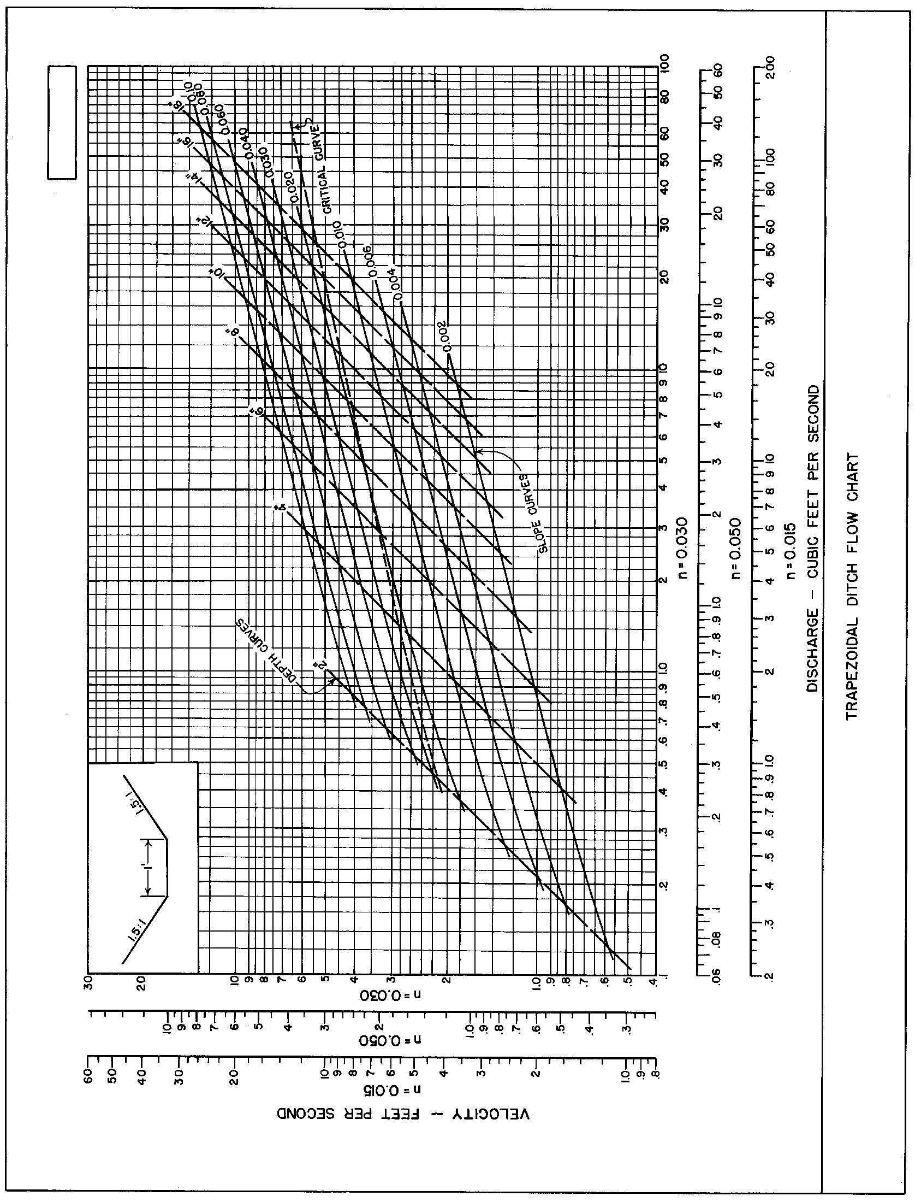

Source: HDS-3

