Appendix 7C-13 Triangular Median Ditch Flow Chart

(Side Slopes = 4:1, 4:1)

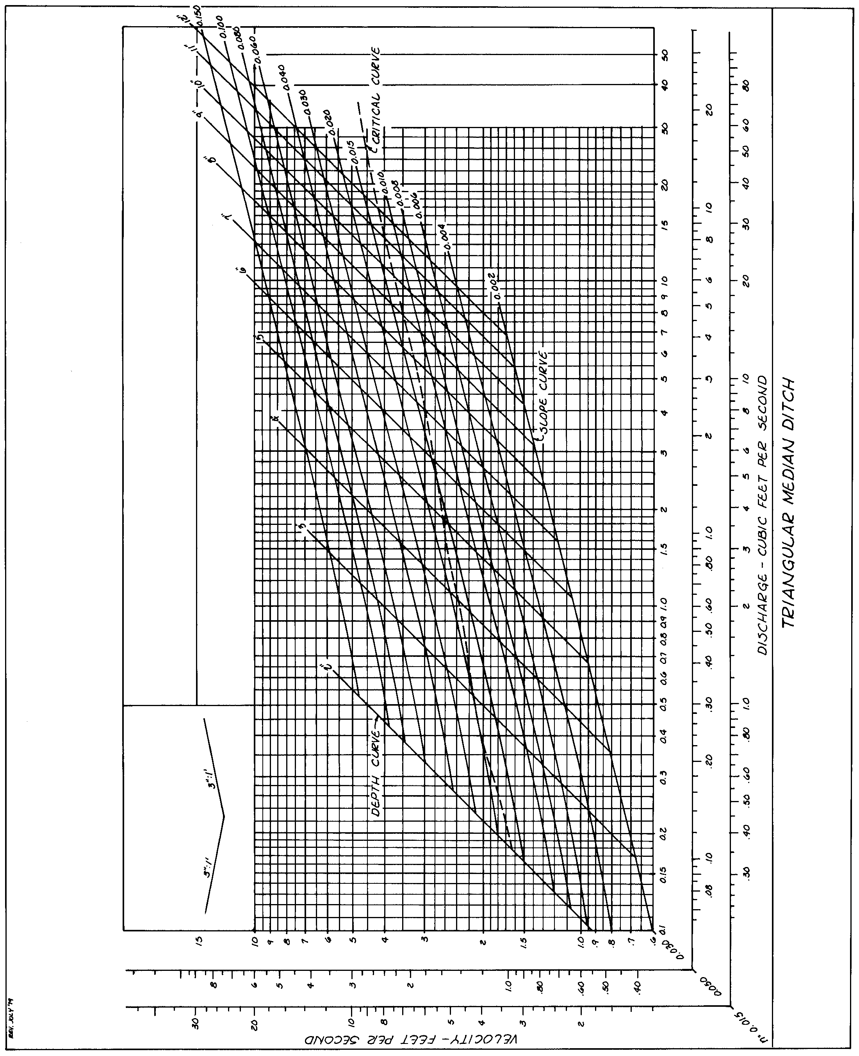

Source: VDOT

