Appendix 7C-10 Side Ditch Flow chart

(Side Slopes = 6:1, 2:1)

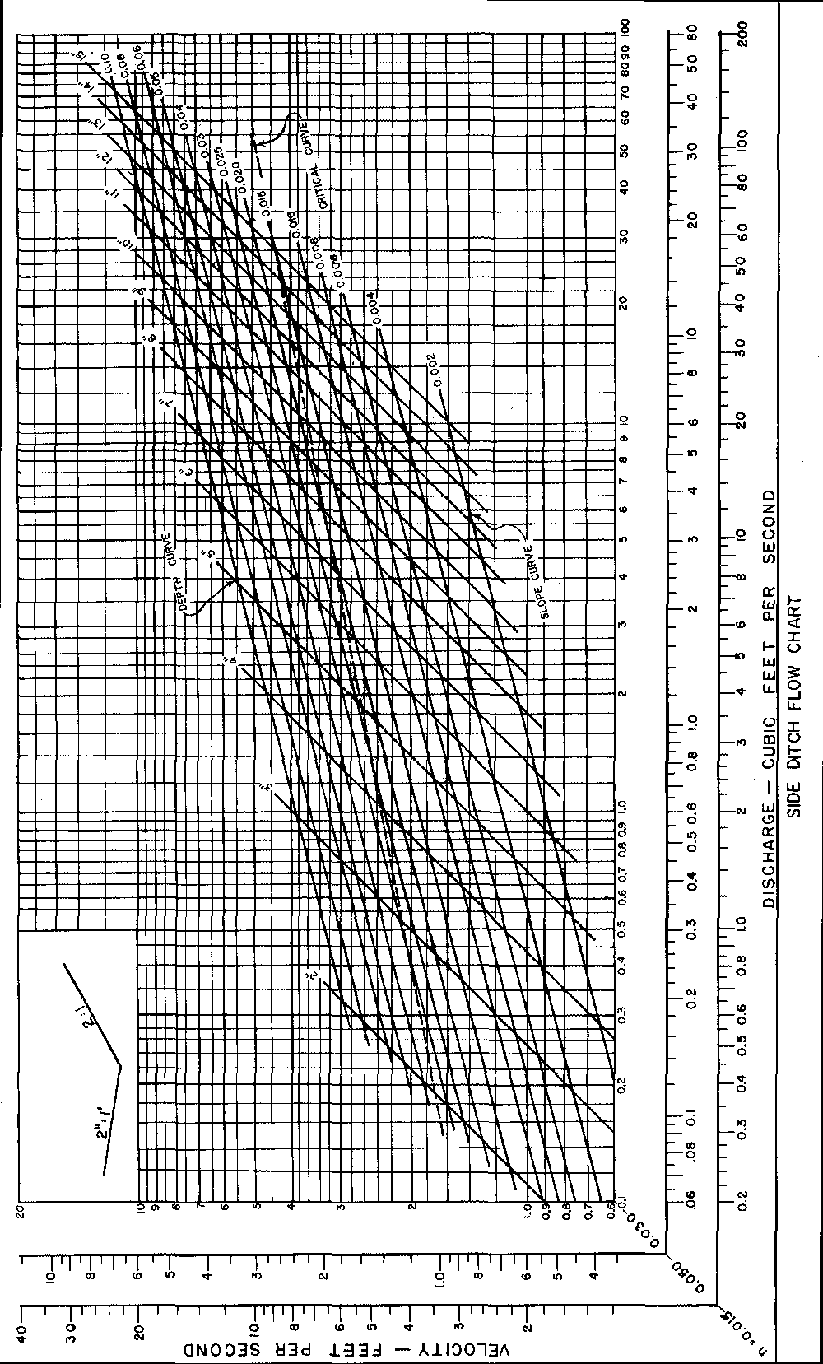
Source: VDOT

