Appendix 7C-9 Side Ditch Flow Chart

(Side Slopes = 3:1, 3:1)

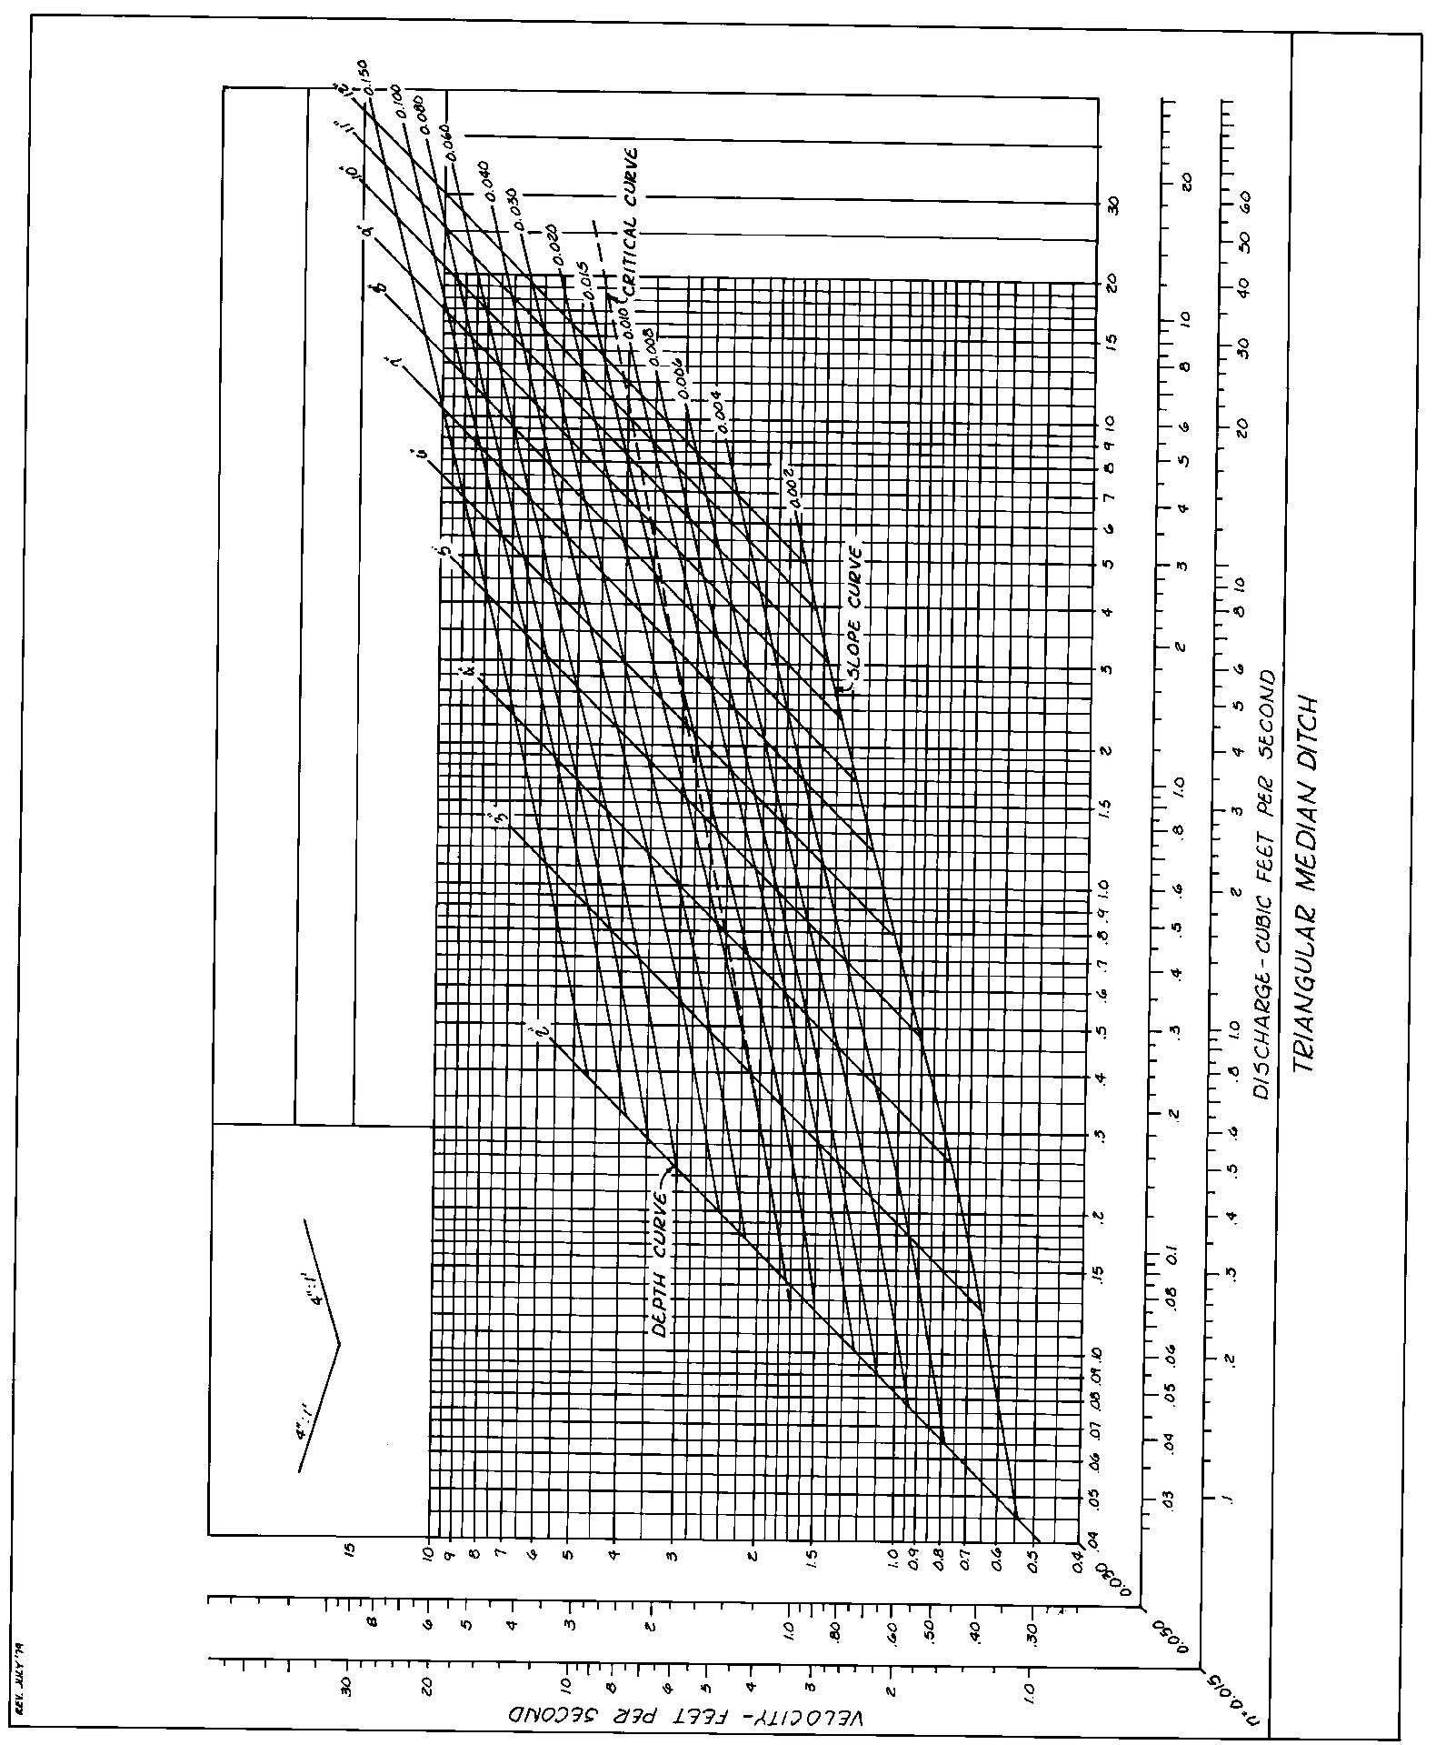

Source: VDOT

