Appendix 7C-5 Side Ditch Flow Chart

(Side Slopes = 4:1, 1:1)
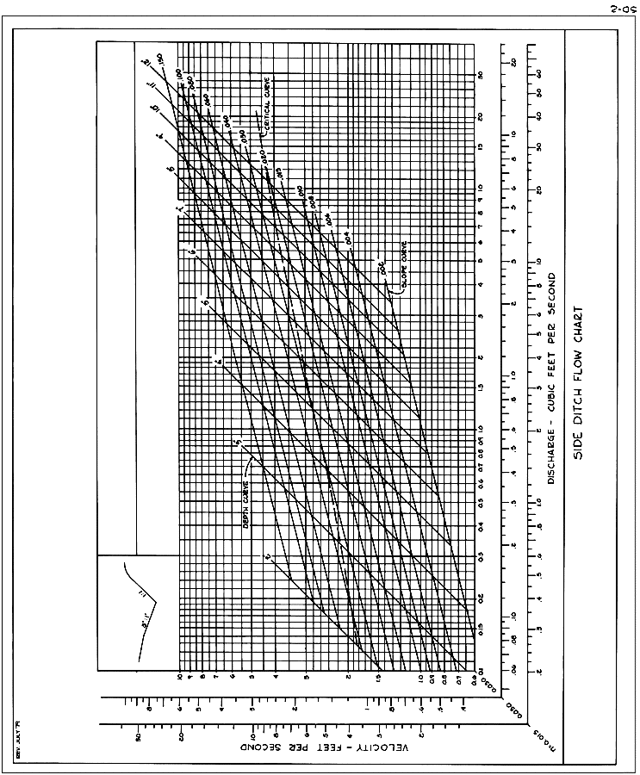
Source: VDOT

