Appendix 7C-3 Nomograph for Solution of Normal Depth

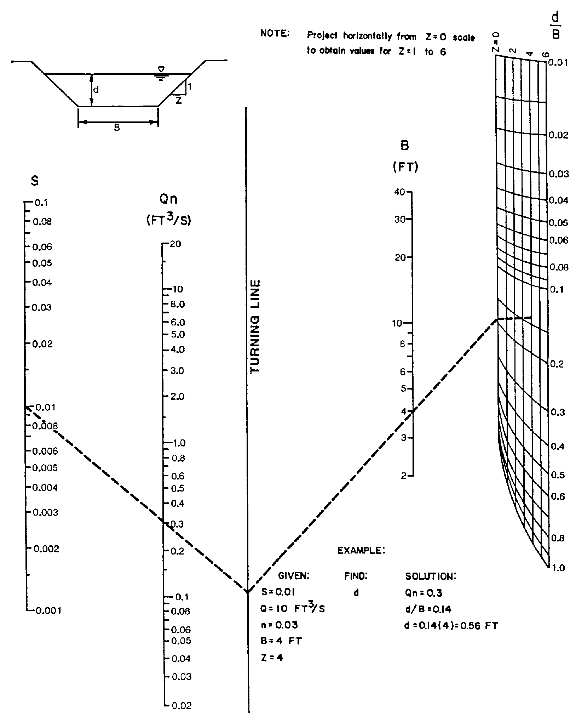

Source: HEC-15 (Archived) 1988

