Appendix 7C-2 Trapezoidal Channel Capacity Chart

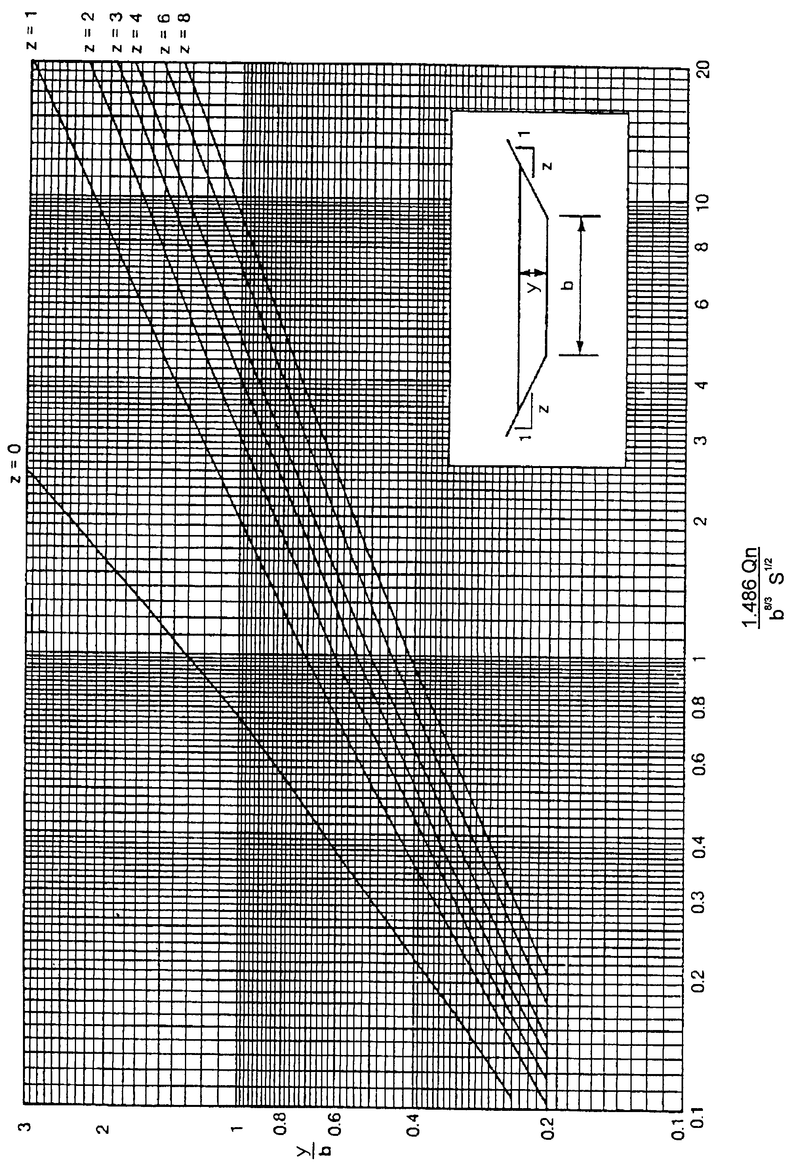

Source:

