Appendix 7B-2 Water Surface Profile Calculation Form
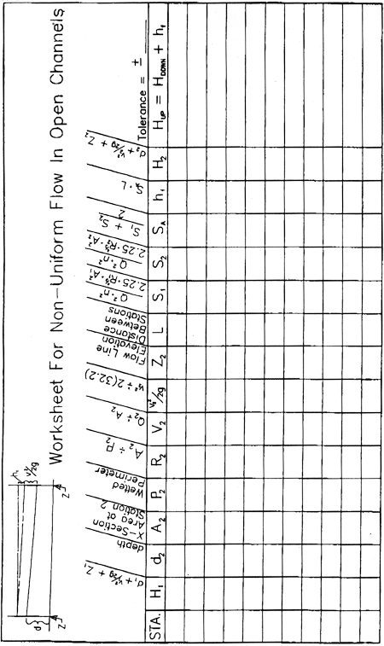
Source:

