Appendix 6I-5 Flow Profile Analysis

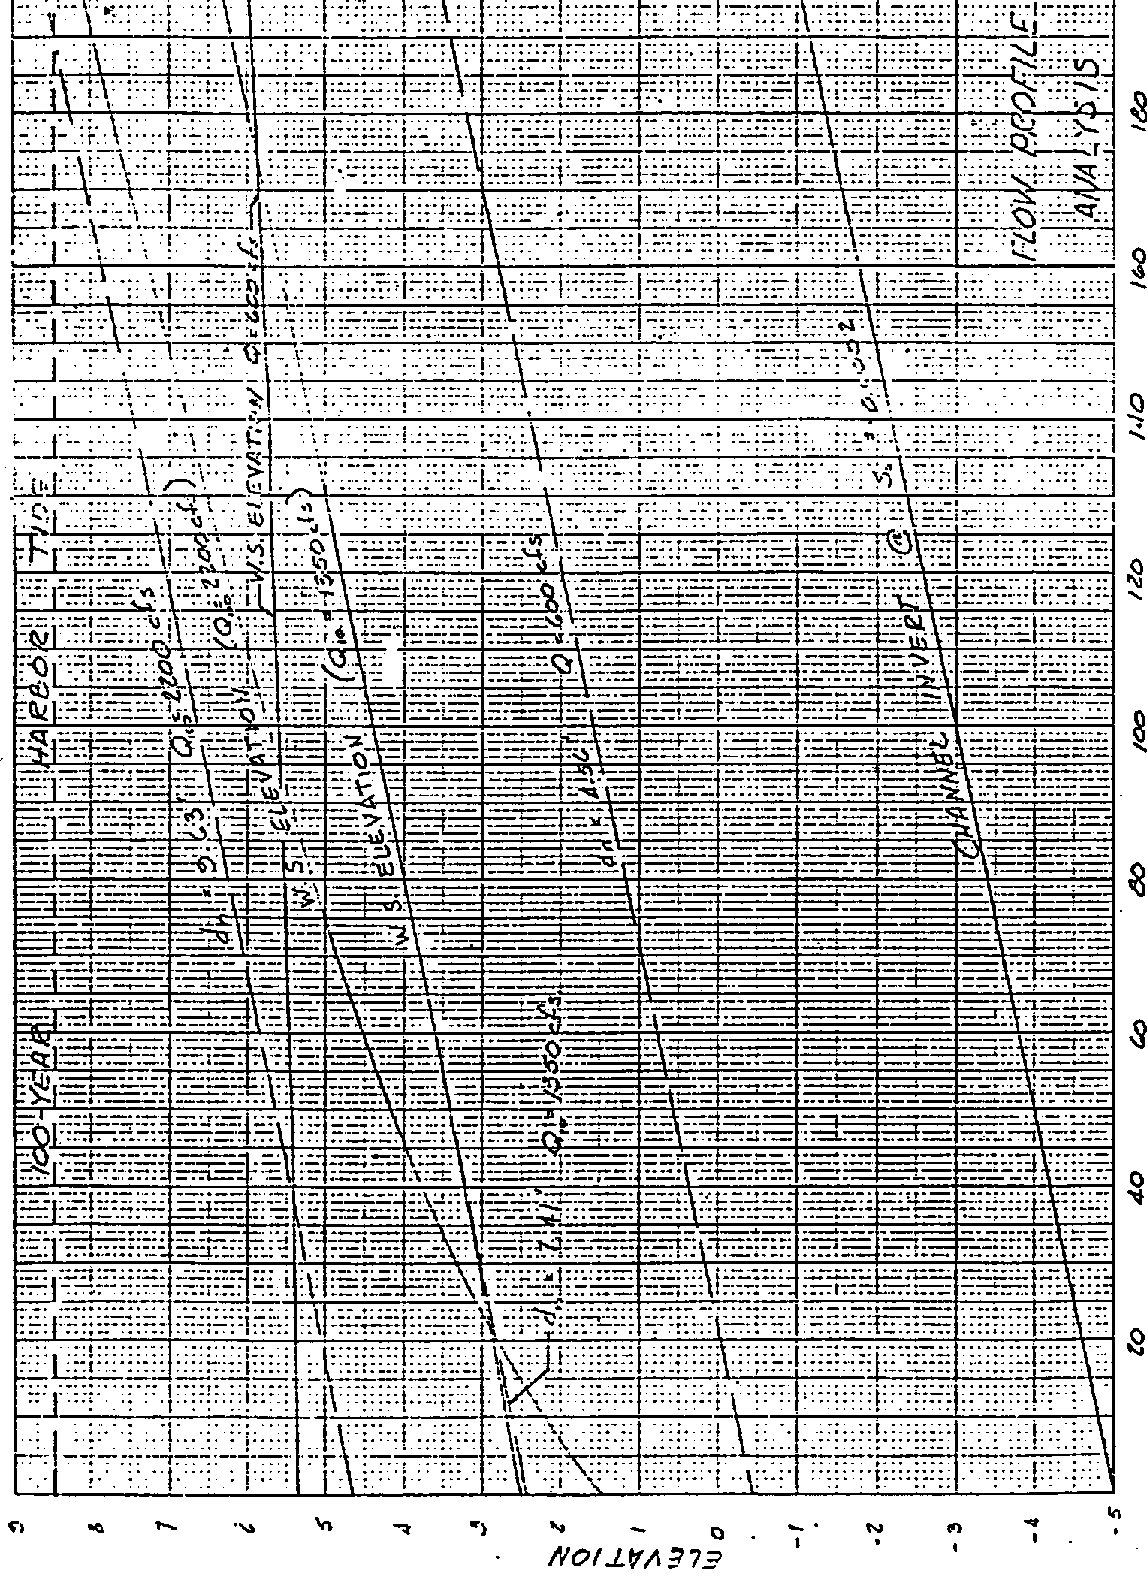
Source: U. S. Army Corps of Engineers

