Appendix 6I-3 Rainfall Coincident with Tidal EL. 4.2 FT
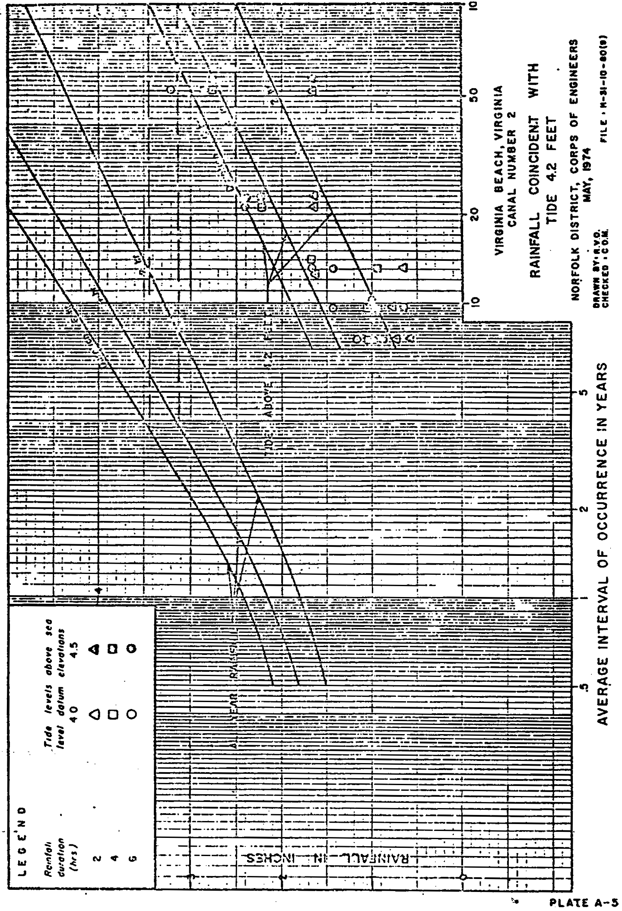
Source: U. S. Army Corps of Engineers

