Appendix 6D-6 Average Velocities for

Estimating Travel Time for

Shallow Concentrated Flow

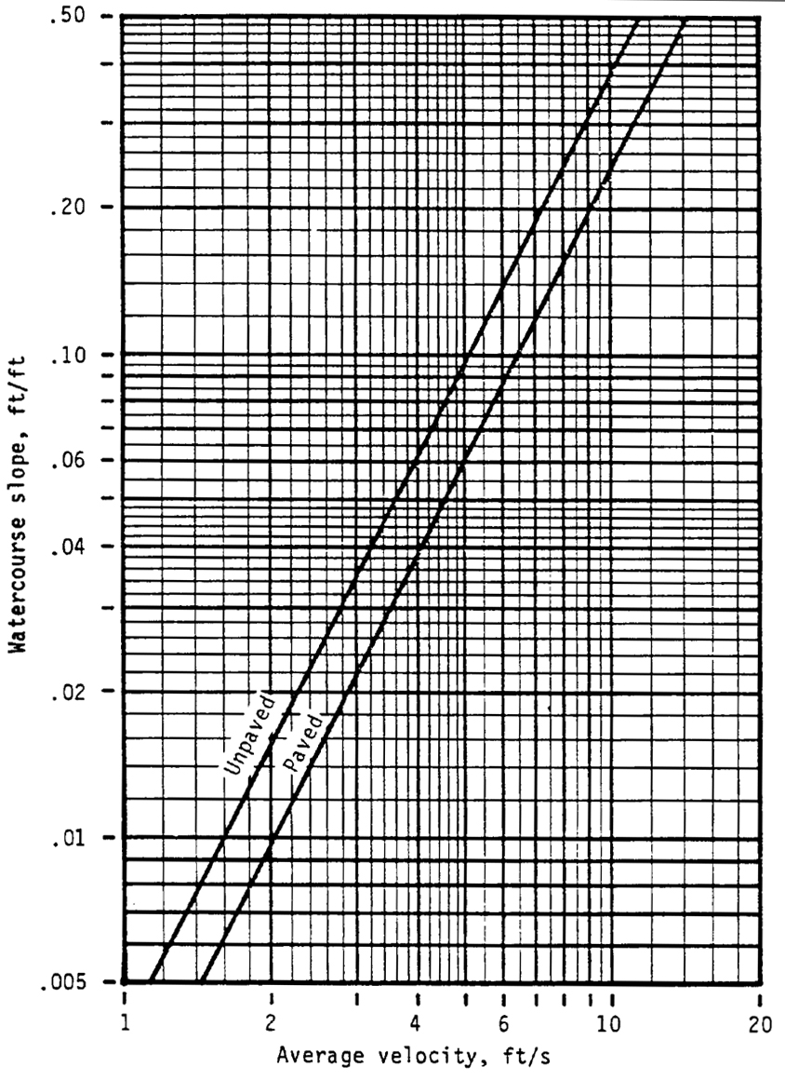
Source:
SCS, 210-VI-TR-55, Second Edition, June, 1986
VDOT has determined that this nomograph produces essentially the same flow time as the “Kirpich” Method.

