Appendix 6D-5 Time of Concentration for

Small Drainage Basins - Kirpich
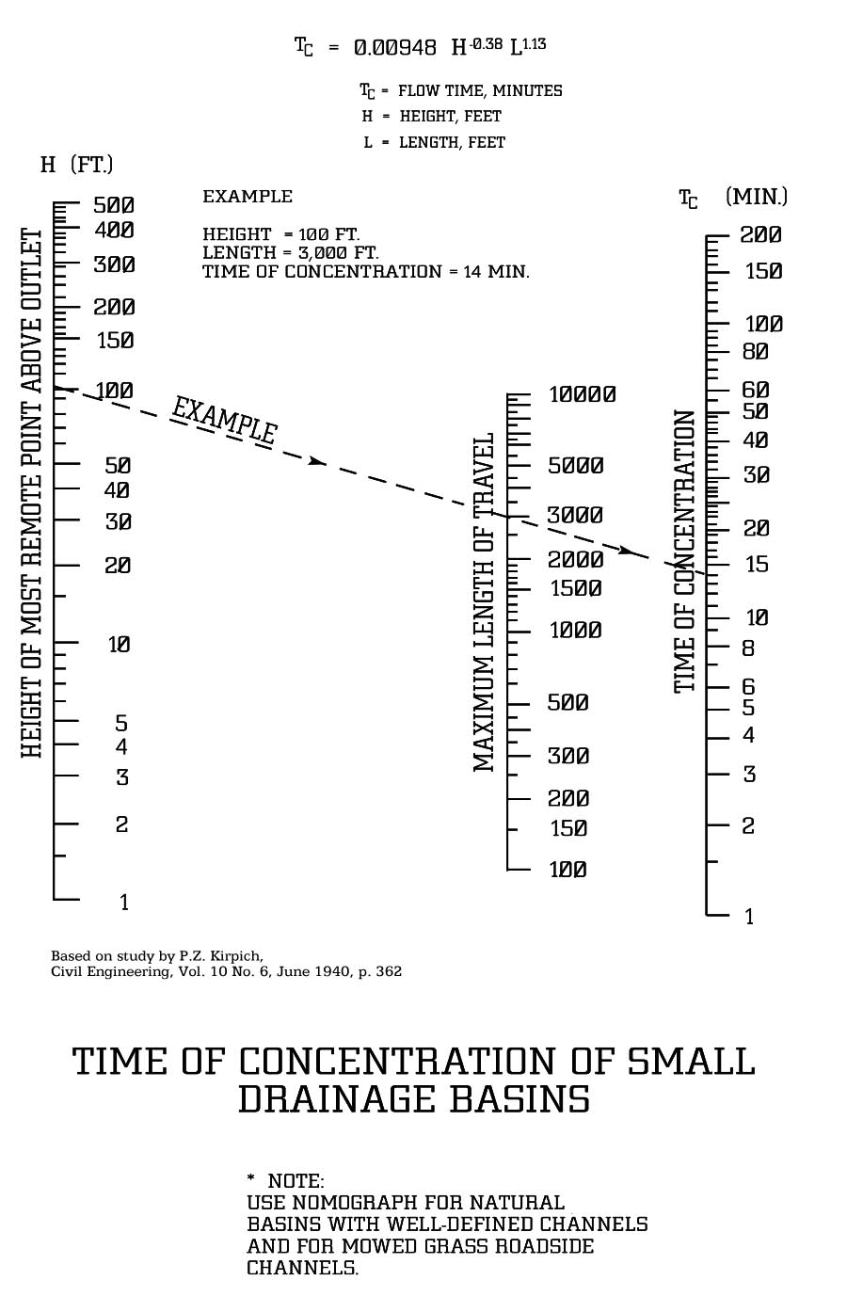
Comments:
VDOT derived an equation from and added it to this nomograph. This was done without the author’s permission in the interest of providing the user with an optional mathematical solution. The Department warrants neither the accuracy nor the validity of this equation and cautions the user that it be used at their own risk.
**The Kirpich Chart should only be used for channel time in Virginia.

