Appendix 6D-4 Overland Flow Velocity

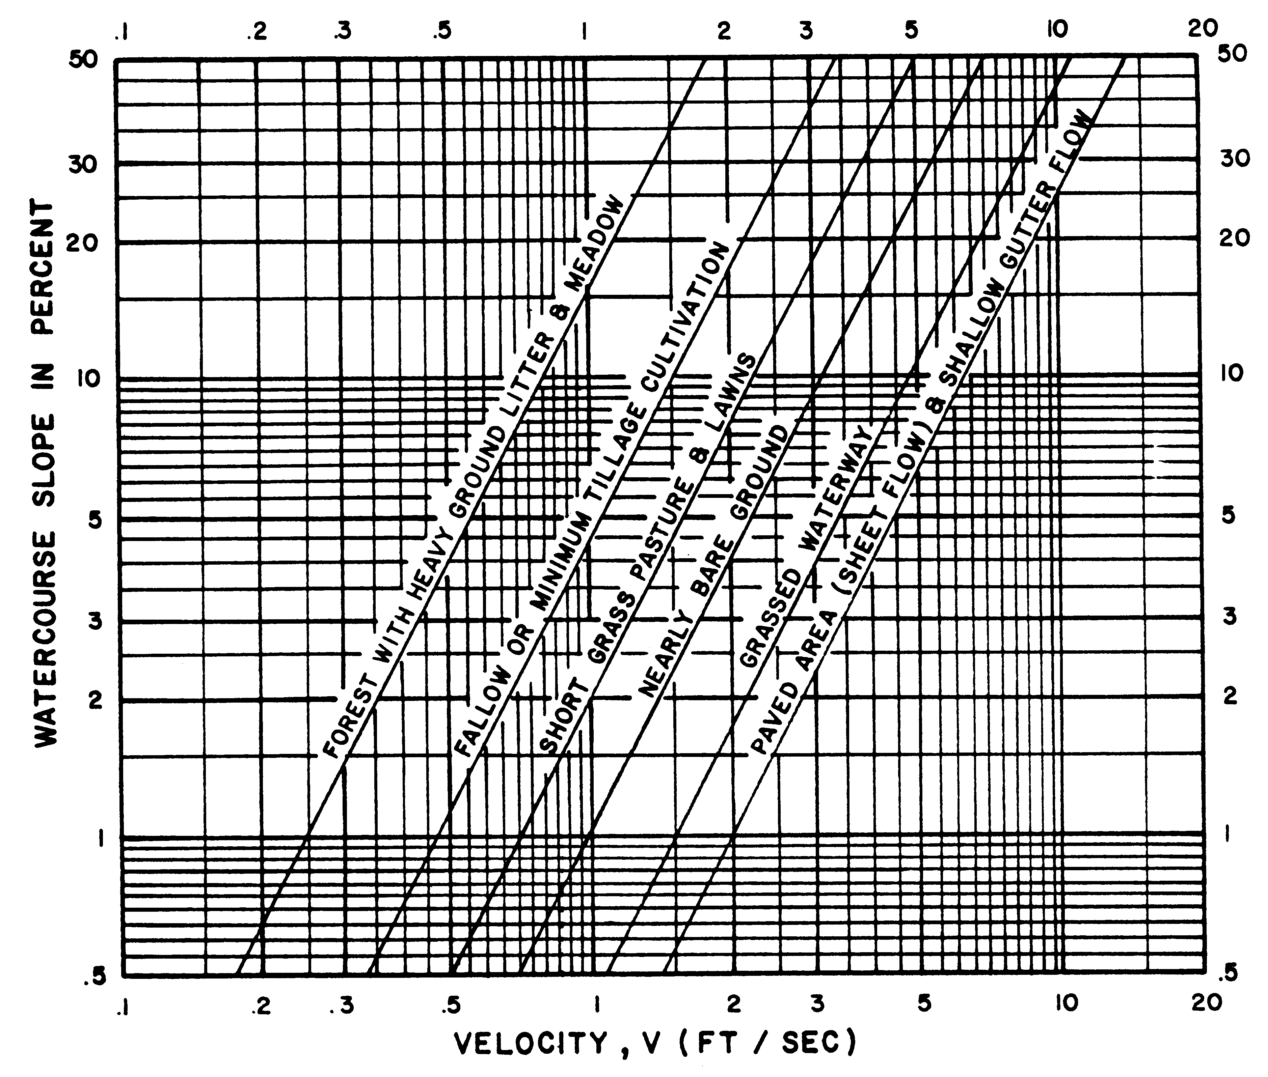

Source:
HEC No. 19, FHWA (archived)

