Appendix 6D-3 Overland Time of Flow

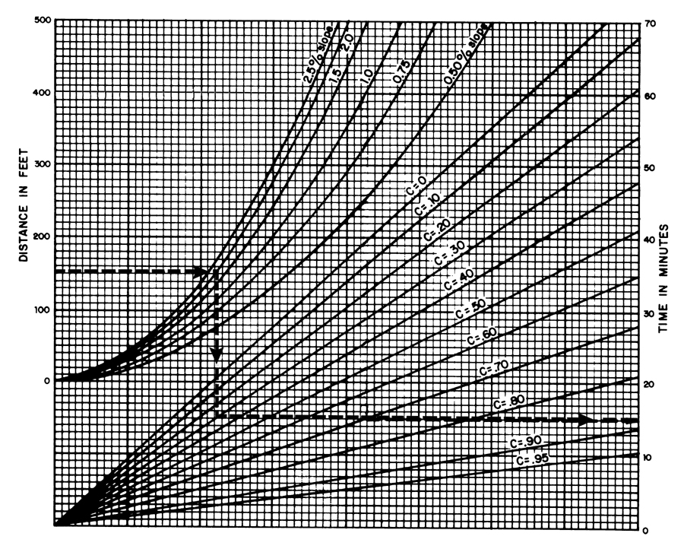

Source:
Airport Drainage, Federal Aviation Administration, 1965

