Appendix 6D-2 Kinematic Wave Formulation

Overland Flow

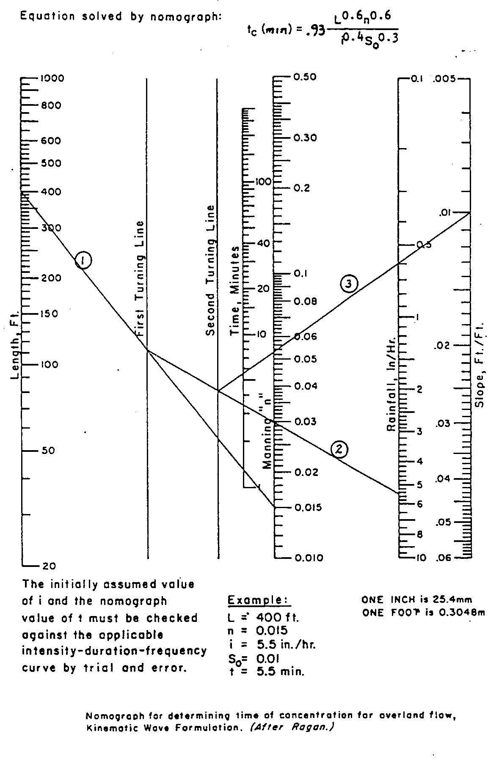
Comments:
VDOT has determined that the Kinematic Wave Method should only be used for:
a) Impervious Surfaces
b) n = 0.05 or less
c) Length = 300’ Maximum
d) See page 2 of 2 for suggested Manning’s roughness coefficients

Appendix 6D-2 Mannings Roughness Coefficient for Shallow Sheet Flow

Surface Description n¹

Smooth surfaces - concrete, asphalt, gravel, or bare soil (compacted) 0.011
Fallow – no residue (non-compacted bare, plowed soil) 0.05
Cultivated soils:
Residue cover < 20% 0.06
Residue cover > 20% 0.17
Grasses:
Short grass prairie 0.15
Dense grasses² 0.24
Bermuda grass 0.41
Range (natural) 0.13
Woods:³
Light underbrush 0.40
Dense underbrush 0.80

Soil Conservation Service Urban Hydrology for small water sheds Technical Release No. 55, Natural Resources Conservation Service, Washington, D.C. 1986

¹ The n values are a composite of information complied by Engman (1986).
² Includes species such as weeping lovegrass, bluegrass, buffalo grass, blue grama grass and native grass mixtures.
³ When selecting n, consider cover to a height of about 1 inch. This is the only part of the plant cover that will obstruct sheet flow.

Source: AASHTO 2005 MODEL DRAINAGE MANUAL (text shown in parentheses are VDOT additions to the original chart which were included to simplify interpretation and application)

