Appendix 13C-3 Wave Run-up on

Smooth Impermeable Slope

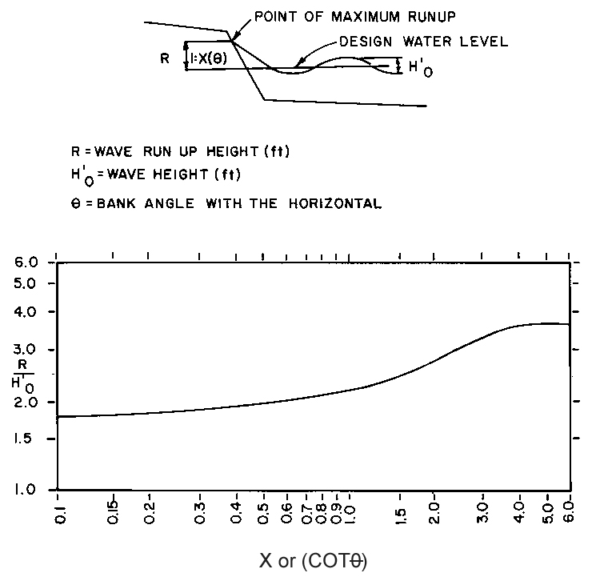

Source:

