Appendix 12C-4 Virginia Coastal Maps Showing Predicted Water Surface Elevations

VIRGINIA DEPARTMENT OF TRANSPORTATION

Maps of the Costal Regions of Virginia

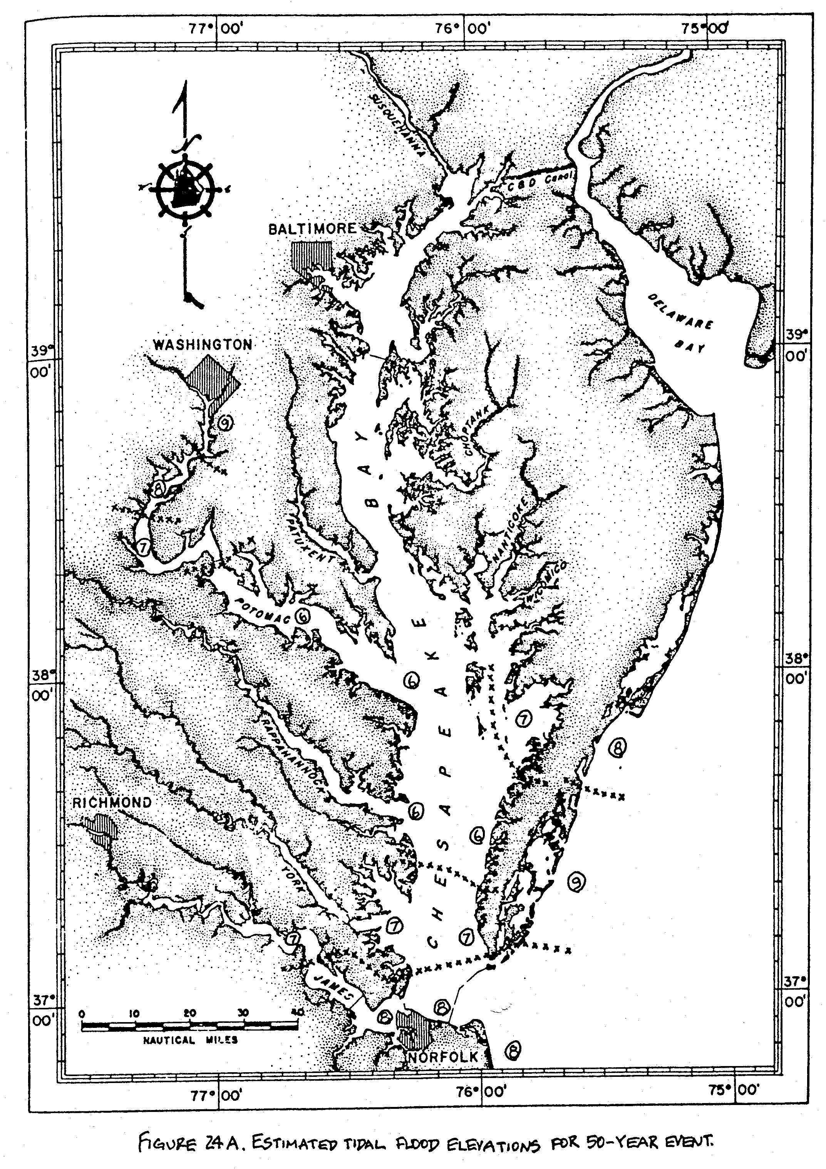

Appendix 12C-4 Virginia Coastal Maps Showing Predicted Water Surface Elevations

VIRGINIA DEPARTMENT OF TRANSPORTATION

Maps of the Costal Regions of Virginia

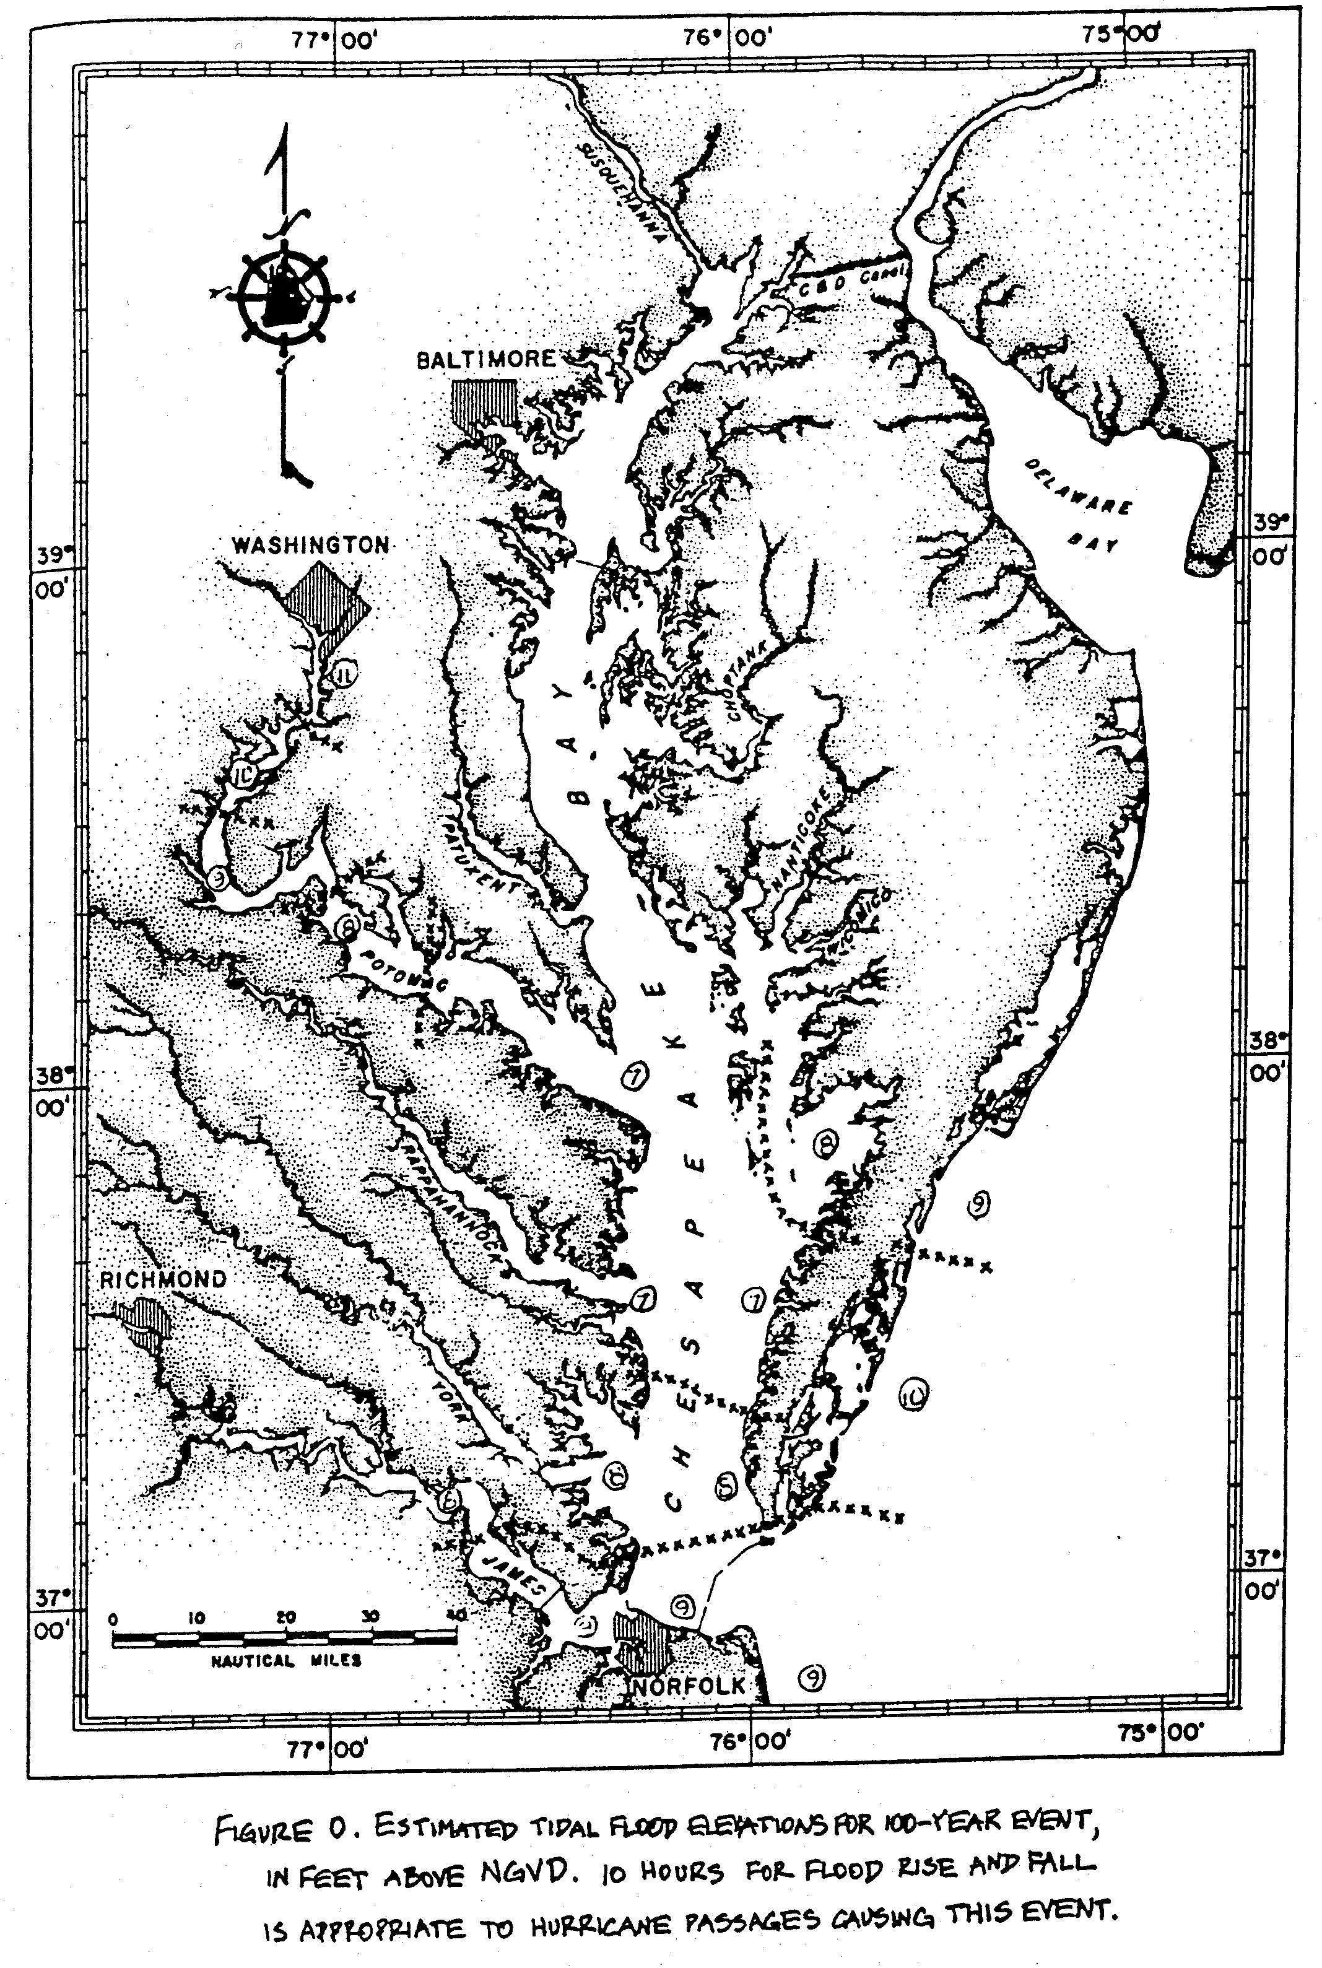

Appendix 12C-4 Virginia Coastal Maps Showing Predicted Water Surface Elevations

VIRGINIA DEPARTMENT OF TRANSPORTATION

Maps of the Costal Regions of Virginia

