- Storm Drains
TABLE OF CONTENTS
Chapter 9 - Storm Drains 9-1
9.1 Introduction 9-1
9.1.1 Objective 9-1
9.2 Design Policy 9-2
9.2.1 Definition 9-2
9.2.2 General Policies 9-2
9.3 Design Criteria 9-3
9.3.1 Design Frequency and Spread 9-3
9.3.2 Hydrology 9-5
9.3.3 Pavement Drainage 9-5
9.3.4 Inlet Design 9-5
9.3.5 Conduit Design 9-5
9.3.6 Access Hole Spacing 9-6
9.3.7 Hydraulic Grade Line 9-6
9.3.8 Unique Conditions 9-6
9.4 Design Concepts 9-7
9.4.1 System Planning 9-7
9.4.1.1 Required Data 9-7
9.4.1.2 Preliminary Layout 9-8
9.4.1.3 Special Considerations 9-8
9.4.2 Hydrology 9-9
9.4.2.1 Applicable Methods 9-9
9.4.2.2 Runoff Coefficients 9-9
9.4.2.3 Time of Concentration 9-9
9.4.2.4 Rainfall Intensity 9-9
9.4.3 Pavement Drainage 9-9
9.4.3.1 Introduction 9-9
9.4.3.2 Hydroplaning 9-10
9.4.3.3 Longitudinal Slope 9-10
9.4.3.4 Cross Slope 9-11
9.4.3.5 Curb and Gutter 9-11
9.4.3.6 Shoulder Curbs 9-12
9.4.3.7 Depressed Median/Median Barrier 9-12
9.4.3.8 Impact Attenuators 9-12
9.4.4 Gutter Flow 9-12
9.4.4.1 Introduction 9-12
9.4.4.2 Manning’s n for Pavement and Gutter Flow 9-13
9.4.4.3 Flow in Gutters 9-13
9.4.4.4 Composite Gutter Sections 9-14
9.4.4.5 Spread 9-14
9.4.5 Inlets 9-14
9.4.5.1 Inlet Types 9-14
9.4.5.1.1 Curb-Opening Inlets 9-15
9.4.5.1.2 Combination Inlets 9-15
9.4.5.1.3 Slotted Drain Inlets and Trench Drain Inlets 9-15
9.4.5.1.4 Grate Inlets 9-16
9.4.5.2 Inlet Locations 9-16
9.4.6 Inlet Capacity 9-16
9.4.6.1 General 9-16
9.4.6.2 Curb Inlets on Grade and Bypass Flow 9-17
9.4.6.3 Curb Inlets on Grade – Design Equations 9-17
9.4.6.4 Slotted Inlets on Grade 9-20
9.4.6.5 Curb Inlets in Sag 9-20
9.4.6.6 Combination Inlets on Grade or in a Sag 9-22
9.4.6.7 Flanking Inlets 9-22
9.4.7 Grate Inlets 9-23
9.4.7.1 Grate Inlets on Grade (Depressed Sections) 9-23
9.4.7.2 Grate Inlets in Sag (Depressed Sections) 9-24
9.4.7.3 Grate Inlets in Curb and Gutter Sections 9-24
9.4.8 Storm Drain Conduit 9-25
9.4.8.1 Introduction 9-25
9.4.8.2 Accumulation of Time in Conduit System 9-26
9.4.8.3 100-Year Pipe at Sag Point 9-26
9.4.8.4 Conduit Material Selection 9-27
9.4.8.5 Hydraulic Capacity 9-27
9.4.8.6 Minimum Grades 9-28
9.4.8.7 Maximum Grades 9-28
9.4.9 Hydraulic Grade Line 9-28
9.4.9.1 Introduction 9-28
9.4.9.2 Tailwater and Outfall Considerations 9-29
9.4.9.3 Conservation of Energy and Energy Losses 9-30
9.4.9.3.1 Conduit Friction Losses 9-32
9.4.9.3.2 Junction Losses 9-32
9.4.9.3.3 Plunging Losses 9-35
9.4.9.3.4 Inlet Shaping (IS-1) 9-35
9.4.9.3.5 Total Headlosses 9-35
9.5 Design Procedures and Sample Problems 9-36
9.5.1 Design Documentation 9-36
9.5.2 Spread Calculations 9-36
9.5.2.1 Uniform Cross Slope Procedure 9-36
9.5.2.1.1 Uniform Cross Slope Sample Problem 9-37
9.5.2.2 Composite Gutter Sections Procedure 9-38
9.5.2.2.1 Composite Gutter Sample Problem 9-38
9.5.3 Inlet Spacing Procedure 9-39
9.5.3.1 Curb Inlet on Grade Sizing Procedure 9-40
9.5.3.1.1 Curb Inlet on Grade Sample Problem 9-41
9.5.3.2 Curb Inlet in Sag Sizing Procedure 9-44
9.5.3.2.1 Curb Inlet in Sag Sizing Sample Problem 9-45
9.5.4 Grate in Sag Procedure 9-46
9.5.4.1 Grate in Sag Sample Problem 9-47
9.5.5 Storm Drain Conduit Design Procedure 9-48
9.5.6 Hydraulic Grade Line Procedure 9-49
9.5.6.1 Storm Drain Conduit Design and Hydraulic Grade Line Sample Problem 9-52
9.6 References 9-55
List of Tables
Table 9-1. Criteria for Inlet Design 9-3
Table 9-2. Design Frequencies for Storm Drain Conduit 9-3
Table 9-3. Access Hole Spacing 9-6
Table 9-4. Flanking Inlet Locations 9-23
Table 9-5. Joint Probability Analyses 9-29
List of Figures
Figure 9-1. Uniform Cross Section 9-13
Figure 9-2. Composite Cross Section 9-14
Figure 9-3. Curb Inlets 9-15
Figure 9-4. Slotted Drain Inlets 9-15
Figure 9-5. Grate Inlets 9-16
Figure 9-6. Curb Opening Inlets (Operating as an Orifice) 9-21
Figure 9-7. Flanking Inlets at a Sag Point 9-23
Figure 9-8. Use of Energy Losses in Developing a Storm Drain System 9-31
Figure 9-9. Angle Between Inflow and Outflow Pipes 9-33
Figure 9-10. Losses in Junction Due to Change in Direction of Flow Lateral 9-34
Figure 9-11. Storm Drain Layout Sample Problem 9-52
Figure 9-12. Storm Drain Design Form LD 229, Sample Problem 9-53
Figure 9-13. Hydraulic Grade Line Design Form LD 347, Sample Problem 9-54
List of Appendices
Appendix 9A-1 Definitions and Abbreviations
Appendix 9A-2 Symbols
Appendix 9B-1 LD-204 Stormwater Inlet Computations
Appendix 9B-2 LD-229 Storm Drain Design Computations
Appendix 9B-3 LD-347 Hydraulic Grade Line Computations
Appendix 9C-1 Flow in Triangular Gutter Sections
Appendix 9C-2 Flow Characteristic Curves (Straight Cross Slope with Curb)
Appendix 9C-3 Flow Characteristic Curves (24" Gutter) - VDOT Standard
Appendix 9C-4 Flow Characteristic Curves (Straight Cross Slope, 18" Gutter)
Appendix 9C-5 Flow Characteristic Curves (Straight Cross Slope 12" Gutter)
Appendix 9C-6 Flow Characteristic Curve (Roll Type Gutter)
Appendix 9C-7 Flow in Composite Gutter Sections
Appendix 9C-8 Ratio of Frontal Flow to Total Gutter Flow
Appendix 9C-9 Velocity in Triangular Gutter Sections
Appendix 9C-10 Grate Inlet Frontal Flow Interception Efficiency
Appendix 9C-11 Grate Inlet Side Flow Interception Efficiency
Appendix 9C-12 Grate Inlet Capacity in Sump Conditions (VDOT Version)
Appendix 9C-13 Performance Curve DI-1 in a Sump
Appendix 9C-14 Performance Curve DI-7 in a Sump
Appendix 9C-15 Performance Curve DI-12 in a Sump (Side Slope 3:1)
Appendix 9C-16 Performance Curve DI-12 in a Sump (Side Slope 6:1)
Appendix 9C-17 Curb-Opening and Slotted Drain Inlet Length for Total Interception
Appendix 9C-18 Curb-Opening and Slotted Drain Inlet Interception Efficiency
Appendix 9C-19 Depressed Curb-Opening Inlet Capacity in Sump Locations
Appendix 9C-20 Curb-Opening Inlet Capacity in Sump Locations
Appendix 9C-21 Curb-Opening Inlet Orifice Capacity for Inclined and Vertical Orifice Throats
Appendix 9C-22 Ratio of Frontal Flow to Total Flow in a Trapezoidal Channel
Appendix 9C-23 Manning's Solution for Flow in Storm Drains
Appendix 9C-24 Nomograph for Computing Required Size of Circular Drain for Full Flow (n=0.013 or 0.015)
Appendix 9C-25 Concrete Pipe Flow Nomograph
Appendix 9C-26 Values of Hydraulic Elements of Circular Section for Various Depths of Flow
Appendix 9D-1 P-1-7/8 and P-1-7/8-4 Grates - FHWA Classification
Appendix 9D-2 P-1-1/8 Grate - FHWA Classification

Storm Drains

Introduction

Objective
This chapter provides guidance on storm drain design and analysis. The quality of the final in-place system usually reflects the attention given to every aspect of the design as well as that accorded to the construction and maintenance of the facility. Most aspects of storm drain design such as system planning, pavement drainage, gutter flow calculations, inlet spacing, pipe sizing, and hydraulic grade line calculations are included in this chapter.
The design of a drainage system must address the needs of the traveling public as well as those of the local community through which it passes. The drainage system for a roadway traversing an urbanized region is more complex than for roadways traversing sparsely settled rural areas. This is often due to:
- The wide roadway sections, flat grades, shallow water courses, absence of side channels
- The potential for more costly property damage which may occur from ponding of water or from flow of water through built-up areas
- The fact that the roadway section must carry traffic, but also act as a channel to convey the water to a disposal point. Unless proper precautions are taken, this flow of water along the roadway could interfere with or possibly halt the passage of highway traffic
- The potential weakening of roadway base and subgrade due to saturation from extensive ponding
The primary goal of storm drain design is to limit the amount of water flowing on the travelway or ponding at sag points in the roadway grade to quantities that will not interfere with the passage of traffic for the design frequency storm. This is accomplished by:
- Placing inlets at such points and at such intervals to intercept flows and control spread
- Providing adequately sized storm drain conduit to convey flow from the inlets to a suitable outfall location
- Providing outfall conditions that do not cause excessive backwater throughout the storm drain system

Design Policy

Definition
For purposes of interpretation of the policies and procedures of VDOT, a storm drain or storm sewer system is defined as follows:
A storm drain system is a drainage system installed to carry stormwater runoff, consisting of two or more pipes in a series connected by one or more drop inlets. An exception to this general rule is: one or more cross drain pipes connected by one or more drop inlets, “hydraulically designed” to function as a culvert(s) and not connected to a storm drain system.

General Policies
Refer to Chapter 2 for general Department policies.
Storm drain systems should be designed for all urban sections in accordance with the criteria and guidelines provided herein. The design of the storm drain system should consider local stormwater management criteria and plans where applicable.

Design Criteria

Design Frequency and Spread
Table 9-1 provides recommended inlet design frequencies and allowable spreads for various roadway classifications.
Table 9-2 provides design frequencies for storm drain conduit.
Table 9-1. Criteria for Inlet Design
Roadway Classification |  | Design Speed  (mph) | Design Storm |  | Maximum Design Spread Width³  (ft)
 |  | Design Speed  (mph) | Frequency  (year^{1,} ²) | Intensity  (in./hr.) | Maximum Design Spread Width³  (ft)
Principal Arterial
With Shoulder | On Grade | ≤ 50 | 10 | Actual | Sh. Width + 3
With Shoulder | On Grade | > 50 | 10 | Actual | Sh. Width
With Shoulder | Sag Location⁵ | All | 10 | Actual | Sh. Width + 3
Without Shoulder | On Grade | ≤ 50 | N/A⁴ | 4 | ½ Driving Lane + Gutter Width (If Any)
Without Shoulder | On Grade⁵ | > 50 | 10 | Actual | ½ Driving Lane + Gutter Width (If Any)
Without Shoulder | Sag Location⁵ | ≤ 50 | N/A⁴ | 4 | ½ Driving Lane + Gutter Width (If Any)
Without Shoulder | Sag Location⁵ | > 50 | 50 | Actual | ½ Driving Lane + Gutter Width (If Any)
Minor Arterial, Collector, Local
With Shoulder | On Grade | ≤ 50 | N/A⁴ | 4 | Sh. Width + 3
With Shoulder | On Grade | > 50 | N/A⁴ | 4 | Sh. Width
With Shoulder | Sag Location | All | N/A⁴ | 4 | Sh. Width + 3
Without Shoulder | On Grade | All | N/A⁴ | 4 | ½ Driving Lane + Gutter Width (If Any)
Without Shoulder | Sag Location | All | N/A⁴ | 4 | ½ Driving Lane + Gutter Width (If Any)

Table 9-2. Design Frequencies for Storm Drain Conduit
Roadway Classification | Design Speed  (mph) | Design Storm Frequency  (year^{1,} ²)
Principal Arterial
With Shoulder | All | 25
Without Shoulder | ≤ 50 | 10
Without Shoulder | > 50 | 25
Minor Arterial, Collector, Local
With or Without Shoulder | All | 10

The following notes apply to the superscripts in Table 9-1 and Table 9-2:

Notes 1 through 3 are General Notes and should be applied to any functional classification roadway where the site conditions are comparable to the conditions described in each note.
1. At locations where the vertical alignment of the roadway creates a sag condition in either a depressed roadway section or a roadway section utilizing concrete barriers, and ponded water on the roadway can only be removed through the storm drain system, a 50-year storm frequency and the actual time of concentration should be used as the design criteria for both the drop inlet and the pipe system.
2. Federal Flood Insurance criteria dictate that the effects of the 100-year storm event (using the actual time of concentration) on buildings insured under the Flood Insurance Program must be investigated. Such cases should only be encountered where the roadway traverses a designated floodplain area containing insured buildings and the depth of water on the pavement is sufficient to overtop the curb and flow to the buildings.
3. The maximum design spread width may not be obtainable due to the pavement/shoulder slope and the height of the curb. In locations where the curb would be overtopped and water would escape the roadway section prior to achieving the maximum design spread width, the maximum depth of ponded water allowed adjacent to the curb for the design storm shall be curb height minus one (1) inch.
Notes 4 through 5 should normally be applied to the specific locations as noted in the criteria table.
4. At locations where it may be reasonably anticipated that the runoff from storm events with rainfall intensities greater than 4 inches per hour will overtax the drop inlet system to the point that excess flow will escape the roadway section and result in potential damage to the adjacent property and/or roadway right of way, the drop inlet system shall be analyzed for a check storm event with a rainfall intensity of 6.5 inches per hour.
If all of the runoff from the check storm event is found to be contained within the roadway section, both at the site and down grade, or if runoff escaping the roadway section is found to not be damaging to adjacent property, the drop inlet system may be used as originally designed under the general criteria. If the drop inlet system fails to meet the check storm criteria, it must be re-designed to accommodate the runoff from the check storm event.
5. Drop inlets in these locations are prone to clogging and are often located in areas where maintenance is difficult. To compensate for partial clogging, the computed slot length value should be adjusted by multiplying by a factor of two (2). The adjusted computed slot length value should then be used to determine the slot length specified on the plans.

Hydrology
The Rational Method is the recommended method for the design of storm drain systems. Drainage systems involving detention storage, pumping stations, and large or complex storm systems require the development of a runoff hydrograph. The Rational Method is described in Chapter 6, Hydrology.

Pavement Drainage
The desirable gutter profile grade for curbed pavements should not be less than 0.3 percent. The minimum gutter profile grade is 0.2 percent. The minimum pavement cross slope should not be less than 2 percent except during the occurrence of superelevation transition. The coincident occurrence of superelevation transitions and sag points or zero grades should be avoided.

Inlet Design
Drainage inlets should be sized and located to limit the spread of water on travel lanes in accordance with the design criteria specified in Section 9.3.1.
Grate inlets and local depression at curb opening inlets should be located outside the through travel lanes to minimize the shifting of vehicles attempting to avoid these areas. All inlet grates should be bicycle safe when used at locations where bicycle travel is anticipated.
Curb inlets are preferred to grate inlets because of their debris handling capabilities.
In locations where significant ponding may occur, such as sag vertical curves, it is recommended practice to place flanking inlets on each side of the inlet located at the low point in the gutter grade.

Conduit Design
Storm drains should have adequate capacity to accommodate runoff that will enter the system. They should be designed considering anticipated future development based on local land use plans. The minimum recommended conduit size for storm drainage pipe is 15-inch diameter or its equivalent for non-circular shapes. Where necessary, it will be permissible to use a 12-inch diameter pipe for laterals or initial pipe runs of 50 feet or less.
Where feasible, the storm drains should be designed to avoid existing utilities. A minimum velocity of 3 feet per second for the design storm is desirable in the storm drain in order to prevent sedimentation from occurring. Attention should be given to the storm drain outfalls to ensure that potential erosion is minimized.
The proposed storm drain system design should be coordinated with the proposed sequence of construction and maintenance of traffic plans on large construction projects in order to prevent unsafe ponding of water and to maintain an outlet throughout the construction of the project.

Access Hole Spacing
The maximum spacing of access structures whether manholes, junction boxes, or inlets should be as identified in Table 9-3 below.

Table 9-3. Access Hole Spacing
Pipe  Diameter  (in) | Maximum  Distance  (ft)
12 | 50
15 - 42 | 300¹
≥ 48 | 800
Note 1: This distance may be increased to 400
feet if the flow velocity for the design storm exceeds
5 feet per second and the flow depth for the design
storm is at least 25 percent of the pipe diameter.

Hydraulic Grade Line
The hydraulic grade line should be checked for all storm drain systems using the VDOT method described in Section 9.5.6. For the design storm, the storm drain should be designed such that the hydraulic grade line does not exceed any critical elevation. A critical elevation is defined as a level above which there would be unacceptable inundation of the travel way or adjoining property. This includes the tops of manholes, junctions, and inlets. Because the inlet design is predicated on free-fall conditions, they hydraulic grade line should not exceed an elevation that interferes with the operational conditions of any inlet because the inlet design is predicated on free-fall conditions. Refer to Table 9-2 for design and check storm frequencies.

Unique Conditions
There may be unique situations that do not permit the application of the criteria provided herein. In such cases, the designer should develop and document site-specific criteria indicating the rationale and factors used to determine such criteria.

Design Concepts

System Planning
The design of a storm drain system is generally a process that evolves as a project develops. The primary ingredients to this process are listed below in a general sequence by which they may be accomplished.
- Data collection (Section 9.4.1.1)
- Coordination with other agencies and adjacent projects
- Preliminary layout of project with respect to surrounding area
- Plan layout of storm drain system
    - Locate main outfall(s)
    - Determine direction of flow
    - Determine contributing drainage areas
    - Determine inlet type, spacing, and capacity (Sections 9.4.4.5, 9.4.5, 9.4.6, and 9.4.7)
    - Determine location of existing utilities
    - Determine location of existing storm drain systems
    - Locate additional access holes
- Size the conduit (Section 9.4.8)
- Perform hydraulic grade line analysis (Section 9.4.9)
- Prepare the plan
- Documentation of design (Section 9.5.1)

Required Data
The designer should be familiar with land use patterns and local comprehensive land use plans, the nature of the physical development of the area(s) to be served by the storm drainage system, the stormwater management plans for the area and the ultimate pattern of drainage (both by overland flow and by enclosed storm drains) to existing outfall locations. Furthermore, there should be an understanding of the characteristics of the outfall since it usually has a significant influence on the design of the storm drainage system. In environmentally sensitive areas, there may be water quality requirements to consider as well.
Actual surveys are the most reliable means of gathering the required data. Photogrammetric mapping has become one of the most important methods of obtaining the large amounts of data required for drainage design. Existing topographic maps are available from the U. S. Geological Survey and the National Resources Conservation Service. Many municipalities and some county governments and even private developers are also valuable sources for the kind of data needed to perform a proper storm drainage design. Governmental planning agencies should be consulted regarding development plans for the area in question. Often, in rapidly growing urban areas, the physical characteristics of an area to be served by a storm drainage system may change drastically in a very short time. In such cases, the designer is to anticipate these changes and consider them in the storm drainage design. Local comprehensive stormwater management plans and floodplain ordinances should also be considered in the storm drainage design process.
For detailed information of survey requirements, refer to the Virginia Department of Transportation Survey Instruction Manual.
When an existing storm drain is to be used, the designer should secure the following information:
- Invert elevations for all significant system components including conduits, drop inlets, catch basins, manholes, junctions, etc.
- Type and size of conduit
This information should extend beyond the limits of the proposed project, at least to the next access structure.

Preliminary Layout
Preliminary or working layouts, featuring the basic components of the intended design, are invaluable in the design development. After design completion, the layout facilitates documentation of the overall plan.
The following items may be included in the preliminary layout:
- General roadway layout (plan and profile)
- Basic hydrologic data
- Pertinent physical features
- Characteristics of flow diversion (if applicable)
- Detention features (if applicable)
- Outfall location and characteristics
- Surface features (topography)
- Utilities
- Proposed or existing foundations and structures
The layout should be used to develop a logical storm drain system that identifies and minimizes utility conflicts, avoids conflicts with structures and conforms to the proposed construction sequencing and maintenance of traffic plans. Additionally, the layout can be used to identify locations for necessary soil borings.

Special Considerations
Primary consideration in the planning of the storm drainage system should be directed toward avoidance of utilities and deep excavations. In many cases, traffic must be maintained on existing roadways or temporary bypasses may be constructed with temporary drainage provided during the construction phase. Consideration should be given to the actual trunk line layout and its constructibility with regards to the maintenance of traffic plan. Some instances may dictate a trunk line on both sides of the roadway with very few cross laterals while other instances may dictate a single trunk line. Such decisions are usually based on economics but may be controlled by existing utilities or other physical features.
The designer should accommodate all natural drainage areas contributing to the system and minimize interference to natural drainage patterns. Except in unusual circumstances, a storm drain system should discharge to a single outfall.
Generally, storm drainage pipes should not decrease in size in a downstream direction regardless of the available pipe slope. However, if found necessary, any decrease in pipe size should not exceed 6 inches.

Hydrology

Applicable Methods
Refer to Chapter 6, Hydrology, for detailed description of hydrologic methods. The recommended method used for storm drain design is the Rational Method. The subsequent text in this chapter assumes use of the Rational Method for estimating peak discharge rates.

Runoff Coefficients
Recommended runoff coefficients for various types of land surfaces are provided in Chapter 6, Appendix 6E-1.

Time of Concentration
When determining the discharge for inlet size and spacing, use the estimated time of concentration for the drainage area to the location of the inlet unless otherwise indicated by the criteria identified in Table 9-1. When determining the discharge for conduit sizing, use the longest travel time to the upstream end of the conduit under consideration.

Rainfall Intensity
The rainfall intensity should be based on the time of concentration identified in Section 9.4.2.3 or the limiting value identified in Table 9-1. Refer to Chapter 6 for determining the appropriate rainfall intensity when using the actual time of concentration.

Pavement Drainage

Introduction
A chief objective in the design of a storm drain system is to move any accumulated water off the travelway as quickly and efficiently as possible. Where the flow is concentrated, the design objective should be to minimize the depth and horizontal extent of that flow. Appropriate longitudinal and transverse slopes can serve to move water off the travel way to minimize the depth of sheet flow and thus minimize the potential for hydroplaning. An objective of the design should be to establish efficient drainage in conjunction with the geometric and pavement design.

Hydroplaning
Refer to FHWA Hydraulic Engineering Circular No. 22, “Urban Drainage Design Manual” for a discussion on hydroplaning. NCHRP research project I-29, "Improved Surface Drainage of Pavements," suggests that hydroplaning conditions can develop for relatively low vehicle speeds and at low rainfall intensities for storms that frequently occur each year. Analysis methods developed through this research effort provide guidance in identifying potential hydroplaning conditions. Unfortunately, it is virtually impossible to prevent water from exceeding a depth that would be identified through this analysis procedure as a potential hydroplaning condition for a wide pavement section during high intensity rainfall. Some of the primary controlling factors for hydroplaning are:
- Vehicle speed
- Tire conditions (pressure and tire tread)
- Pavement micro and macro texture
- Roadway geometrics (pavement width, cross slope, grade)
- Pavement conditions (rutting, depressions, roughness)
Speed appears as a significant factor in the occurrence of hydroplaning, therefore, it is considered to be the driver's responsibility to exercise prudence and caution when driving during wet conditions (Highway Drainage Guidelines, Volume 9, Storm Drain Systems). In many respects hydroplaning conditions are analogous to ice or snow on the roadway.
Designers do not have control over all of the factors involved in hydroplaning. However, many remedial measures can be included in development of a project to reduce hydroplaning potential. The following is provided as guidance for the designer as practical measures to consider in accordance with the AASHTO Policy on Geometric Design of Highways:
Pavement Sheet Flow
- Maximize transverse slope
Gutter Flow
- Limit spread on the travelway (inlet spacing)
- Maximize interception of gutter flow above superelevation transitions
- Limit duration and depth of ponded water in sag locations
- Limit depth and duration of overtopping flow

Longitudinal Slope
A minimum longitudinal slope is more important for a curbed pavement section than for an uncurbed pavement section since a curbed pavement section is susceptible to the spread of stormwater adjacent to the curb. Flat slopes on uncurbed pavements can also lead to a spread problem if vegetation is allowed to build up along the pavement edge.
Desirable gutter grades should not be less than 0.3 percent for curbed pavements with an absolute minimum of 0.2 percent. Minimum grades can be maintained in very flat terrain by use of a rolling profile. To provide adequate drainage in sag vertical curves, a minimum slope of 0.3 percent should be maintained within 50 feet of the low point in the curve. This is accomplished where the length of the curve divided by the algebraic difference in the grades is equal to or less than 165 feet per percent (ft/%). Although spread is not usually a problem at crest vertical curves, on extremely flat curves a similar minimum slope should be provided to facilitate drainage.

Cross Slope
The current AASHTO Policy on Geometric Design is standard practice and should be consulted prior to any deviation from the recommendations contained herein.
The USDOT, FHWA (FHWA-RD-79-30, 31, 1979) reports that cross slopes of 2 percent have little effect on driver effort in steering, especially with power steering, or on friction demand for vehicle stability. Thus, the minimum recommended cross slope is 2 percent.
A careful check should be made of designs to minimize the number and length of flat pavement sections in cross slope transition areas. Consideration should be given to increasing cross slopes in sag vertical curves, crest vertical curves, and in sections of flat longitudinal grades where needed. Where curbs are used, depressed gutter sections can be effective at increasing gutter capacity and reducing spread on the travelway. Where curbs or raised barriers are used at superelevation transitions, inlets should be located at the upstream side of the transition where the cross slope is at 1 percent.
Generally, shoulders should be sloped to drain away from the travelway except in areas of narrow raised medians.

Curb and Gutter
Curbing at the outside edge of pavements is normal practice for low-speed, urban highway facilities. It serves several purposes, including containing the surface runoff within the roadway section and directing it away from adjacent properties, preventing erosion, providing pavement delineation and enabling the orderly development of property adjacent to the roadway. Curbs may be either barrier or mountable type.
A curb and gutter forms a triangular channel that can be an efficient hydraulic conveyance facility, which can convey runoff of a lesser magnitude than the design flow without impact of the traffic. When a design storm flow occurs, there is a spread or widening of the conveyed water surface. This spread of the water surface includes not only the gutter width, but also parking lanes or shoulders, and portions of the travelway. The designer, as discussed in Section 9.4.4.5, must limit this spread.
Where practicable, it is desirable to intercept runoff from cut slopes and other areas draining toward the roadway before it reaches the curb and gutter section. This minimizes the deposition of sediment and other debris on the roadway and reduces the amount of water that must be carried in the gutter section.

Shoulder Curbs
Shoulder curbs may be appropriate to protect fill slopes from erosion caused by water from the roadway pavement. See Location and Design Instructional and Information Memo (I&IM) LD (D) 150 for details.
Shoulder curbs may be appropriate at bridge ends where concentrated flow from the bridge deck would otherwise run down the fill slope. This section of curb should be long enough to include any pavement transitions. Shoulder curbs are not required on the high side of superelevated sections or adjacent to barrier walls on high fills. Drop inlets are the preferred means of intercepting flow along these sections. Drop inlets should be located in accordance with the criteria in Table 9-1 for spread and frequency. A limiting factor that sometimes dictates the location of shoulder curb drop inlets is the requirement that the depth of the design flow at the curb should be limited to one (1) inch below the top of the curb.

Depressed Median/Median Barrier
Depressed medians are commonly used to separate opposing lanes of traffic on divided highways. It is preferable to slope median areas and inside shoulders to a center depression to prevent drainage from the median area from running across the travel way. Where median barriers are used particularly at horizontal curve locations with associated superelevations, it is necessary to provide inlets and connecting storm drain pipes to collect the water that accumulates against the barrier. Slotted drains adjacent to the median barrier and in some cases weep holes in the barrier can also be used for collection of the water.

Impact Attenuators
The location of impact attenuator systems should be reviewed to determine the need for drainage structures in these areas. With impact attenuator systems such as G.R.E.A.T. or C.A.T. systems, it is necessary to have a clear or unobstructed open area as traffic approaches the point of impact in order to allow a vehicle to impact the system head on. If the impact attenuator is placed in an area where superelevation or other grade separation occurs, grate inlets and/or slotted drains may need to be placed to prevent water from running through the clear open area and crossing the travelway. Curb, curb-type structures or swales cannot be used to direct water across this clear open area as these types of structures could cause vehicle vaulting in the area of the impact attenuator system.

Gutter Flow

Introduction
Gutter flow calculations are necessary in order to relate the quantity of flow in the curbed channel to the spread of water on the shoulder, parking lane, or travel lane. Gutter flow calculations can be performed using equations in the following sections or using nomographs provided in Appendices 9C-1 through 9C-7. Computer programs, such as the FHWA HEC-12 or HY25, are often used for this computational process.

Manning’s n for Pavement and Gutter Flow
It is recommended that an n-value of 0.015 be used in the computational analysis for pavement and gutter flow.

Flow in Gutters
Flow in a gutter operates under the principles of open channel flow. Gutter capacity is a function of the geometric shape of the gutter, the roughness of the pavement surface, the longitudinal slope, and the allowable spread.
The gutter capacity for a uniform cross slope (as shown in Figure 9-1) may be computed using Equation 9.1.

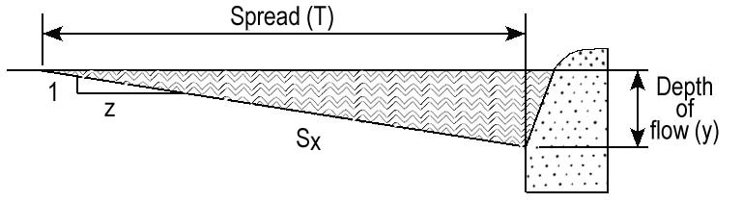
Cross Slope,
Figure 9-1. Uniform Cross Section
(9.1)
Where:
Q = Gutter flow rate, cfs
n = Manning’s roughness coefficient
S = Longitudinal (gutter) slope, ft/ft
S_{x} = Pavement cross slope, ft/ft
T = Spread width, ft

Composite Gutter Sections
The designer may choose to use a composite section. A composite section may be one in which the concrete gutter maintains a steeper cross slope than the travel lanes as shown in Figure 9-2.

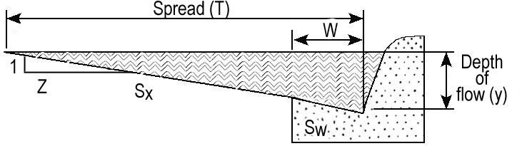
Figure 9-2. Composite Cross Section

The steeper gutter slope for the width of the gutter pan (W) increases the gutter capacity. The capacity of composite gutter sections for varying hydraulic controls, such as spread, depth, cross slope, and longitudinal slope can be found using Appendices 9C-1, and 9C-3 through 9C-8 and is used in the inlet spacing procedure.

Spread
The spread is a function of discharge, cross section geometry, section roughness, and longitudinal slope. The spread increases with the length of pavement and/or increase in contributing drainage area.
Spread calculations are used to determine curb inlet spacing on roadways. The calculated spread for the design discharge should not exceed the allowable spread. Refer to Table 9-1 for allowable spread criteria. The spread in a uniform gutter section may be calculated using Equation 9.2.
(9.2)
The spread in various types of composite sections may be determined by using the appropriate chart in Appendices 9C-2 through 9C-6.

Inlets

Inlet Types
Standard details for various inlet types can be found in the VDOT Road and Bridge Standards, Volume 1. Where practicable, the designer should select an appropriate standard detail that accommodates the hydraulic and geometric needs.
Inlets used for the drainage of highway surfaces can be divided into four major classes as follows:
- Curb-Opening inlets
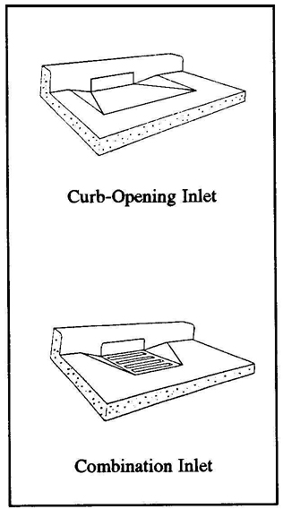
Figure 9-3. Curb Inlets
Figure 9-3. Curb Inlets

- Combination inlets
- Slotted drain inlets
- Grate inlets

Curb-Opening Inlets
These inlets are vertical openings in the curb covered by a top slab. They can convey large quantities of water and debris. They are preferable to grates for pavement drainage especially at locations where grate inlets would be hazardous for pedestrians or bicyclists.

Combination Inlets

Inlets with curb opening and grate combinations are common. The designer should ignore the interception capacity of the grate when computing the capacity of a combination inlet. Combination inlets are sometimes used in order to place the inlet chamber and storm drain trunk line under the gutter pan and away from the sidewalk or utility space.
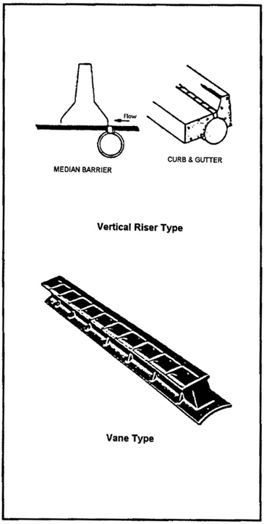
Figure 9-4. Slotted Drain Inlets

Slotted Drain Inlets and Trench Drain Inlets
Slotted drain inlets consist of a slotted opening with bars perpendicular to the opening. Slotted inlets function as weirs with flow entering from the side. They can be used to intercept sheet flow, collect gutter flow with or without curbs, modify existing systems to accommodate roadway widening or increased runoff, and reduce ponding depth and spread at grate inlets. They can also be used to intercept flow in areas of limited space such as a retrofit in a problem area. The designer should ensure that maintenance access is provided with the design for this type of inlet. The two types of slotted inlets in general use are the vertical riser type and the vane type. VDOT does not have a standard for this type of inlet.
Trench drains are usually comprised of a long narrow grate built on a tray or preformed trench. They have uses similar to slotted drains.

Grate Inlets
Typically, grate inlets are used in depressed medians, graded areas, ditches, at the toe of fill in urban areas and other areas not subject to traffic. Grates should be bicycle safe where bike traffic is anticipated and structurally designed to handle the appropriate loads when they do need to be located in areas subject to traffic.
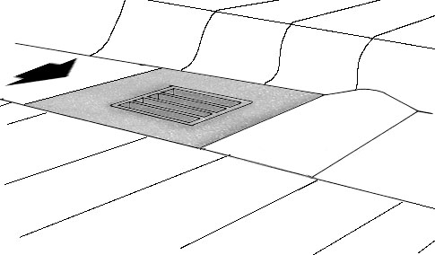
Figure 9-5. Grate Inlets

Inlet Locations
Inlets are required at locations to collect runoff within the design controls specified in Table 9-1. In addition, there are a number of locations where inlets may be necessary with little regard to contributing drainage area. These locations should be marked on the plans prior to any computations regarding discharge, spread, inlet capacity, or bypass. Examples of such locations are as follows:
- Sag points in the gutter grade
- Either side of sag point inlet (flanking inlets)
- Upstream of median breaks, entrance/exit ramp gores, crosswalks and street intersections
- Immediately upstream and downstream of bridges
- At 1% cross slope upstream of cross slope reversals
- On side streets at intersections, where flow is approaching the main line
- Behind curbs, shoulders, or sidewalks to drain low areas or to intercept concentrated flow
- Where necessary to collect snow melt
Inlets should not be located in the path where pedestrians are likely to walk.

Inlet Capacity

General
Inlets should first be located on the preliminary layout. The designer should locate inlets starting from the crest of the gutter grade and working down grade to the sag point. The location of the first inlet from the crest can be found by determining the length of pavement and the area back of the curb sloping toward the roadway that will generate the design runoff. The design runoff can be computed as the maximum allowable flow in the curbed channel that will meet the design criteria for spread of water on the travelway as specified in Table 9-1.
Where the contributing drainage area consists of a strip of land parallel to and including a portion of the highway, the first inlet location can be calculated as follows:
(9.3)
Where:
L = Distance from the crest, ft
Q_{t} = Maximum allowable flow, cfs, as determined by allowable spread
C = Composite runoff coefficient for contributing drainage area
W = Width of contributing drainage area, ft
i = Rainfall intensity for design frequency, in/hr

If the drainage area contributing to the first inlet from the crest is irregular in shape, trial and error will be necessary to match a design flow with the maximum allowable spread.

Curb Inlets on Grade and Bypass Flow
Curb-opening inlets are effective in the drainage of highway pavements where flow depth at the curb is sufficient for the inlet to perform efficiently. Curb openings are relatively free of clogging tendencies and offer little interference to traffic operation. The throat of a typical curb inlet may be depressed below the normal gutter line to improve efficiency. This additional depression is referred to as “local depression.”
Curb inlets on grade should be designed either to intercept all of the approach flow or most of the approach flow, allowing only a small portion to bypass the inlet and carry on downgrade to the next inlet. Generally, allowing for bypass flow maximizes the use of the inlet opening and is acceptable if the resultant bypass flow does not cause the allowable spread to be exceeded downstream. Department practice is not to allow bypass flow immediately up grade of the following locations:
- Intersections
- Superelevation transitions
- Ramps
- Bridges
To space successive down grade inlets, it is necessary to compute the amount of flow which will be intercepted by the inlet (Q_{i}) and subtract it from the total gutter flow to compute the bypass flow. The bypass flow from the first inlet is added to the computed flow to the second inlet. The second inlet should then be located and sized to meet the spread criteria defined in Table 9-1 using the combined flow.

Curb Inlets on Grade – Design Equations
Computer programs are often used for the following calculations. The length of curb-opening inlet required for total interception of gutter flow on a pavement section with a straight cross slope is expressed by:
(9.4)
Where:
L_{T} = Curb opening length required to intercept 100% of
the gutter flow, ft
Q = Gutter flow rate, cfs
n = Manning’s roughness coefficient (0.015 for VDOT applications)
S = Longitudinal slope, ft/ft (along flowline)
S_{e} = Equivalent cross slope, ft/ft

Appendix 9C-17 provides a graphical solution of Equation 9.4.
If no local depression is applied, the equivalent cross slope (S_{e}) is equal to the pavement cross slope (S_{x}). If a local depression is applied the effective cross slope (S_{e}) is determined using Equation 9.5.
(9.5)
Where:
S_{e} = Equivalent cross slope, ft/ft
S_{x} = Cross slope of the pavement, ft/ft
S’_{w}= Cross slope of gutter measured from cross slope of the pavement, ft/ft
=
W = Width of local depression, ft
a = Depth of total inlet depression, inches [measured from point where cross slope (S_{x}) intercepts face of curb]
=
S_{w} = Normal cross slope of area defined by “W”, ft/ft
E_{o} = Ratio of flow in the depressed section to the total gutter flow

VDOT standard inlets (DI-2, DI-3 and DI-4) used in curb and gutter sections apply one inch of local depression for each one-foot width of the concrete gutter pan. For inlets used in curb only sections, a local depression of one inch is applied over a horizontal distance of one foot from the face of the curb. For applications of local depression for other types of inlets, see the standard drawings in the VDOT Road and Bridge Standards.

The efficiency ratio (E_{o}) may be determined using Equation 9.6 or by using Appendix 9C-8.
(9.6)
S_{w} = Normal cross slope of area defined by “W”, ft/ft
Where:
E_{o} = Ratio of depression flow to total gutter flow
K_{w} = Conveyance of the depressed gutter section, cfs
K_{o} = Conveyance of the gutter section beyond the depression, cfs

The conveyance, K, of any portion of the gutter section may be computed using Equation 9.7. The curb height is ignored when considering the wetted perimeter.
(9.7)
Where:
K = Conveyance of cross section, cfs
A = Cross section flow area, sq. ft
n = Manning’s roughness coefficient
P = Wetted perimeter, ft

The designer may select a standard curb opening length that is equal to or longer than the required length, L_{T}. If the provided length is longer than that required length using Equation 9.4, there will be no bypass flow for the design discharge and the designer should proceed to the next inlet down grade.
If the designer selects an inlet that is shorter than the required length computed by Equation 9.4, there will be bypass flow at the inlet location. The efficiency of curb-opening inlets shorter than the length required for total interception is expressed by:
(9.8)
Where:
E = Curb opening efficiency
L = Curb opening length provided, ft
L_{T} = Curb opening length required for 100% interception, ft

Appendix 9C-18 provides the graphical solution of Equation 9.8.
The intercepted flow is then computed as:
(9.9a)
Where:
Q_{i} = Intercepted flow, cfs
E = Curb opening efficiency
Q = Total flow approaching inlet, cfs

The bypass flow (Q_{b}) is the difference between the total approach flow and the intercepted flow.
(9.9b)
If bypass flow occurs, the designer must ensure that the computed bypass flow is included in the spread calculation and the inlet capacity calculation for the next inlet down grade.

Slotted Inlets on Grade
Slotted inlets can be used on curbed or uncurbed sections and are usually located in areas of limited space. They should be placed longitudinally in the gutter. Slotted inlets should generally be connected into inlet structures or manholes so they will be accessible to maintenance personnel in case of clogging or freezing.
The determination of required length of slotted drain for total interception is the same as outlined in Section 9.4.6.3 for curb inlets on grade except that no gutter depression is applied to slotted drain inlets (Equation 9.4). Similarly, if the provided length of slotted drain is shorter than the required length for total interception, the calculation of intercepted flow is determined using Equations 9.8, 9.9a, and 9.9b.

Curb Inlets in Sag
The capacity of a curb-opening inlet in sag depends on water depth at the curb, the curb opening length, the height of the curb opening and the local depression. The inlet operates as a weir to depths equal to the curb opening height and as an orifice at depths greater than 1.4 times the opening height. At depths between 1.0 and 1.4 times the opening height, flow is in a transition stage.
The equation for the interception capacity of a depressed curb-opening inlet operating as a weir is:
(9.10)
Where:
Q_{i} = Intercepted flow, cfs
C_{w} = Weir coefficient, use 2.3
L = Length of curb opening, ft
W = Width of local depression, ft
d = Depth of water at curb measured from a point where the normal pavement cross slope (S_{x}) would intercept the curb face, ft

The weir coefficient and 1.8-multiplier reflect the effective flow conditions at the lip of the transition to the inlet depression. Thus, the effective depth is considered from the water level to the gutter line, not the depressed throat of the inlet.
The weir equation for curb-opening inlets without depression is
(9.11)
Where:
Q_{i} = Intercepted flow, cfs
C_{w} = Weir coefficient, use 3.0
L = Length of curb opening, ft
d = Depth of water at curb measured from a point where the normal pavement cross slope (S_{x}) intercepts the curb face, ft

The depth limitation for operation as a weir is less than or equal to 1.2h, where h is the height of the curb opening. The weir coefficient applies to the inlet throat.
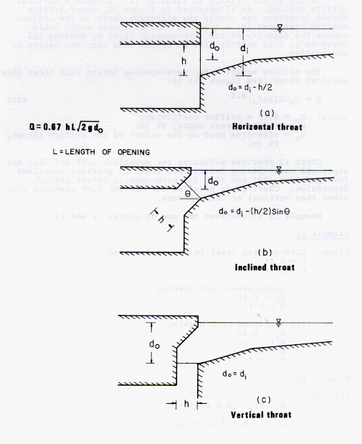
Figure 9-6. Curb Opening Inlets (Operating as an Orifice)

Curb-opening inlets operate an orifice at depths greater than approximately 1.4h. Typical curb opening inlet throat configurations are shown in Figure 9-6. Throat configuration (b) is typical of VDOT curb inlets. The interception capacity can be computed by:

(9.12)
Where:
C_{o} = Orifice coefficient, use 0.67
h = Height of curb-opening orifice, ft
A = Clear area of opening, sq. ft.
d_{o} = Effective head on the center of the orifice throat, ft
For VDOT standard curb inlets,
d_{i} = Depth of flow at the curb including inlet depression (if present), ft
h = Throat opening measured normal to the throat opening, ft

Equation 9.12 is applicable to depressed and undepressed curb-opening inlets.
Appendices 9C-19, 9C-20, and 9C-21 provide graphical solutions for the capacities of curb inlets in sags.

Combination Inlets on Grade or in a Sag
If combination curb opening and grate inlet or a slotted drain and grate inlet is used, it should be designed as an on grade curb or slotted drain inlet without consideration of the grate due to its propensity to clog.

Flanking Inlets
At major sag points significant ponding may occur. It is recommended practice to place a minimum of one flanking inlet on each side of the inlet at the sag point as shown in Figure 9-7. The flanking inlets should be placed to limit ponding in the flatter slope approaches to the sag inlet and to act in relief of the sag inlet should it become clogged. Refer to Table 9-4 for recommended flanking inlet locations. The typical location for flanking inlets is 50 feet each side of the sag point.

Table 9-4. Flanking Inlet Locations
Distance to flanking inlet in sag vertical curve locations using depth at curb criteria (ft).
d↓ K→ | 20 | 30 | 40 | 50 | 70 | 90 | 110 | 130 | 160 | 167 | 180 | 220
0.1 | 20 | 24 | 28 | 31 | 37 | 42 | 47 | 51 | 56 | 58 | 60 | 66
0.2 | 28 | 34 | 40 | 44 | 52 | 59 | 66 | 72 | 79 | 81 | 84 | 93
0.3 | 34 | 42 | 49 | 54 | 64 | 73 | 81 | 88 | 97 | 99 | 103 | 114
0.4 | 40 | 49 | 57 | 63 | 75 | 85 | 94 | 102 | 113 | 116 | 120 | 133
0.5 | 45 | 55 | 63 | 72 | 84 | 95 | 105 | 114 | 127 | 129 | 134 | 148
0.6 | 49 | 60 | 69 | 77 | 92 | 104 | 115 | 125 | 139 | 142 | 147 | 163
0.7 | 53 | 65 | 75 | 84 | 99 | 112 | 124 | 135 | 150 | 153 | 159 | 176
0.8 | 57 | 69 | 80 | 89 | 106 | 120 | 133 | 144 | 160 | 163 | 170 | 188
NOTES: 1. × = (200dK)^{0.5}, where × = distance from the low point
2. Drainage maximum K = 167(A/%).
3. d = depth at curb (ft).

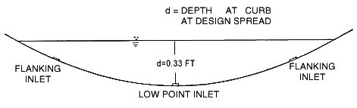
Figure 9-7. Flanking Inlets at a Sag Point

Grate Inlets

Grate Inlets on Grade (Depressed Sections)
Grate inlets on grade are used in depressed medians and ditches. VDOT standard inlets 5, 7A, 12A and 12C are typically used for this purpose. It is preferable to use a small backup berm or dike (as shown in the Road and Bridge Standards, Volume 1) located just downstream of the inlet. The berm ensures the interception of the on grade flow and causes the inlet to function as a sag inlet. The designer needs to indicate on the plans that a back-up berm is required and provide details for the berm, including the height of the berm. For grate inlets on-grade on roadways or in depressed medians and ditches without the use of a back-up berm, use the procedures presented in FHWA publication, HEC-12 or HEC-22.
The computation methodology for grate inlets in sag is presented in Section 9.4.7.2. These computations are often done with a computer program, such as FHWA HY-22 or Visual Urban.

Grate Inlets in Sag (Depressed Sections)
When grates are used in a sag, assume that the efficiency of the grate will be reduced by 50% due to clogging with debris. This is accomplished by dividing the effective perimeter and open area of the grate by two and using the resulting values in the computational process.
A grate inlet in sag operates as a weir up to a depth of about five (5) inches and as an orifice for depths greater than about 17 inches. Between these depths, a transition from weir to orifice flow occurs. The capacity of a grate inlet operating as a weir is:
(9.13)
Where:
C_{w} = Weir coefficient, use 3.0
P = Effective perimeter of grate, ft
The effective perimeter of the grate in sag is 2(L+W), when the grate is used in a depressed median or ditch and 2W +L when adjacent to a curb, where (L) is the length of grate and (W) is the width of grate.
d = Depth of water at curb measured from the normal cross slope gutter flow line, ft

The capacity of a grate inlet operating as an orifice is:
(9.14)
Where:
C_{o} = Orifice coefficient, use 0.67
A = Effective clear open area of grate, sq. ft.
g = Gravitational acceleration, 32.2 ft/s²

Appendices 9C-12 through 9C-16 provide nomograph solutions of Equations 9.13 and 9.14 for various grate sizes and provides dimensions for standard VDOT grate type inlets. The effects of grate size on the depth at which a grate operates as an orifice are apparent from the charts. Transition from weir to orifice flow results in interception capacity less than that computed by either weir or the orifice equation. This capacity can be approximated by drawing in a curve between the lines representing the perimeter and net area of the grate to be used.

Grate Inlets in Curb and Gutter Sections
To determine the efficiency of grate inlets in curb and gutter sections, use the procedures presented in FHWA publications, HEC-12 or HEC-22.

Storm Drain Conduit

Introduction
This section describes the methodology for computing conduit sizes. Section 9.5.5 presents the VDOT recommended method of calculation, which may be performed using the design form LD-229 provided in Appendix 9B-2.
After the preliminary locations of inlets, connecting pipes, and outfalls are determined, the next step is the computation of the rate of discharge to be carried by each reach of the storm drain, and the determination of the size and slope of pipe required to convey this discharge. This is done by starting at the upstream reach, calculating the discharge and sizing the pipe, then proceeding downstream, reach by reach, to the point where the storm drain connects with other drains or the outfall. If possible, the conduit depth should be set based on either the minimum depth of the inlet for the pipe size or the minimum cover for the pipe. The grade of the storm drain pipe should approximate the road grade if the conduit is a trunkline paralleling the roadway.
When the primary trunk line passes through a junction (structure) or when two or more secondary trunk lines converge and are carried forward in a single primary trunk line, it is preferable to match invert elevations of inflow pipes, with the invert elevation of the outflow pipe set at least 0.1 feet lower than the lowest inflow pipe invert elevation. This is applicable both for pipes of the same size or different sizes. The designer is cautioned to ensure that, when using the matching invert concept, the minimum cover requirements for the particular pipe sizes are met. The invert elevations of lateral pipes entering the junction that are significantly smaller in size than the trunk line can be established based on that required to provide the required flow capacity in the lateral pipe or to meet minimum cover requirements.
Matching crown line elevations in a junction may at times provide a slightly improved hydraulic grade line performance for one specified design storm. However, the preferred method of matching inverts provides a more efficient flow transition over a wide range of discharges. In areas where the grade of the storm sewer conduit is steeper than the finished grade profile, matching invert elevations, in lieu of matching crown line elevations, can also reduce the depth to which the pipe must be laid.
The rate of discharge at any point in the storm drain is not necessarily the sum of the inlet flow rates of all inlets above that section of storm drain. It is generally less than this total. The time of concentration is most influential and as the time of concentration grows larger, the rainfall intensity to be used for the design decreases. In some cases, where a relatively large drainage area with a short time of concentration is added to the system, the peak flow may be larger using the shorter time even though the entire drainage area is not contributing. The prudent designer will be alert for unusual conditions and determine which time of concentration controls for each pipe segment.
For ordinary conditions, storm drains should be sized on the assumption that they will flow full or practically full under the design discharge but will not flow under pressure head. Actual tailwater conditions may cause the system to flow full, especially in low-lying areas. The Manning's formula is recommended for determining the initial size or capacity of the conduit. Hydraulic grade line calculations are then made to check the effects of tailwater conditions and energy losses through the system.
Refer to Table 9-2 for design frequencies for storm drain conduit. In locations such as depressed sections and underpasses where ponded water can be removed only through the storm drain system, a 100-year frequency storm should be considered to design the storm drain that drains the sag point.

Accumulation of Time in Conduit System
The Rational Method is used to determine peak discharges through the storm drain conduit network assuming the limitations of the method are reasonable. It is necessary to compute the incremental travel time through the system and accumulate this time to adjust the time of concentration that is used to compute the peak discharge for each consecutive segment of the conduit. The design rainfall intensity is based on the estimated accumulated time to the upstream node of the conduit run to be sized. Refer to Chapter 6, Hydrology, for the rainfall intensity equation for the Rational Method. Travel through each length of conduit is computed using the uniform flow velocity in the conduit. The velocity in the storm drain should be based on partial flow or full flow, whichever is applicable. The designer should also check for conditions that would create full flow in the system; such as, the hydraulic grade line.

100-Year Pipe at Sag Point
Where a storm drain system drains a major sag point in a depressed roadway section or a roadway section with concrete barriers, and ponded water on the roadway can only be removed through the storm drain, it should be sized to accommodate the runoff from a 50-year frequency rainfall using the actual time of concentration.
At these locations and many others where excessive ponded water on the pavement could be reasonably expected to cause personal injury or significant property damage, the storm drain system shall be analyzed for a check storm event with a 100-year frequency, using the actual time of concentration. If the ponded depths of water on the pavement from the check storm event are determined to cause insignificant risk, the storm drain system may be used as originally designed. If the storm drain system fails to meet the check storm criteria, it must be re-designed to accommodate the runoff from the check storm event.
This can be done by computing the bypass occurring at each upstream inlet during a 100-year rainfall and accumulating it at the sag point. The inlet at the sag point as well as the storm drain conduit leading from the sag point must be sized to accommodate this additional bypass within the criteria established. To design the conduit leading from the sag point, it may be helpful to convert the additional bypass created by the 100-year rainfall into an equivalent CA, which can be added to the design CA. This equivalent CA can be approximated by dividing the 100-year bypass by I₁₀ in the conduit at the sag point.
Some designers may want to design separate systems in order to prevent the above ground system from draining into a depressed area. This concept may be more costly but in some cases may be justified. Each case must be evaluated on its own merits and the impacts and risk of flooding a sag point assessed.

Conduit Material Selection
Refer to I&IM LD (D) 121 for a list of allowable materials for the storm drain pipe. The type of material is allowable dependent upon the functional classification of the roadway.

Hydraulic Capacity
The most widely used formula for determining the hydraulic capacity of storm drains for gravity and pressure flows is the Manning's formula and it is expressed by the following equation:
(9.15)
Where:
V = Mean velocity of flow, fps
n = Manning's roughness coefficient
R = Hydraulic radius, ft =
A = Flow area, sq. ft.
P = Wetted perimeter, ft
S = Slope of the energy grade line, ft/ft

In terms of discharge, by using the Continuity Equation (Q = AV), the above formula becomes:
(9.16)
Where:
Q = Rate of flow, cfs
A = Flow area, sq. ft.

For storm drains flowing full, the above equations become:
(9.17)
Where:
D = Diameter of pipe, ft

Appendices 9C-23, 24, and 25 provide nomographs for solution of Manning's formula for full flow in circular storm drains. Appendix 9C-26 can be used to determine partial flow depth in storm drains through the ratio of various hydraulic elements, such as velocity (V/V_{full}) and discharge (Q/Q_{full}). The typical design process will use either a computer program or “Feild’s Hydraulics Calculator” (circular slide rule) to determine the pipe size and grade.

Minimum Grades
All storm drains should be designed such that velocities of flow will not be less than 3 feet per second at design flow. For very flat grades the general practice is to design components so that flow velocities will increase progressively throughout the length of the pipe system. The storm drainage system should be checked to be sure there is sufficient velocity in all of the drains to deter settling of particles. Minimum slopes required for a velocity (V) can be calculated using Equation 9.18 (Manning's formula). A slope of 0.1 percent is considered the minimum slope for constructibility.
(9.18)

Maximum Grades
Slopes that incur uniform flow velocities in excess of 10 feet per second should be avoided because of the potential for abrasion. Slopes in excess of 16 percent are not preferred because of the need for anchor blocks. In steeper terrain, large elevation differences can be accommodated using drop structures. See DDM #2 in Chapter 15, Drainage Design Instructions, for details.

Hydraulic Grade Line

Introduction
This section describes the methodology for computing the hydraulic grade line. Section 9.5.6 presents the VDOT recommended method of calculation, which may be performed with design form LD-347 provided in Appendix 9B-3.
The hydraulic grade line (HGL) is the last important feature to be established relating to the hydraulic design of storm drains. This grade line aids the designer in determining the acceptability of the proposed system by establishing the elevations to which water will rise in the structures (inlets, manholes, etc.) along the system when the system is operating under for the recommended design frequency storm.
In general, if the HGL is above the crown of the pipe, pressure flow hydraulic calculations are appropriate. Conversely, if the HGL is below the crown of the pipe, open channel flow calculations are appropriate. A special concern with storm drains designed to operate under pressure flow conditions is that inlet surcharging and possible access hole lid displacement can occur if the hydraulic grade line rises above the surface elevation. A design based on open channel conditions must be carefully planned as well, including evaluation of the potential for excessive and inadvertent flooding created when a storm event larger than the design storm pressurizes the system. As hydraulic calculations are performed, frequent verification of the existence of the desired flow condition should be made. Storm drain systems can often alternate between pressure and open channel flow conditions from one section to another.
The detailed methodology employed in calculating the HGL through the system begins at the system outfall with the tailwater elevation. If the outfall is an existing storm drain system, the HGL calculation must begin at the outlet end of the existing system and proceed upstream through the existing system, then upstream through the proposed system to the initial inlet. The same considerations apply to the outlet of a storm drain as to the outlet of a culvert.

Tailwater and Outfall Considerations
For most design applications, the tailwater will either be above the crown of the outlet or can be considered to be between the crown and critical depth. In determining the HGL, begin with the actual tailwater elevation or an elevation equal to 0.8 times the diameter of the outlet pipe (0.8D), whichever is higher.
When estimating tailwater depth on the receiving stream, the designer should consider the joint or coincidental probability of two events occurring at the same time. For the case of a tributary stream or a storm drain, its relative independence may be qualitatively evaluated by a comparison of its drainage area with that of the receiving stream. A short duration storm, which causes peak discharges on a small watershed, may not be critical for a larger watershed. Also, it may safely be assumed that if the same storm causes peak discharges on both watershed, the peaks will be out of phase. To aid in the evaluation of joint probabilities, refer to Table 9-5. Joint Probability Analyses.
Table 9-5. Joint Probability Analyses
Watershed Area  Ratio | Frequencies For Coincidental Occurrence
Watershed Area  Ratio | 10-Year Design |  | 100-Year Design
Watershed Area  Ratio | Main Stream | Tributary | Main Stream | Tributary
10 000 TO 1 | 1  10 | 10  1 | 2  100 | 100  2
1 000 TO 1 | 2  10 | 10  2 | 10  100 | 100  10
100 TO 1 | 5  10 | 10  5 | 25  100 | 100  25
10 TO 1 | 10  10 | 10  10 | 50  100 | 100  50
1 TO 1 | 10  10 | 10  10 | 100  100 | 100  100

For a storm drain system, in the table above, the area ratio refers to the size ratio of the drainage area of the outfall channel (mainstream) to the drainage area of the storm drain system (tributary). Using this approach suggests that two possible conditions should be checked. For example, for an area ratio of 100:1, a 10-year design could be considered as the higher of a 10-year storm on the storm drain system with a 5-year tailwater or a 5-year storm on the storm drain system with a 10-year tailwater.

Conservation of Energy and Energy Losses
When computing the hydraulic grade line, the calculations proceed from the system outfall upstream to each structure on the system. The calculation of the hydraulic grade line is based on conservation of energy as shown in Equation 9.19, which includes major and minor energy losses within the system.
(9.19)
Where:
HGL_{us} = Elevation of the hydraulic grade line at upstream structure, ft
h_{m} = Summation of minor head losses such as junctions, bends etc., ft
h_{f} = Friction head loss, ft
HGL_{ds} = Elevation of hydraulic grade line at downstream structure, ft

Major head losses result from friction within the pipe. Minor head losses include those attributed to the following:
- Junctions
- Exits
- Entrances
- Bends in pipes
- Access holes
- Conflict pipes
- Plunging flow
- Expansions and contractions
- Appurtenances such as weirs, diverters, valves and meters
When computing the hydraulic grade line, the design discharge and the effective conduit velocity should be used in computing the minor head losses. If the HGL is below the crown line of the conduit, partial-flow or normal velocity of the conduit (based on the design discharge) should be used in computing the losses. If the HGL is above the crown line of the conduit, the full flow velocity (the design discharge divided hby the cross sectional area of the conduit) should be used in computing the losses. Since it is not known where the HGL will fall (above or below the crown line of the conduit) the designer should first calculate the HGL assuming partial-flow or normal velocity in the conduits. If the computed HGL is below the crown line of the conduits, the assumption of normal velocity and the computed HGL is verified. If the computed HGL is above the crown line of the conduits, then full flow velocity should be assumed and the HGL recalculated.
Energy losses used in analyzing a storm drain system are indicated in Figure 9-8.
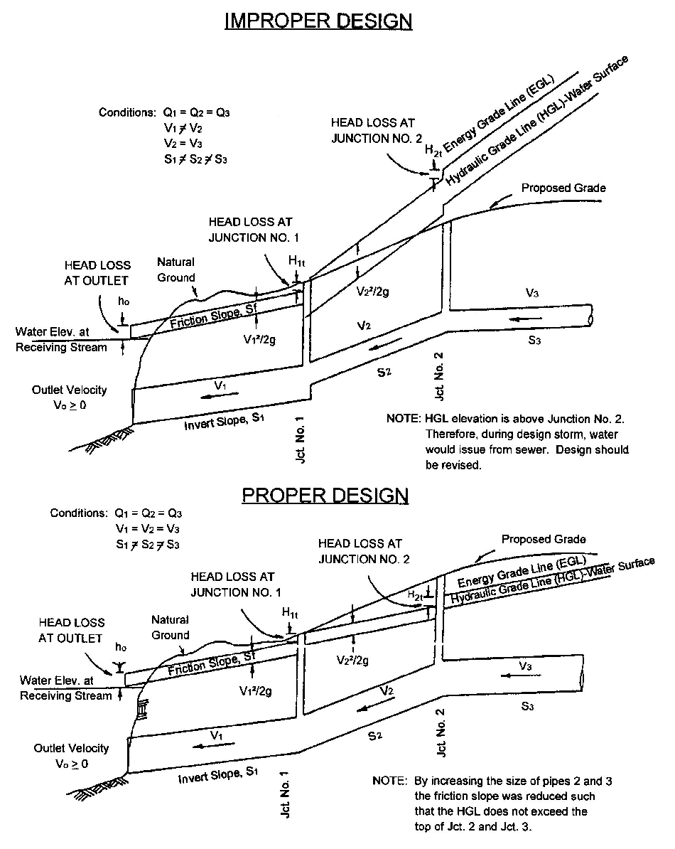

Figure 9-8. Use of Energy Losses in Analyzing a Storm Drain System

Conduit Friction Losses
The friction slope is the energy slope in feet per foot for that run. The friction loss is simply the energy gradient multiplied by the length of the run. Energy losses from pipe friction may be determined by rewriting the Manning's equation with terms as previously defined:
(9.20)
Then the head losses due to friction may be determined by the formula:
(9.21)
Where:
H_{f} = Friction head loss, ft
S_{fo} = Friction slope, ft/ft
L = Length of outflow pipe, ft

Junction Losses
Junction losses are the sum of entrance, exit and bend losses. The total junction losses are given in Equation 9.22.
(9.22)
Where:
H_{t} = Total junction losses, ft
H_{i}, H_{o}, H_{Δ} = Entrance, exit, and bend losses, respectively, ft

9.4.9.3.2.1 Entrance (Expansion) Losses
Equation 9.23 represents the entrance loss at a junction.
(9.23)
Where:
H_{i} = Entrance head loss, ft
V_{i} = Velocity in the inlet conduit, fps
g = Gravitational acceleration, 32.2 ft/s²
K_{e} = Entrance loss coefficient (VDOT K_{e} = 0.35). Where more than one inlet pipe is present, use the velocity of the one with the greatest momentum (Q*V).

9.4.9.3.2.2 Exit (Contraction) Losses
The exit loss, H_{o}, is a function of the change in velocity in the outlet of the pipe as shown in Equation 9.24.
(9.24)
Where:
H_{o} = Exit loss, ft
V_{o} = Velocity in the outlet conduit, fps
K_{o} = Exit loss coefficient (VDOT K_{o} = 0.25) (A K_{o} value of 0.3 should be used when computing the loss at the initial inlet of the system)

9.4.9.3.2.3 Bend Losses
The loss at bends in the conduit system is shown in Figure 9-9 and is computed with Equation 9.25. Bend losses are applied to a junction in which the outgoing conduit is at an angle greater than 0º to the incoming conduit. The sharper the bend (approaching 90º) the more severe the energy loss becomes. Conduits should not be designed to have bend angles greater than 90º.
(9.25)
Where:
H_{Δ} = Headloss at a bend, ft
K = Bend loss coefficient
V_{i} = Velocity in the inlet conduit, fps

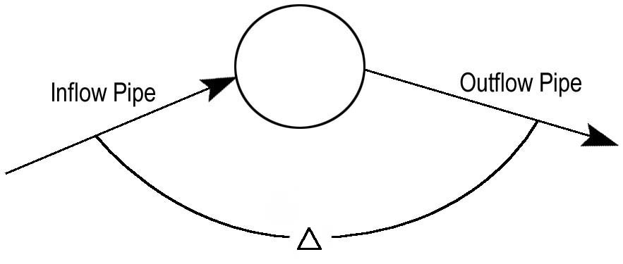
Figure 9-9. Angle Between Inflow and Outflow Pipes
VDOT recommended values of K for change in direction of flow in laterals can be found on design form LD-347, Appendix 11B-3. Figure 9-10 shows a graphical representation of the bend loss coefficient (K) to change in direction of flow lateral.

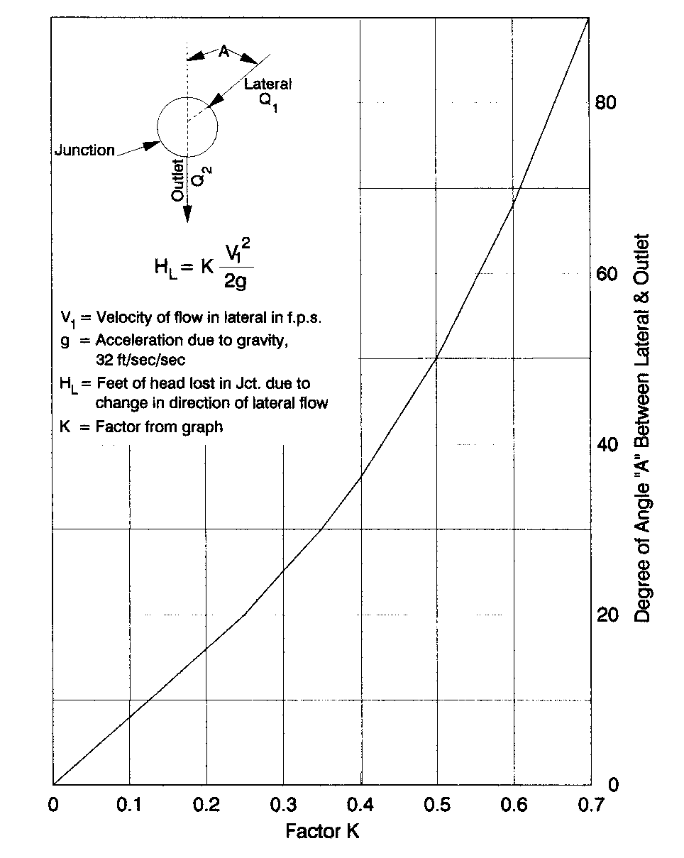
Figure 9-10. Losses in Junction Due to Change in Direction of Flow Lateral

Plunging Losses
Plunging losses are applied if the surface inlet inflow is 20 percent or more of the total flow through the junction or a lateral conduit enters a junction with its invert elevation above the crown line elevation of the outgoing trunkline conduit and the flow from the lateral is 20 percent or more of the total flow through the junction. Plunging flow losses increase the total junction loss by 30 percent as defined by Equation 9.26.
(9.26)

Inlet Shaping (IS-1)
Inlet shaping refers to how the invert is shaped within the access hole to provide smooth flow through the structure. Applying VDOT Standard IS-1, inlet shaping, reduces the total junction losses by 50 percent as defined by Equation 9.27 if there are no plunging losses or Equation 9.28 if there are plunging losses.
(Where no plunging losses occur) (9.27)
or
(Where plunging losses occur) (9.28)
VDOT Standard IS-1, inlet shaping, should be specified in all structures where a change of flow direction occurs, intersecting flows occur and any other location where there is concern with continuity of flow through a structure.

Total Headlosses
The total headlosses are computed by adding the conduit friction loss to the total junction losses as represented by Equation 9.29.
(9.29)
Where:
H = Total headloss, ft

Design Procedures and Sample Problems
The typical design process would perform all of the calculations in Section 9.5 by the use of computer programs with the possible exception of the hydraulic grade line procedure.

Design Documentation
The following items should be included in the drainage documentation.
- Computation forms for inlets (LD-204), conduits (LD-229), hydraulic grade lines (LD-347)
- Drainage area map
- Information concerning outfalls and tailwaters, existing storm drains, and other design considerations
- A storm drain schematic
- Output from FHWA HEC-12 and/or HY25 computer programs.

Spread Calculations

Uniform Cross Slope Procedure
Condition 1: Find spread, given gutter flow, Q.
Step 1: Determine the following parameters:
Longitudinal slope (S)
Cross slope (S_{x})
Manning's roughness coefficient (n)
Step 2: Compute spread (T), using Equation 9.2.
Alternatively, use the chart contained in Appendix 9C-2. The procedure for using this chart is provided below.
Step 3: Draw a perpendicular line from gutter flow (Q) to longitudinal or gutter slope (S).
Step 4: Draw a perpendicular line from longitudinal or gutter slope (S) to cross slope (S_{x}).
Step 5: Draw a perpendicular line from cross slope (S_{x}) to intersect with Width (x). Spread (T) will be the value at the intersection with Width (x).
Condition 2: Find gutter flow (Q), given spread (T).
This procedure is similar to Condition 1. Solve Equation 9.1 for discharge, Q, or work the procedure for Condition 1 in reverse.

Uniform Cross Slope Sample Problem
Condition 1: Find spread given the following:
Step 1: Determine the following parameters.
Gutter flow, Q = 5 cfs
Longitudinal slope, S = 0.0035 ft/ft
Cross slope, S_{x} = 0.0208 ft/ft
Manning's roughness coefficient, n = 0.015
Step 2: Compute Spread (T), using Equation 9.2.
Refer to the chart in Appendix 9C-2 to view the graphical solution.
Condition 2: Find the gutter capacity given the following:
Step 1: Determine the following parameters.
Allowable spread, T = 14 ft
Longitudinal slope, S = 0.0035 ft/ft
Cross slope, S_{x} = 0.0208 ft/ft
Manning's roughness coefficient, n = 0.015

Step 2: Compute gutter flow (Q), using Equation 9.1.

Composite Gutter Sections Procedure
The capacity of a composite section at an allowable spread can be calculated using Equation 9.1 by breaking the problem into three triangular sections; however, it may be more expedient to use the appropriate nomograph contained in Appendices 9C-2 through 9C-6.
Condition 1: Find spread, given gutter flow.
Step 1: Determine input parameters, including longitudinal slope (S), cross slope (S_{x}), gutter pan width (W), Manning's n, and gutter flow (Q).
Step 2: Draw a line from gutter flow (Q) to longitudinal or gutter slope (S).
Step 3: Draw a line from longitudinal or gutter slope (S) to roadway cross slope (S_{x}).
Step 4: Draw a perpendicular line from cross slope (S_{x}) to intersect with Width (x). Spread (T) will be the value at the intersection with Width (x).
Condition 2: Find gutter flow, given spread.
Step 1 Determine input parameters, including spread (T), cross slope (S_{x}), longitudinal slope (S), gutter pan width (W), and Manning's n.
Step 2 Perform the procedure given in Condition 1 in reverse.
Step 3 The gutter flow is the point at which the line crosses the “Discharge” axis.
Note: The chart contained in Appendix 9C-7 can also be used to calculate the spread in a composite gutter section.

Composite Gutter Sample Problem
Condition 1: Using the chart in Appendix 9C-3, determine Spread (T).
Step 1: Determine input parameters.
Longitudinal slope (S) = 0.04 ft/ft
Cross slope (S_{x}) = 0.0208 ft/ft
Depressed section width (W) = ft
Manning's n = 0.015
Gutter flow (Q) = 3.8 cfs
Note: Appendix 9C-3 is only applicable for gutter pan width,
W = 2 ft.

Steps 2 and 3: Using Appendix 9C-3, draw perpendicular lines using the information contained in Step 1 and using the procedure for Condition 1 in Section 9.5.2.2.
Step 4: Determine the Spread (T).
T = 7.5 feet

Inlet Spacing Procedure
In order to design the location of the inlets for a given project, information such as a layout or plan sheet suitable for outlining drainage areas, road profiles, typical cross sections, grading cross sections, superelevation diagrams and contour maps are necessary. The inlet computation sheet, LD-204, Appendix 9B-1, should be used to document the computations. The procedure follows:
Step 1: Locate high points (crests) and low points (sags) and mark on the plans the location of inlets, which are necessary even without considering any specific drainage area. These would include sags with flankers, curb returns from roads draining onto an intersection, and superelevation transitions prior to cross slope reversal when the cross slope is 1 percent.

Step 2: Starting at the high point, work towards the low point.

Step 3: From the drainage map, select a trial drainage area approximately 300 to 500 feet below the high point and delineate the area including any area that may come over the curb (offsite area). Where practical, large offsite areas should be intercepted before reaching the roadway.

Step 4: Indicate the proposed inlet number in Col. 1 and in Col. 2 the type of inlet. Col. 3 will be filled in after the inlet is sized. In Col. 4 show the station and reference the baseline.

Step 5: Compute the drainage area in acres and enter in Col 5.

Step 6: Determine the C-value for each land use as described in Chapter 6 and enter in Col. 6.

Step 7: Calculate the product C and A for each land use and enter in Col. 7.
Step 8: Sum the CA products and enter in Col. 8.
Step 9: Depending on the classification of roadway and type of inlet, determine time of concentration (t_{c}) based on the criteria defined in Table 9-1. Determine the rainfall intensity (i) based on the classification of roadway as defined in Table 9-1 and enter in Col. 9.
Step 10: Calculate discharge (Q) by multiplying Col. 8 and Col. 9 and enter in Col. 10. The discharge (Q) in Col. 10 is also entered in the total discharge (Q_{T}) Col. 12 for the first inlet.
Step 11: Determine gutter slope or longitudinal slope (S) and cross slope (S_{x}) and enter in Col. 13 and 14, respectively.
Step 12: Using the appropriate Appendix 9C-2 through 9C-7, or Equation 9.2, determine spread (T) and enter in Col. 15.
If spread (T) exceeds the allowable spread, based on the functional classification of roadway, the designer should consider reducing the drainage area to the inlet. This eliminates the need to account for carryover discharge when designing the next downstream inlet unless the designer allows carryover discharge and/or the designer is required to evaluate the check storm. In that instance, the designer should proceed to the curb inlet on grade sizing procedure in Section 9.5.3.1.
If the designer is sizing a sag inlet, refer to the curb inlet in sag sizing procedure in Section 9.5.3.2.

Curb Inlet on Grade Sizing Procedure
This procedure uses the same computations as described under Section 9.5.2, Inlet Spacing Procedure. The results can be entered in LD-204, Appendix 9B-1.
Step 1: Repeat Steps 5 through 12 from the inlet spacing procedure presented in Section 9.5.3.
Step 2: Determine the gutter pan width (W) and enter in Col. 16.
Step 3: Compute the ratio of flow in the depressed section (W) to the spread (T), and enter in Col. 17.
Step 4: Determine the gutter pan cross slope (S_{w}) and enter in Col. 18. For VDOT standard gutter pan, this is 1 inch per foot (0.083 ft/ft). Compute the ratio of S_{w}/S_{x} and enter in Col. 19.
Step 5: Determine the ratio of frontal flow to total gutter flow (E_{o}) using Appendix 9C-8 and enter in Col. 20.
Step 6: Compute the total inlet depression (a) and enter in Col. 21.
a = (S_{w}-S_{x})12W+Local Depression
Step 7: Compute the cross slope of the gutter pan including local depression (S’_{w}) and enter in Col. 22.
Step 8: Compute the equivalent cross slope (S_{e}), using Equation 9.5, and enter in Col. 23.
S_{e} = S_{x} + S’_{w} (E_{o})
Step 9: Compute the required inlet length (L_{T}) for total interception using Appendix 9C-17 or Equation 9.4 and enter into Col. 24.
If no bypass flow is allowed, round the required inlet length (L_{T}) up to a nominal dimension of at least L_{R}. Refer to Road and Bridge Standards to determine nominal lengths available for curb opening inlets. The inlet sizing is complete and the designer can proceed to the next inlet by repeating Steps 1 through 9. If bypass flow is to be considered, proceed to Step 10.
Step 10: Determine the inlet length to be specified (L) to be used and enter in Col. 25.
Step 11: Compute and enter in Col. 26.
Step 12: Determine capture efficiency (E) using Appendix 9C-18 or Equation 9.8 and enter in Col. 27.
Step 13: Compute the flow intercepted (Q_{i}), using Equation 9.9a, by multiplying Col. 12 and Col. 27 and enter in Col. 28.
Step 14: Calculate bypass flow or carryover flow (Q_{b}), using Equation 9.9b, by subtracting Col. 28 from Col. 12 and enter in Col. 29.
Step 15: The carryover flow (Q_{b}) from the first inlet is entered in Col. 11 for the next downstream inlet.
Step 16: Repeat Steps 1 through 16 for each successive inlet until analyzing the sag inlet. Note: When computing the total gutter flow (Q_{T}), add the carryover flow (Q_{b}) from the previous upstream inlet.

Curb Inlet on Grade Sample Problem
Find: The curb inlet length required for 100 % interception and what the bypass flow would be if a 6 ft slot were used.
Step 1: Repeat Steps 5 through15 from the inlet spacing procedure presented in Section 9.5.3.
Given: Q = 2 cfs, n = 0.015, S = 0.01 ft/ft, S_{x} = 0.0208 ft/ft, W = 2 ft,
S_{w} = 0.0833 ft/ft, local inlet depression = 2 in.

Use Appendix 9C-3 to find Spread (T) = to 7.6 ft.
Step 2: Determine the ratio of flow in the depressed section (W) to the Spread (T), .
Step 3: Determine the ratio of frontal flow to total gutter flow (E_{o}) using Appendix 9C-8 and enter in Col. 21.
Using Appendix 9C-8, E_{o} = 0.69
Step 4: Compute the total inlet depression (a) and enter in Col. 22.
a = (S_{w} - S_{x})12W + Local Depression
a = (0.0833-0.0208)(12)(2)+2 = 3.5 in
Step 5: Compute the cross slope of the gutter pan including local depression (S’_{w}) and enter in Col. 23.
Step 6: Compute the equivalent cross slope (S_{e}), using Equation 9.5, and enter in Col. 24.
S_{e} = S_{x} + S’_{w} (E_{o})
S_{e} = 0.0208 + (0.146)(0.69)= 0.121 ft/ft

Step 7: Compute the required inlet length (L_{T}) for total interception using Appendix 9C-17 or Equation 9.4 and enter into Col. 25.

If no bypass flow is allowed, round the required inlet length (L_{T}) up to a nominal dimension of at least L_{R}. Refer to Road and Bridge Standards to determine nominal lengths available for curb opening inlets. The inlet sizing is complete and the designer can proceed to the next inlet by repeating Steps 1 through 7. If bypass flow is to be considered, proceed to Step 8.

The minimum length for 100% interception would be L_{T} = 8.9 ft.
Step 8: Determine the inlet length to be specified (L) to be used and enter in Col. 26. In this instance the design would round up to the nearest nominal inlet length as provided by the Road and Bridge Standards.

If no bypass flow were allowed, a standard length of 10 ft would be appropriate.

Using an inlet length of 6 ft would require proceeding to Step 9.

Step 9: Compute and enter in Col. 26.
Step 10: Determine capture efficiency (E) using Appendix 9C-18 or Equation 9.8 and enter in Col. 27.
Step 11: Compute the flow intercepted (Q_{i}) by multiplying Col. 12 and Col. 27 and enter in Col. 28.

Q_{i} = EQ_{T}
Q_{i} = 0.87 x 2 = 1.74 cfs

Step 12: Calculate bypass flow or carryover flow (Q_{b}), using Equation 9.9b, by subtracting Col. 28 from Col. 12 and enter in Col. 29.
Q_{b} = Q_{T}– Q_{i}
Q_{b} = 2–1.74 = 0.26 cfs
Step 13: The carryover flow (Q_{b}) from the first inlet is entered in Col. 11 for the next downstream inlet.

Curb Inlet in Sag Sizing Procedure
Step 1: Determine the allowable depth of ponding (d) and enter in Col. 30.
This is the depth above the undepressed gutter line to the water surface associated with the allowable spread and should be at least 1 inch below the top of curb.
Step 2: Determine the height of the curb inlet opening (h) and enter in Col. 31. Calculate the ratio of d/h and enter in Col. 32.
If , the inlet is in weir control.
If , the inlet is transitioning to orifice control and design would proceed to Step 4.
Step 3: Compute the required length (L_{R}) when the inlet is in weir flow by rearranging Equation 9.10 as follows and enter in Col. 25, then proceed to Step 5.
(9.29)
Where:
Q = Total flow reaching inlet, cfs
C_{w} = Weir coefficient, use 2.3.
d = Allowable ponding depth, ft
W = Inlet depression width, ft

Step 4: Compute the required length (L_{R}) when the inlet is in orifice flow by rearranging Equation 9.12 as follows and enter in Col. 25, then proceed to Step 5.
(9.30)
Where:
Q = Total flow reaching inlet, cfs
C_{o} = Orifice coefficient = 0.67
D = Depth of opening, ft. The depth will vary slightly with the inlet detail used.
g = Acceleration due to gravity = 32.2, ft/s²
h = Effective head at the centroid of the inlet opening, ft

Step 5: Select a standard inlet length (L) that is greater than the required length (L_{R}).

Step 6: If the area behind the inlet is prone to flooding or there is the potential for property damage, a check storm intensity of i = 6.5 in/hr will be used to evaluate all inlets down to the sag inlet in question. If the inlet can handle the check storm without flooding then the previous design need not be changed. However, if there is flooding, it may be necessary to double the inlet size. Refer to Table 9-1.

Curb Inlet in Sag Sizing Sample Problem
Find: The required inlet length assuming a factor of safety of 2.
Given: Q = 3 cfs, allowable spread = 8 ft, S_{x} = 0.0208 ft/ft, Inlet depression = 2 in, Standard length increment =2 ft, W = 2 ft, Curb height = 6 in, slot height = 5 in.
Step 1: Determine the allowable depth of ponding (d) and enter in Col. 30. This is the depth above the undepressed gutter line to the water surface associated with the allowable spread and should be at least 1 inch below the top of curb.
The depth to 1 inch below the top of curb = 6 - 1 = 5 in (0.42 ft).
The depth of allowable ponding = T(S_{x})
Depth of ponding is less than 1 inch below the top of curb (0.34<0.42)
Step 2: Determine the height of the curb inlet opening (h) and enter in Col. 31. Calculate the ratio of d/h and enter in Col. 32.
If , the inlet is in weir control
If , the inlet is transitioning to orifice control and design would proceed to Step 4
0.80<1.2, therefore proceed to Step 3

Step 3: Compute the required length (L_{R}) when the inlet is in weir flow by rearranging Equation 9.10 as follows and enter in Col. 25, then proceed to Step 5.
Step 4: Compute the required length (L_{R}) when the inlet is in orifice flow by rearranging Equation 9.12 as follows and enter in Col. 25, then proceed to Step 5.
Step 5: Select a standard inlet length (L) that is greater than the required length (L_{R}).
Using a factor of safety of 2, the required length (L_{R}) is 5.95 ft. Use an actual inlet length (L) of 6 ft.
Step 6: If the area behind the inlet is prone to flooding or there is the potential for property damage, a check storm intensity of i = 6.5 in/hr will be used to evaluate all inlets down to the sag inlet in question. If the inlet can handle the check storm without flooding then the previous design need not be changed. However, if there is flooding, it may be necessary to double the inlet size. Refer to Table 9-1.

Grate in Sag Procedure
Step 1: Choose a grate and determine standard dimensions to use as a basis for calculations. These dimensions usually include open area and perimeter.
Step 2: Determine an allowable ponding depth (d) for the inlet location. If used in a median ditch, the depth should be the medium depth minus a freeboard or the height of the backup berm. The designer should consider the available depth when evaluating median ditches for roads in superelevation.
Step 3: Determine the capacity of a grate inlet operating in weir control using Appendices 9C-12 through 9C-16 or Equation 9.13. Under weir conditions, the grate perimeter controls the capacity. To account for clogging, assume one-half of the perimeter of the inlet is available.
Step 4: Determine the capacity of a grate inlet operating under orifice control using Appendices 9C-12 through 9C-16 or Equation 9.14. Under orifice conditions, the grate area controls the capacity. To account for clogging, assume one-half of the grate opening area is available.
Step 5: Compare the calculated capacities from Steps 3 and 4 and choose the lower value as the design capacity.

Grate in Sag Sample Problem
Determine the capacity of a DI-7 inlet with a Type I grate.
Given: Allowable depth of ponding above grate = 2 ft.
Step 1: Choose a grate and determine standard dimensions to use as a basis for calculations. These dimensions usually include open area and perimeter.
Using Appendix 9C-12, determine:

Grate open area = 6 sq. ft.
Grate perimeter = 12.8 ft.

Step 2: Determine an allowable ponding depth (d) for the inlet location. If used in a median ditch, the depth should be the medium depth minus a freeboard or the height of the backup berm. . The designer should consider the available depth when evaluating median ditches for roads in superelevation
Allowable depth of flow above grate = 2 ft
Step 3: Determine the capacity of a grate inlet operating in weir control using the Appendices 9C-12 through 9C-16 or Equation 9.13. Under weir conditions, the grate perimeter controls the capacity. To account for clogging, assume one-half of the perimeter of the inlet is available.
Q_{i} = C_{w}Pd^{1.5}
= 3.0(12.8)(0.5)(2)^{1.5}
= 54 cfs
Step 4: Determine the capacity of a grate inlet operating under orifice control using the Appendices 9C-12 through 9C-16 or Equation 9.14. Under orifice conditions, the grate area controls the capacity. To account for clogging, assume one-half of the grate opening area is available.
Q_{i} = C_{o}A(2gd)^{0.5}
= 0.67(6)(0.5)[2(32.3)(2)]^{0.5}
= 23 cfs
Step 5: Compare the calculated capacities from Steps 3 and 4 and choose the lower value as the design capacity.
Inlet capacity for the DI-7 is 23 cfs
Compare these results using the Appendices 9C-12 through 9C-16. Note that Appendix 9C-14 is specifically used for a DI-7, with a Type I grate. This inlet type is generally used in depressed roadway medians.

Storm Drain Conduit Design Procedure
The design process must begin at the most upstream conduit and proceed downstream to the outfall. The sizes of conduits for all branches upstream of a conduit run must be evaluated before proceeding downstream.
The following procedure refers to the tabulated form LD-229 “ Storm Drain Design Computations” in Appendix 9B-2.
Step 1: Identify the upstream and downstream structures (inlets, manholes, etc.) in Col. 1 and 2.
Step 2: Enter the drainage area for the inlet at the upstream end in Col. 3.
Step 3: Enter the runoff coefficient in Col. 4 for the drainage area identified in Step 2.
Step 4: Multiply the runoff coefficient from Col. 4 with the drainage area from Col.3 to determine the incremental CA value and place in Col. 5.
Step 5: If the conduit is to convey flow from a source in addition to that identified in Step 2, add the additional CA value to what was determined in Step 4 to yield the accumulated CA and enter in Col. 6.
Step 6: Determine the longest travel time by using the inlet time of concentration from a previous upstream inlet plus the intervening pipe flow time (Step 13) or the time of concentration for the localized inflow intercepted by the inlet at the upstream end of a run of pipe. Enter this time in Col. 7.
Step 7: Determine the rainfall intensity (i) based on the longest time identified in Step 6 and place in Col. 8. Refer to Chapter 6 for Intensity-Duration-Frequency curves.
Step 8: Multiply the rainfall intensity (i) established in Col. 8 with the accumulated CA in Col. 6 to determine the design discharge (Q) in Col. 9.
Step 9: Determine the minimum conduit slope and diameter and enter in Col. 13 and 14. Compute the invert elevations of the upstream and downstream ends of the conduit. If the designer finds it more convenient to work in percent (ft/100 ft.) as opposed to ft/ft, the unit designation for Col. 13 should reflect percent.
Step 10: Determine pipe length by measuring the out-to-out distance between structures from the plan sheet and enter in Col. 12.
Step 11: With diameter and slope determined, invert elevations for the upstream and downstream ends of a pipe segment are entered in Col. 10 and 11. If possible, the invert elevations should be based on either the minimum depth of the inlet or the minimum cover for the conduit. The minimum slope of the conduit should approximate the slope of the road grade if the conduit is a trunk line or parallel to the highway.
Step 12: Determine the capacity of the conduit using Manning’s Equation or Appendix 9C-23, 9C-24, or 9C-25, and enter in Col. 15. The calculated pipe capacity should exceed the design discharge (Col. 9) identified in Step 8. If the capacity is too low, choose a larger conduit diameter or increase the slope and recompute the capacity.
Step 13: Determine the velocity of flow in the pipe based on the design discharge and actual pipe slope and enter in Col. 16. Partial flow velocity should be used if pipe is not flowing full.
Step 14: Determine the flow time through the conduit by dividing the conduit length Col. 17 with the velocity (Col. 16) and enter in Col. 17. Be careful to ensure consistent time units.
Step 15: Add the travel time through the pipe to the inlet time used in Col. 7 and note this value for possible use in Step 6 for the next conduit run downstream. Determine the time of concentration for the next downstream inlet.
Step 16: Repeat Steps 1 to 13 for subsequent conduit runs downstream.

Hydraulic Grade Line Procedure
All head losses in a storm drainage system should be considered in computing the hydraulic grade line to determine the water surface elevations under design conditions in the various inlets, catch basins, manholes, junction boxes, etc. The hydraulic grade line should be computed for all storm drain systems using the design frequency discharges. At underpasses and roadway sections, where the only relief for ponded water is through the storm drain system, the hydraulic grade line should be checked for the 100-year storm event.
The general assumption for hydraulic grade line is that of outlet control. That is, subcritical flow conditions exist and the head losses are determined from downstream to upstream. Hydraulic control is a set water surface elevation from which the hydraulic calculations begin. The head losses are calculated beginning from the control point to the first junction and the procedure is repeated for the next junction. The VDOT method of computation is recommended and the computations may be tabulated on VDOT Form LD-347, Appendix 9B-3, using the following procedure:
Step 1: Enter in Col. 1 the station for the junction immediately upstream of the outflow pipe. Hydraulic grade line computations begin at the outfall and are worked upstream taking each junction into consideration.
Step 2: Enter in Col. 2 the outlet water surface elevation, tailwater, if the outlet will be submerged during the design storm or 0.8 times diameter (0.8D) plus the invert out elevation of the outflow pipe whichever is greater.
Step 3: Enter in Col. 3 the diameter (D_{o}) of the outflow pipe.
Step 4: Enter in Col. 4 the design discharge (Q_{o}) for the outflow pipe.
Step 5: Enter in Col. 5 the length (L_{o}) of the outflow pipe.
Step 6: Enter in Col. 6 the friction slope (S_{fo}) in ft/ft of the outflow pipe. This can be determined by using Equation 9.26, pipe capacity charts in Chapter 8, or from the “Feild’s Wheel”.
Step 7: Multiply the friction slope (S_{fo}) in Col 6 by the length (L_{o}) in Col. 5 and enter the friction loss (H_{f}) in Col. 7.
Step 8: Enter in Col. 8 the velocity (V_{o}) of the flow from the outlet pipe. Velocity should be based upon whether the pipe flowing partially full or full, as applicable.
Step 9: Enter in Col. 9 the contraction loss (H_{o}).
Step 10: Enter in Col. 10 the design discharge (Q_{i}) for each pipe flowing into the junction, except lateral pipes with inflow of 10 percent or less of the total flow through the junction.
Step 11: Enter in Col. 11 the velocity of flow (V_{i}) for each pipe flowing into the junction (for exception see Step 10). Velocity should be based upon whether the pipe flowing partially full or full, as applicable.
Step 12: Enter in Col 12 the product of Q_{i} and V_{i} for each inflowing pipe. When several pipes flow into a junction, the line producing the greatest Q_{i}V_{i} product is the line that would produce the greatest expansion loss (H_{i}). (For exception, see Step 10).
Step 13: Enter in Col. 13 the controlling expansion loss (H_{i}).
Step 14: Enter in Col. 14 the angle of skew of each inflowing pipe to the outflowing pipe (for exception, see Step 10).
Step 15: Enter in Col. 15 the greatest bend loss (H _{Δ}). Typical coefficients of K can be found on form LD-347.
Step 16: Enter in Col. 16 the total junction losses (H_{t}) by summing the values in Col. 9 (H_{o}), Col. 13 (H_{i}), and Col. 15(H_{Δ}).
Step 17: If the junction incorporates surface inflow, such as from drop inlets, and this flow accounts for 20 percent or more of the total flow through the junction if a lateral pipe enters a junction with its invert elevation above the crown line elevation of the outgoing trunkline pipe and this flow accounts for 20 percent or more of the total flow through the junction, increase H_{t} by 30 percent. Enter the adjusted H_{t} in Col. 17.
Step 18: If the junction incorporates VDOT Standard IS-1, reduce the value of H_{t} (column 16 or 17, whichever is greater) by 50 percent and enter the adjusted value in Col. 18.
Step 19: Enter in Col. 19 the total headloss (H), the sum of H_{f} and H_{t}, where H_{t} is the final adjusted value of the H_{t} (the greater of column 16, 17 or 18).
Step 20: Enter in Col. 20 the sum of the elevation in Col. 2 and the total headloss (H) in Col. 19. This elevation is the potential water surface elevation for the junction under design conditions.
Step 21: Enter in Col. 21 the rim elevation or the gutter flow line, whichever is lowest, of the junction under consideration in Col. 1. If the potential water surface elevation exceeds the rim elevation or the gutter flow line, whichever is lowest, adjustments are needed in the system to reduce the elevation of the H.G.L.
Step 22: Once the HGL elevation for the junction under consideration has been established, repeat the procedure starting with Step 1 for the next junction upstream.

Storm Drain Conduit Design and Hydraulic Grade Line Sample Problem
Design a storm sewer system for a site in the Richmond are based on the layout shown in Figure 9-11. Use a 10-year design storm and use concrete pipe (n = 0.013).
Design Data:
Inlet # 1 2 3 4
CA 0.9 0.5 1.25 1.98
t c (minutes) 15 12 17 16
Top Elev. 103.25’ 101.25’ 101.75’ 98.75’

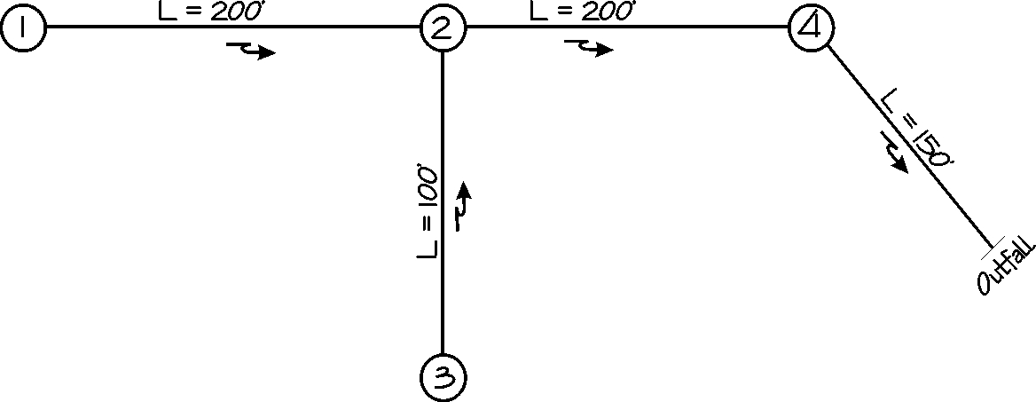
Figure 9-11. Storm Drain Layout Sample Problem
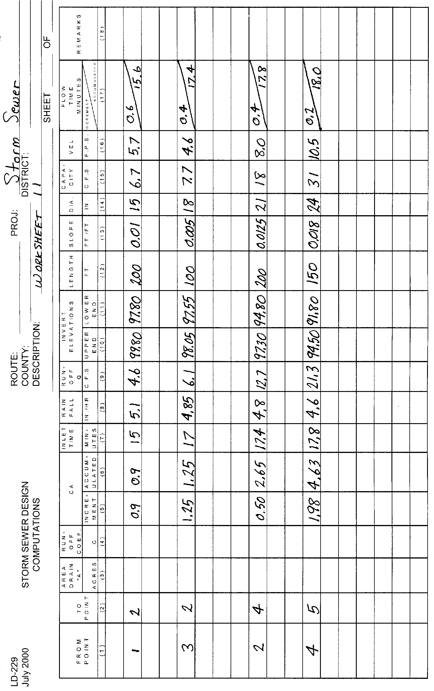
Figure 9-12. Storm Drain Design Form LD 229, Sample Problem
Figure 9-13. Hydraulic Grade Line Design Form LD 347, Sample Problem

References
American Association of State Highway and Transportation Officials. Volume 9, Highway Drainage Guidelines, Storm Drainage System, 1992
Bridge Deck Drainage Guidelines. FHWA Report No. RD-014, December 1986
Federal Highway Administration. Design of bridge Deck Drainage, Hydraulic Engineering Circular No. 21, 1993
Pavement and Geometric Design Criteria for Minimizing Hydroplaning. FHWA Report No. RD-79-31, December 1979
Dah-Chen Wood. Public Roads, Vol. 52, No. 2, Bridge Drainage System Needs Criteria. U. S. Department of Transportation, September 1988
U. S. Department of Transportation, Federal Highway Administration, 1984. Drainage of Highway Pavements, Hydraulic Engineering Circular No. 12
U. S. Department of Transportation, Federal Highway Administration, 1979. Design of Urban Highway Drainage – The State of the Art. FHWA-TS-79-225

