Appendix 9D-1 P-1-7/8 and P-1-7/8 4 Grates –

FHWA Classification

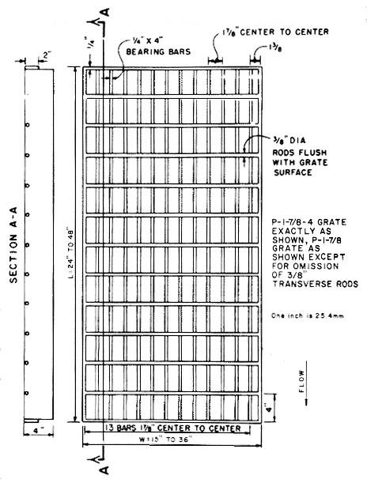

Source: HEC-12

