Appendix 9C-24 Nomograph for Computing Required Size

of Circular Drain for Full Flow

(n=0.013 or 0.015)
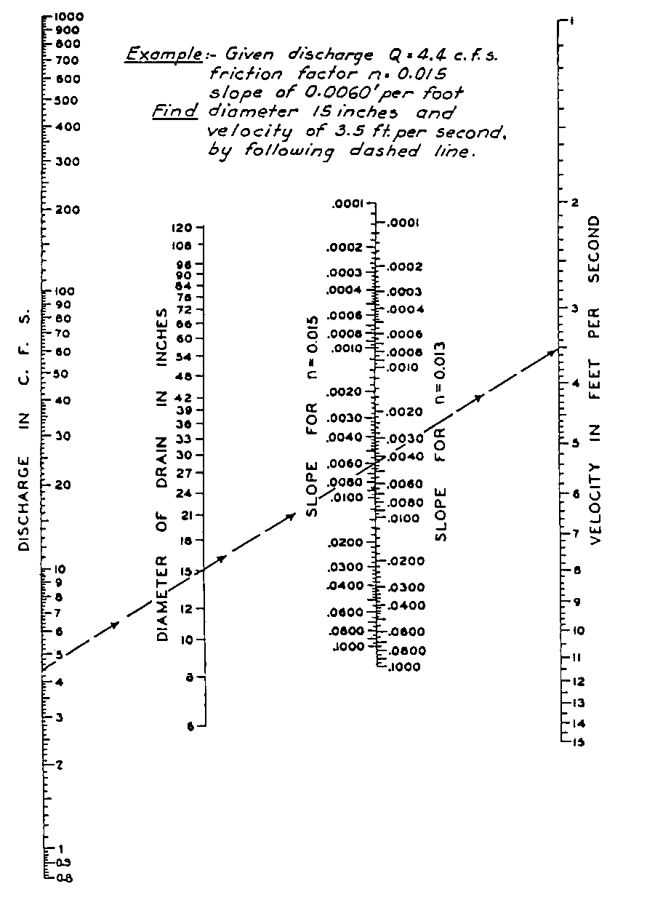

Source:

